
student support services - money support team

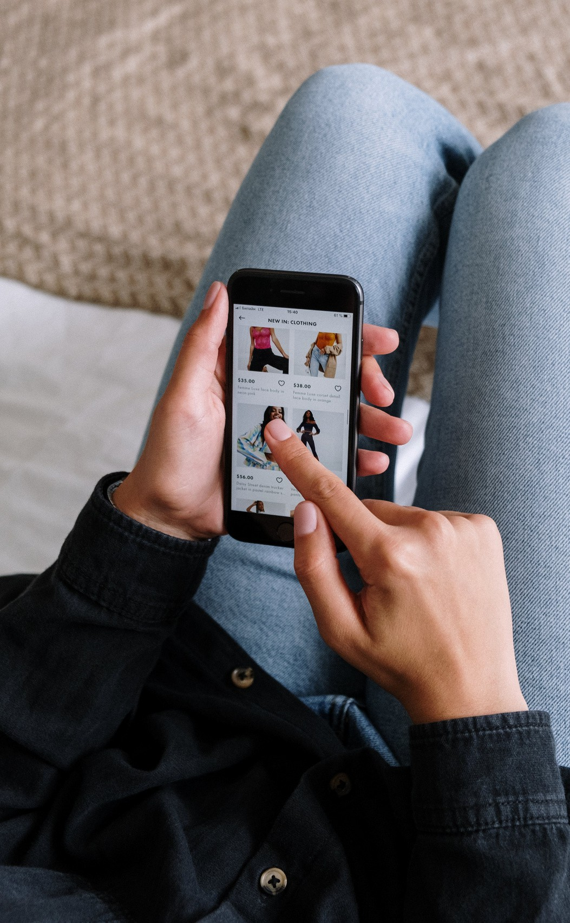
Navigating the Buy Now, Pay Later Landscape Safely

What is Buy Now, Pay Later?

Buy Now, Pay Later is a way of making purchases and spreading the repayments for these purchases over several weeks or months. Instead of you paying the retailer for goods or services either in store or online, you enter into an agreement with your BNPL provider to make payments to them and they will pay the retailer on your behalf.

- BNPL providers make money by taking a cut from retailer sales, not by charging interest.
- Key providers include Klarna, Clearpay, LayBuy, and PayPal pay in 3.
- Usage statistics: 36% of Brits (more than 19 million people) have used BNPL as of 2023, with 55% of millennials using it.

Repayment options
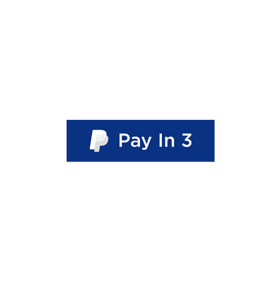
Repayment rules can be different depending on the BNPL lender you go for. Just make sure to check out when these payments are due and sync them up with when you're expecting your income. This way, you avoid any surprise payments that might catch you off guard.

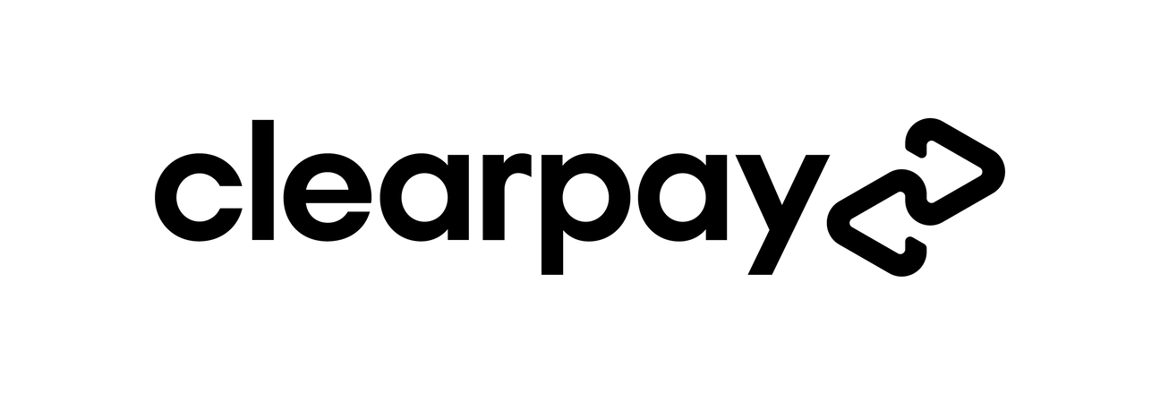



3 payments 6 payments
4 payments
3 payments

pay 1st instalment at purchase then every 30 days
pay 1st instalment at purchase then weekly
pay 1st instalment at purchase then every 2 weeks
pay 1st instalment at purchase then monthly

last instalment paid 60 days after purchase
last instalment paid 5 weeks after purchase
last instalment paid 6 weeks after purchase
last instalment paid 2 months after purchase

Expanding landscape

Traditionally BNPL was used for online purchases, however, is now quickly growing.

- Apps from major BNPL lenders include In-Store digital cards which can be used in high street stores and as payment for services such as dentists and garages. As of the end of 2022, BNPL apps had reached almost 10 million downloads on Google Play and the App Store
- The emergence of BNPL to purchase gift cards.
- The term "Eat Now, Pay Later" is emerging, with partnerships between BNPL Lenders and food delivery companies.

Benefits of using BNPL

- Immediate affordability without waiting for payday.
- Smaller, more manageable payments.
- No interest charges.
- Easy setup with minimal credit checks.

While it might seem like a tempting way to make purchases, it's important to be cautious. Remember, it's still a form of debt, and it doesn't take much for things to get out of hand if you're not careful
and stay within your means.

Key points to remember

- Avoid impulse buys.
- Assess your ability to make repayments.
- Keep track of your BNPL debt.
- Consider whether you would make the purchase without BNPL.

Explore with caution: understand the risks

- Overspending: BNPL can encourage overspending, it can be tempting to make purchases beyond your means since you can spread the payments over time. This can lead to pressure on your finances if you are not careful about your spending habits.

- Late Fees and Interest Charges: If you fail to make payments on time, you may incur late fees or interest charges. These fees can add up quickly, making the overall cost of the purchase higher than if you had paid upfront.

- Debt Accumulation: Using BNPL services for multiple purchases can lead to the accumulation of debt. If you have several ongoing instalment plans, managing multiple payments might become challenging, and the total debt can spiral out of control.

- Credit Score Impact: Some BNPL services may report late payments or defaults to credit agencies, potentially negatively impacting your credit score. A lower credit score can affect your ability to secure loans or credit in the future.

- Dependency on BNPL Services: Relying too heavily on BNPL services may lead to a dependency on this form of credit. This can then make budgeting and saving difficult or in some cases, impossible.

- Limited Consumer Protections: BNPL services may not always offer the same level of consumer protections as traditional credit cards. This could leave you with fewer options in a dispute over a purchase.

- Impulse Purchases: The ease of using BNPL services can lead to impulsive buying decisions. With more and more people using BNPL App’s to purchase goods, and an increase in the level of direct marketing through these apps encouraging spending, you may be more likely to make unplanned spontaneous purchases, contributing to unplanned debt.

Although BNPL is a way of spreading payments, it is important to be clear that it is still another form of credit. When shopping online there is often not enough time to stop, pause and understand the consequences of the credit agreement you are about to enter into. Staying mindful of the possible risks and making well-informed choices can steer you clear of financial troubles linked to BNPL. It's not the ideal option for those stretching their budget too thin. In the end, the concept of "pay later" isn't always as straightforward as it appears.

Wise advice
Jake Butler from Save the Student suggests:

“If you normalise paying for things in this way it could encourage poor, and often risky, financial behaviour in the future.

Rather than encourage students not to use the service, I would recommend that more thought goes into whether you would make the purchase if the service didn't exist. If the answer is no, then it's best to abandon your basket.”

Want to know more?

There are lots of great resources and information if you want to understand more about the BNPL market. A great starting point is:



MoneySavingExpert Save the Student

Seeking Help
If you are concerned about debt or financial worries, reach out to our Money Support Team. Honest discussions are the starting point to gaining support. Appointments can be made through the Student HUB by emailing ask@stir.ac.uk calling 01786 466022 or using Live Chat via your portal.

BNPL statistics

A third (33%) of UK consumers report using this form of lending **

Overall, 70% of BNPL users are paying through these means more often as a direct result of the cost of living crisis *

Almost half (49%) of users aged 18-24 claim to have been targeted through paid social media adverts.*

Over a quarter of users (25%) did not claim to know how much money was going out of their account monthly, as a result of paying off their loans *
Almost two in five (39%) Gen Z users (those aged 18-24) are using BNPL so that they can afford to keep up with fashion trends. *

BNPL shoppers were charged £39 million in late fees in the past year. ***



** ***
*

* Forbes Advisor surveyed 2,000 British adults about their usage of BNPL services
** Which Policy report Jan 2022
*** Citizens advice say 1 in 10 BNPL shoppers have been chased by debt collectors

