
Your Spending Review.
GET THE MOST OUT OF YOUR MONEY BY TAKING CONTROL OF YOUR FINANCES

It’s easy to spend money and even easier to lose track of what you are spending it on.
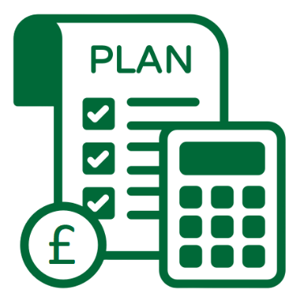
If you struggle to make ends meet each month or you just don’t have enough income to cover your current spending, is it time to review your current spending levels and habits?
This exercise will help you to examine your spending and work out where you could make positive changes. Whether you are already on top of your budget and looking for a bit of inspiration, or a complete budgeting novice who needs to get on track, reviewing how much you spend and what you spend your money on can really help you to take control of your finances and make a positive difference.

- Identify exactly how much you spend & where this money really goes | - Help you consider all types of spending for your budget & not just direct debits or regular bills
- Help you to identify any bad spending habits you have developed | - Allow you to look at patterns & better understand your motivations for how you spend
- Inspire you to stay on track & think twice before you buy things | - Spur you on to positive & long-lasting changes
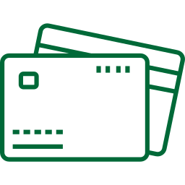
Reviewing your spending habits will help you to:

How to review your spending:
If you do most of your spending with a credit or debit card, look at last month’s statement(s) and work out where your money is going.
Break it down: To make it easier to identify possible areas to work on, let’s break things down a little and categorise your spending. Have your bank statement(s) ready, either in paper or electronic format and get ready to review your spending habits over the last month.

Review your last month’s spending for each of the below categories by entering all expenditure from your bank statement (s) into the relevant categories.
Remember to be honest with yourself!

Household Items  Food shopping, toiletries, cleaning supplies etc. | Food & Drinks  On the-go purchases on top of your normal food shopping: coffees, takeaways etc.
Subtotal = | Subtotal =
Going Out/Socialising  Pub, cinema, football matches etc. | Clothing & Accessories  Whether it’s a shopping spree or popping to the shops
Subtotal = | Subtotal =
Gaming, Phones, & Tech  In-app purchases, downloads, upgrades  Do not include monthly mobile phone contract | Other Spending  Gambling, smoking, travel, any other unplanned purchases
Subtotal = | Subtotal =
Add together subtotals for each category to find your total spend for the month and enter it below:
£

What do you notice?
When you are on a tight budget, it can be hard to keep track of where your money goes. As you look at each section, are you surprised about what you have spent in each category? While it might not seem like a lot, lots of little spending can add up to have a big impact on your budget. The good news is that this can be an area that you can improve, leading to more savings!





Vs.

Wants
Needs
Think about how much of your spending is on necessary things that you needed, and how much you may have spent on non-essential items that you wanted.

What non-essential items have you been buying? List them below:
£

What has this spending added up to over the month?

Are you prepared to give up or reduce spending on any of these non-essentials?

Things to consider:



When do you spend?
Understanding when you have spent money is as important as thinking about what you bought and where you bought it. If you notice you are more likely to go on a shopping spree or do a lot of socialising after you have received your student loan and or wages, can you do anything to change this?
Why do you spend?
Another important aspect to consider is why you have spent money. How did your mood or environment affect your spending patterns? If you notice that you are more likely to order take-away when you are tired, can you do anything to change this pattern?

What patterns have you noticed in relation to when you spend more? What patterns have you noticed in relation to your mood and spending habits? Detail them here:

Having worked through your spending and reviewed your figures, you should now have a
much clearer idea of where your money has gone. You have also considered other aspects of your spending that you might never have thought about before, including when you spend the most and how your mood and environment have impacted your spending.
Sometimes all we need is a little bit of awareness before being able to re-evaluate and change our behaviours. And that change can be significant or a series of smaller changes to your behaviour and habits. Either will lead to a change in your spending.

How are you going to change?
Set achievable goals that will make a difference!
Goal:

What will you do to stay on track:

What might take you off course:

What can you do to avoid being derailed:

Goal:

What will you do to stay on track:

What might take you off course:

What can you do to avoid being derailed:

Goal:

What will you do to stay on track:

What might take you off course:

What can you do to avoid being derailed:

Moving forward:
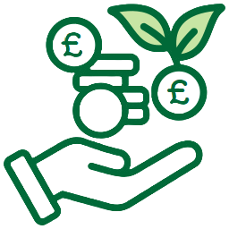
Having reviewed and reflected on your spending habits, and set yourself some goals to take forward, you should now be able to:
- Identify exactly how much you spend and where this money really goes
- Understand all aspects of your spending and not just your direct debits
- Identify any bad spending habits you have developed
- Start to make positive and long- lasting changes
Managing your money:
A budget is possibly the single most important tool for effectively managing your money. It identifies whether you have enough money coming in to meet your essential outgoings, and how much you can afford to spend on things that you desire or want. It allows you to see when and where you need to make changes to your spending, and can help you plan ahead for big purchases.
If you would like more information to make positive financial changes, budgeting, or to address any issues that this exercise has identified, we have lots of advice and guidance to support you. Check out our website at:


https://www.stir.ac.uk/student-life/support-wellbeing/student-support-services/money-support/managing-your-money/
You will find in-depth information on topics such as budgeting, lifestyle spending, shopping and travel, with onward signposting to specialist tools and resources to support you to manage your money. Whether you want to cut down on the food shop or start saving for a home, these web resources will help.
If you are worried about your situation or feel that you need more comprehensive or one-to-one support, you can book an appointment with an Adviser for one-to-one support through the Student Services Hub:


https://www.stir.ac.uk/student-life/support-wellbeing/
student support services – money support team

