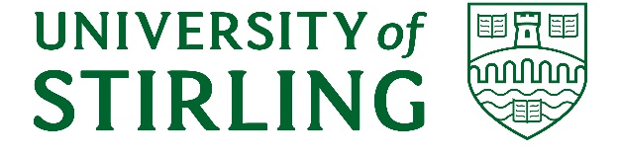

UNIVERSITY OF STIRLING
UNIVERSITY RESEARCH ETHICS COMMITTEE
Research Ethics Review Appeals Procedure
Introduction
- The University of Stirling is committed to research that truly makes a difference and is conducted to the highest possible ethical standards. To safeguard the interests of researchers and participants, research within the University only proceeds after scrutiny by one of our three Research Ethics Panels. As part of this commitment, the University has established procedures for appealing the decisions of the individual Research Ethics Panels to the University Research Ethics Committee (UREC).
- This procedure applies to University staff and postgraduate research students engaged in research projects that have been reviewed by the delegated Research Ethics Panels.
- A researcher may appeal the decision of the Research Ethics Panels on any of the following grounds:
  - There appears to have been procedural irregularities in the review process which may have been impacted on the decision reached.
  - Demonstrable evidence exists of inadequate reviews, prejudice or bias in the process.
- Dissatisfaction with the ethics review decision alone is not sufficient grounds for appeal. Members of the University Research Ethics Committee will scrutinise appeals independently and, if the above conditions do not apply they will dismiss the complaint.
Appeal Procedure
- Researchers wishing to make an appeal against the decision of one of the Research Ethics Panels should initially write to the Chair of the relevant Research Ethics Panel for further review. Once this route of appeal has been exhausted, the appellant should appeal in writing to the Committee Manager of the University Research Ethics Committee (ethics@stir.ac.uk) within 10 working days of receiving the Research Ethics Panel decision. Receipt of the appeal will normally be acknowledged within 5 working days.
- The appeal will be scrutinised independently by three members of the University Research Ethics Committee nominated by the Committee Manager. These individuals will not have been involved in the original review of the application. Their role is to decide if the conditions of the appeal have been met and deliberate the appeal. The members of UREC can, if necessary, call on additional expertise if this is deemed desirable
- The members of UREC chosen to deliberate the appeal have the full authority of UREC to confirm or vary the original decision under appeal. Notification of the outcome of the deliberation will be provided in writing to the appellant and the original Research Ethics Panel by the UREC Committee Manager, normally within three weeks of receiving the request to appeal.
- Possible outcomes:
  - Appeal not upheld. The original Research Ethics Panel decision stands.
  - Partially upheld decision. Feedback and revisions to the original application requested and, once completed, the application should be returned to original Research Ethics Panel.
  - Appeal upheld. A letter of approval will be issued.
- The decision of the University Research Ethics Committee is final, there is no further right of appeal if the appeal is not upheld.
- The Committee Manager of the University Research Ethics Committee will work with the Research Development Manager to ensure that if there are any institutional or contractual issues related to research funding or research partners, these are dealt with appropriately.
- A decision to reject an appeal will not prejudice the review of future ethics applications from the appellant.
- Should any evidence of research misconduct arise from the process, this will be dealt with under the University of Stirling procedure for Allegations of Research Misconduct.

Rachel Beaton
Research Integrity and Governance Manager
Research, Innovation & Business Engagement
November 2022

