Insights from the BAMSA project
Using digital leisure to tackle social isolation

Globally, loneliness and isolation are on the rise, with policymakers recognising that there is an epidemic of loneliness that spans the generations. The Scottish Government set out its approach to tackling social isolation in A Connected Scotland (2018), a national strategy to tackle isolation and loneliness and build stronger social connections. Key priorities include the creation of opportunities for people to connect with each other, and to support an infrastructure that fosters connections. Additionally, the Scottish Government published A Fairer Scotland for Older People (2019), a framework developed to challenge the inequalities older people face as they age and to celebrate older people in Scotland. This included the promotion of activities that give older people the opportunity to remain engaged in their communities, alongside activities that bring different generations together.

Covid-19 and subsequent national lockdowns meant older and clinically vulnerable populations have had to live largely sequestered lives indoors, removed from their usual everyday leisure practices, families and friends. As a result, the role of digital technology in maintaining social connections has been invaluable. The Bridge: A MindSport for All (BAMSA) project explored how digital bridge (the card game) provided a crucial means of support, fun and social connection during lockdown and beyond.

This briefing paper, drawing on the project’s key findings and recommendations, provides a summary of implications for policymakers and practitioners in Scotland. Its findings will be of particular relevance to those interested in developing safe and engaging leisure activities for older populations that provide meaningful connection, particularly in the wake of Covid-19 and the ongoing attendant health risks the virus poses.

Key findings

- The use of technology to enable the continuation of online leisure activities during the Covid-19 pandemic was crucial in tackling social isolation and connecting individuals with like-minded interest groups.

- Data from the Bridge in the Time of Covid project, revealed the importance of bridge as an online leisure activity for older, at-risk populations in Scotland and beyond.

- Playing online also improves digital literacy. Assumptions about technologically shy older populations have been challenged by the research. Nevertheless, learning and adopting new technologies for social connections requires the support of dedicated teachers, families and friends. Those individuals who lack the economic access to digital technologies and support groups are less likely to participate in a leisure activity online.

- As a partnership card game, bridge fosters cohesiveness, empathy and cooperation. It also helps to bridge the intergenerational gap through a shared activity that can create reciprocal benefits for both older and younger populations.

Study

The Bridge: A MindSport for All (BAMSA) project has explored how transferable skills, community, friendship and partnership are all present in the game of bridge (Punch et al. 2020). Extending this research, the Covid-19 study explored how the pandemic impacted people’s everyday leisure experiences during various national lockdowns in Scotland and beyond. Whilst the study collected views from all ages, the majority of participants were between 65-80 years of age. Although lockdown affected all age groups, there is acknowledgment that older populations with underlying health conditions were most at risk of contracting the virus.
Qualitative diary data was collected from April 2020 to December 2020, spanning the first national and international waves of lockdowns, re-openings and subsequent closures. Over 300 diary accounts from more than 100 participants from 19 different countries were submitted.
Access to digital technologies, support networks and online communities are crucial to tackling social isolation and loneliness. The study showed how older adults successfully moved from playing bridge in a face-to-face environment to gradually embracing digital bridge. The success of the digital switchover was made possible by a wide range of dedicated bridge teachers and organisers who spent considerable time encouraging and supporting their technologically averse and shy members to move to online bridge.

As bridge clubs closed around the world, the mindsport shifted online and the global bridge community enabled many players to become digitally literate for the first time. Platforms are now available that incorporate video and audio communication, which provides further scope for participants to socialise. BAMSA’s Covid Impacts on Bridge study shows that many 80-year-olds who had never used a computer before are now playing online bridge.
Once the initial hurdles of managing the online software gaming technology had been learned, the majority of participants spoke about spending ‘more time than ever’ playing online bridge. Many over-70s have described online bridge as a 'lifesaver' during the pandemic. Furthermore, the digital technologies enabled them to connect to geographically diverse players, families and friends around the globe from the safety of their homes. In this way, participants spoke about digital bridge providing structure and routine for their everyday lives during lockdown, as well as developing new digital literacy skills through a much-loved leisure activity.
Digital bridge will continue post-lockdown, enabling players with reduced mobility to stay engaged and connected. Bridge has been transformed by technological changes during the pandemic, enabling a hybrid of digital and face-to-face games to meet a variety of players' needs. In this way, bridge provides opportunities to engage in an intergenerational, multi-national, geographically diverse community that is both local and global. For an ageing population in an increasingly lonely world, the case study of bridge highlights how a mindsport provides important arenas of social connection, participation in leisure activities and community.
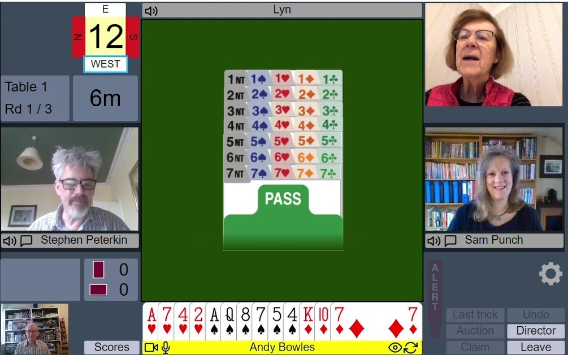
Bridging the digital divide: Online platforms such as RealBridge enabled the benefits of the mindsport to continue throughout the Covid-19 pandemic, prompting many players to embrace digital skills.

Implications for policy and practice

Organisations and individuals interested in tackling social isolation through technological interventions should consider the following areas:

- Community – The bridge community is both local and global. Bridge can be used to tackle the intergenerational gap through a shared activity, creating opportunities for people to connect and meeting Priority 3 of A Connected Scotland.

- Interest – People have a variety of interests and leisure activities. The use of mindsports, and bridge in particular, can have beneficial effects in several areas. Bridge is played by people of all ages, including people who are not able to participate in physical sport (e.g. due to age or disability). Playing bridge, whether face-to-face or online, combats social isolation and loneliness, and improves community building, a key focus of A Fairer Scotland for Older People.

- Risk – Supporting leisure activities in digital spaces for at risk populations is a way to sustain social connection where the risks of face-to-face interaction are increased, or where other barriers prevent in-person participation.

- Financial Security – Access to technologies that support engagement and connection online should not be assumed. Appropriate financial development and support is required to reach those without the economic means (and at higher social isolation risk) to develop a meaningful leisure activity online, as mentioned in the framework for A Fairer Scotland for Older People.
- Support Infrastructure – The bridge community has a variety of skilled teachers and educators who can support the learning and playing of bridge online and face-to-face. However, assumptions about accessing this network should not be assumed and further support that fosters these social and leisure connections is needed (as highlighted in Priority 4 of A Connected Scotland).

About this research

This briefing is based on research undertaken by Bridge: A MindSport for All (bridgemindsport.org):

- Dr Miriam Snellgrove, Research Fellow, Faculty of Social Sciences, University of Stirling
- Professor Samantha Punch, Professor of Sociology, Faculty of Social Sciences, University of Stirling
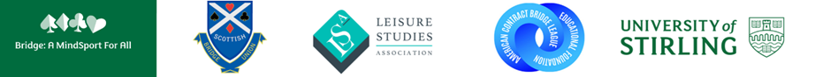
- Tim Rees, BAMSA Steering Group

If citing this research, please refer to Bridge in the Time of Covid-19 report, available online at: https://bridgemindsport.org/wp-content/uploads/2021/01/Covid-Project-December-2021-Summary.pdf

Further BAMSA studies cited in this report can be found here:
- Punch, S. and Snellgrove, M. (2020) Playing your Life: Developing Strategies and Managing Impressions in the Game of Bridge Sociological Research Online.
- Punch, S., Russell, Z. and Cairns, B. (2020) (Per)forming Identity in the Mind-sport Bridge: Self, Partnership and Community International Review for the Sociology of Sport.
Contact
Professor Samantha Punch
Faculty of Social Sciences
University of Stirling
s.v.punch@stir.ac.uk

September 2021

