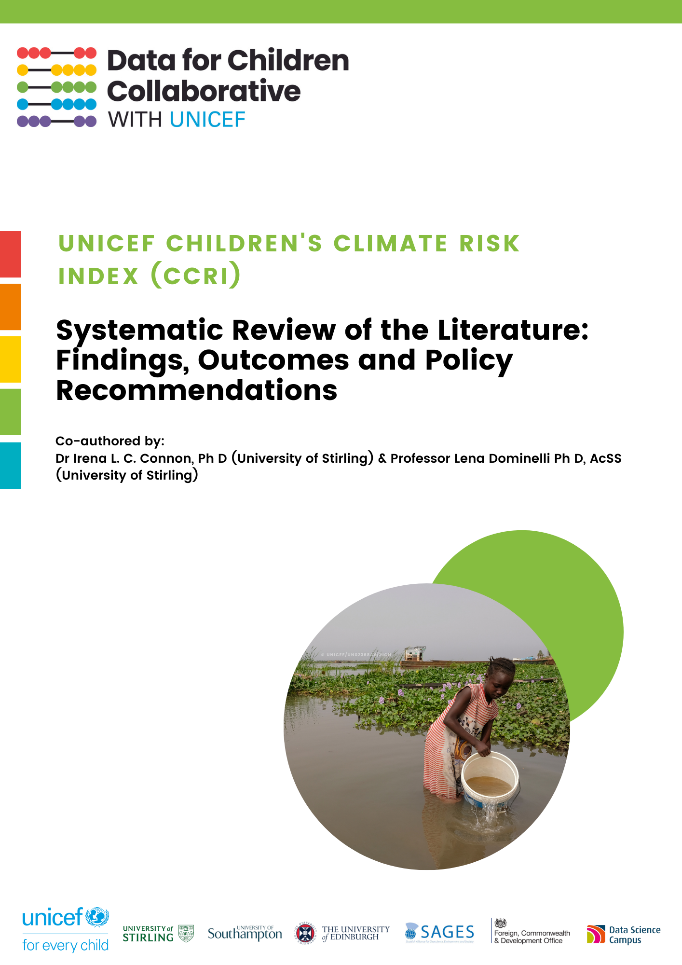
UNICEF CHILDREN’S CLIMATE CHANGE RISK INDEX PROJECT (CCRI)

Systematic Review of the Literature:
Findings, Outcomes and Policy Recommendations

Co-authored by Dr. Irena L. C. Connon, Ph D (University of Stirling)
irena.connon@stir.ac.uk
&
Professor Lena Dominelli, Ph D, AcSS, (University of Stirling)
lena.dominelli@stir.ac.uk

Report Design by Alessandra Fassio (Data for Children Collaborative with UNICEF)

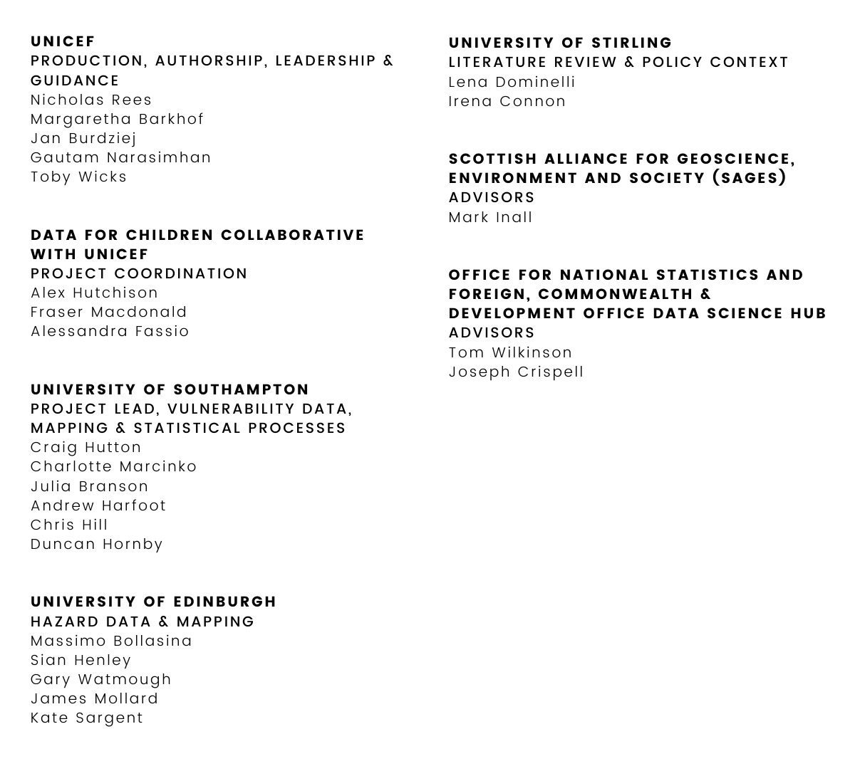
CCRI Project Team:

CONTENTS

LIST OF TABLES AND FIGURES iii
INTRODUCTION 2
Systematic Literature Review 3
Citation Analysis, Diagram of Linkages between Climate Risk Factors and their Importance for Child Health Outcomes, and Development of Child-Centered Systems-Based Iterative Loop Model 3
Structure of Report 3
METHODOLOGY 5
Selection of Thematic Research Strands (Strings) 5
Development of two Analytical (Conceptual) Frameworks 5
Systematic Literature Searches 7
Coding and Analysis of Articles and Reports 9
Citation Analysis and Development of a Diagram of Linkages between Climate Risk Factors and their Importance for Child Health Outcomes 9
Developing the Child-Centered Systems-Based Iterative Loop Model 10
FINDINGS, OUTCOMES AND DISCUSSION 12
Findings and Discussion of the Systematic Literature Review 12
Thematic Strand 1: Climate change, Risks, Hazards and Related Disasters 12
Thematic Strand 2: Vulnerability Mitigation Activities Associated with Climate Change, Hazards, Risks, and Related Disasters 15
Thematic Strand 3: Stages of Climate Change-Related Disasters 18
Thematic Strand 4: Climate Stresses and Shocks 19
Thematic Strand 5: Health and Wellbeing and Climate Risk 21
Thematic Strand 6: Discrimination and Oppression in Relation to Climate Change 23
Thematic Strand 7: Resilience and Climate Risks, Hazards, and Related Disasters 25
RELATIONS BETWEEN CLIMATE RISK FACTORS LINKED TO CHILD HEALTH OUTCOMES 28
CITATION ANALYSIS RESULTS 30
DIAGRAM OF LINKAGES BETWEEN CLIMATE RISK FACTORS AND THEIR IMPORTANCE FOR CHILD HEALTH OUTCOMES 31
Child-Centred Systems-Based Iterative Loop Model 33
CONCLUSION 36
Key Recommendations 37
NEXT STEPS 38
Action for Policymakers 38
Future Research Directions 39
REFERENCES 40

LIST OF TABLES AND FIGURES

List of Tables:

Table 1: Findings – Thematic Strand 1 (p.13)

Table 2: Findings – Thematic Strand 2 (p.16)

Table 3: Findings – Thematic Strand 3 (p.17)

Table 4: Findings – Thematic Strand 4 (p.20)

Table 5: Findings – Thematic Strand 5 (p.22)

Table 6: Findings – Thematic Strand 6 (p.24)

Table 7: Findings – Thematic Strand 7 (p.26)

Table 8: Forms of Hazards, Shocks and Stresses identified by Pillar 1 (p.27)

Table 9: Factors Linked to Child Vulnerability to the Health Risks Associated with Climate Change (p.27)

Table 10: Summary of Findings of the Citation Analysis of the Academic Literature (p.29)

List of Figures:

Figure 1: Map Showing Severity of Climate Risk at the Global Scale (p.2)

Figure 2: Flow Chart Summarising the Reduction Process to Determine the Number of Academic Articles included in the Final Sample (p.7)

Figure 3: Flow chart Summarising the Policy-relevant Literature Search and Reduction Process (p.10)

Figure 4: Diagram showing Relational Linkages between Pillar 1 and Pillar 2 Factors for Child Health Outcomes (p.28)

Figure 5: Diagram of Linkages between Climate Risk Factors and their Importance for Child Health Outcomes (p.31)

Figure 6: Holistic Chart of Relationships between Variables for Child-Centred Climate Change Risk Index Using Systems-Based Approach (p.34)

EXECUTIVE SUMMARY

Introduction
This report has been compiled as part of the Children’s Climate Risk Index (CCRI) Project for UNICEF based on the work undertaken for the systematic literature review (SLR) in work package (WP2) by Irena Connon (Research Fellow and Co-I) and Lena Dominelli (Social Sciences Lead). The purpose is to provide a descriptive overview of the findings of the Systematic Literature Review from which a Diagram of Linkages between Climate Risk Factors and their Importance for Child Health Outcomes and a Child-Centred Iterative Loop Framework for Action were developed. This report considers:

- How and to what extent the existing research and policy literature has examined the interactions and intersections between all the individual, structural, institutional, cultural factors, policies, and wider geographical domains that determine the risks, vulnerabilities, mitigation strategies and outcomes for individuals, including children, experiencing climate change hazards, risks, and related disasters.
- The extent to which the agency, decision-making capacity, and rights of children, adolescents and young people has been captured within the existing academic research literature.

Methodology
The systematic literature review explored seven key themes: 1) Climate change, risks, hazards, and related disasters; 2) Vulnerability mitigation activities associated with climate change, 3) Stages of climate-related disasters; 4) Climate shocks and stresses, 5) Climate change, risks, health, and wellbeing; 6) Discrimination and oppression in relation to climate change, and 7) Resilience and climate change hazards, risks, and related disasters. The findings and the contributions made by other members of the CCRI project team were then drawn upon to develop the Diagram of Factors Linked to Children’s Climate Change Health Risk and the Child-Centred Iterative Loop Framework. The weighting that the existing literature attributed to each linkage was derived by using citations as a proxy of importance.

Key Findings
Our systematic review of academic and policy-relevant grey literatures found that:

- Little is known about the intersections between the multi-layered factors and how they influence differences in risks for children (including adolescents and young people).
- The risks manifest in the day-to-day realities of children are not well understood.
- The impacts that vary according to the specific ages of children are rarely considered.
- Adults make decisions about children’s futures without understanding and addressing the specific climate risks that children face.
- There remains a notable absence of children’s agency and decision-making capacities within the existing research.

The citation analysis revealed the three relationships most commonly identified as influencers of health risks associated with climate change were: 1) poverty and child health, 2) education and child health, and 3) poverty and education. However, given the lack of research examining risk from children’s perspectives, this can only be said to be reflect adult understandings of children’s risk rather than children’s own understandings. The Child-Centred Iterative Loop Framework highlights the limitations within existing knowledge, particularly the tendency to focus on adults’ perceptions of climate risks to children, and repositions children in the centre as agents.

Conclusion and Recommendations
As children are disproportionately affected by the impacts of climate change, it is fundamental for them to be positioned at the centre of all developments in research, policy, decision-making, and practice, and for them to be recognised as agents capable of determining their own futures as envisaged in the United Nations Convention on the Rights of the Child (CRC). Opportunities for children to exercise their agency and for research to be conducted in partnership with children to coproduce and utilise qualitative forms of inquiry to understand their real-life experiences of climate risk are critical to future development.

INTRODUCTION

Social and environmental justice are first-order priorities for policy and decision-making around climate change at sub-national, national, and international levels. In professional and academic settings, most social justice discourse has been expert-led, leaving a gap regarding the absence of the voices of marginalized groups. This is particularly the case for children, whose direct voices on climate change are missing from the National Action Plans demanded by the Paris Agreement and by countries committed to the United Nation’s Convention on the Rights of the Child (CRC), although this Convention emphasized the importance of children’s agency and right to be heard in decisions that affect them. Understanding the risks climate change poses to children and (including young people) is fundamental to meeting the challenges undermining children’s current and future wellbeing. For children’s rights to be fully realized, their voices and agencies have a key role to play in how new knowledge is developed and how their understandings of risk and vulnerabilities are incorporated in risk mitigation decision-making aimed at safeguarding their futures.

The Children’s Climate Change Index (CCRI) helps pinpoint areas at the global scale where children are most at risk now by highlighting those locations where the severity of climate risks is at its highest (Figure 1). However, the mitigation of children’s vulnerabilities to these risks requires an understanding of the ways in which individual, structural, institutional, cultural, policy and wider geographic factors shape children’s vulnerability to these risks. Furthermore, developments designed to mitigate vulnerabilities among children must allow them to exercise their rights, and express their own voices, agencies, and decision-making capacities.
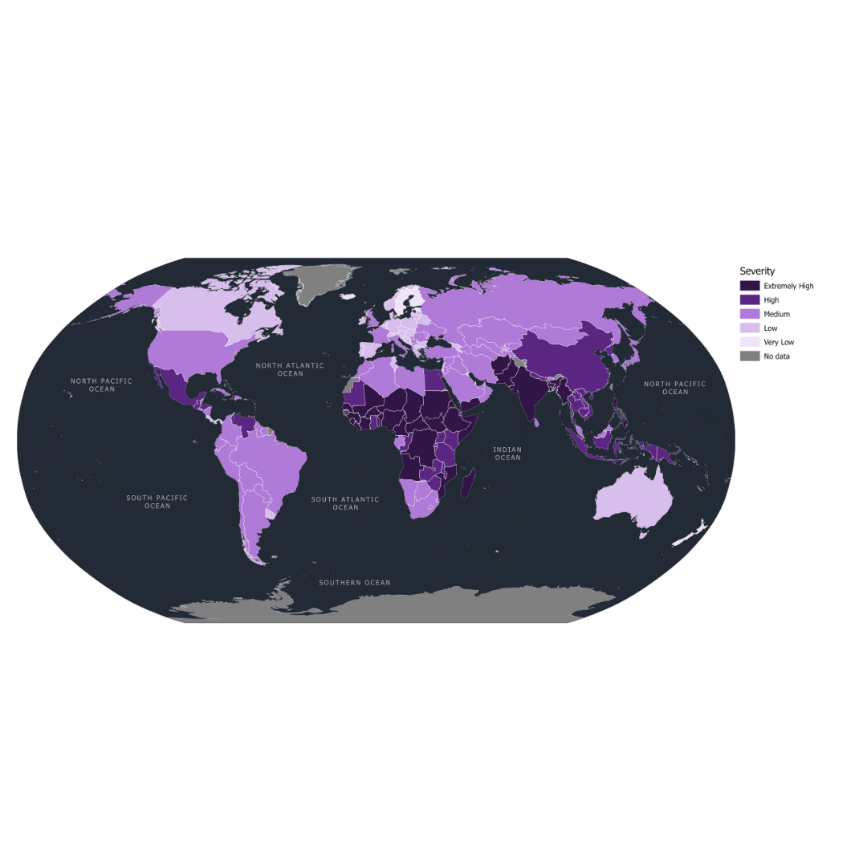
Figure 1: Map showing severity of risk at the global scale (Rees et al. 2021; 14)
Systematic Literature Review
A systematic literature review (SLR) was undertaken to determine: 1) how and to what extent the existing academic and policy-relevant literature has considered the interactions and intersections between all the different, multi-layered factors that influence the differentiated outcomes associated with climate change risks to children, and 2) the extent to which the agency, decision-making capacities and voices of children has been captured in the existing research. The systematic review explored seven key themes: 1) Climate change, risks, hazards, and related disasters; 2) Vulnerability mitigation activities associated with climate change hazards, risks, and related disasters, 3) Stages of climate-related disasters; 4) Climate shocks, and stresses, 5) Climate change, risks, health, and wellbeing; 6) Discrimination and oppression in relation to climate change, risks, hazards and related disasters; and 7) Resilience and climate change hazards, risks, and related disasters. Although the Children’s Climate Risk Index was developed using the IPCC 2014 definition of risk, where risk is defined as the outcome of hazard, exposure and vulnerability, and with the term vulnerability referring to the susceptibility of people to a phenomenon (e.g. tropical cyclone), for this literature review the term vulnerability was understood more broadly to include the social factors that affect exposure to and outcomes associated with environmental hazards (e.g socio-economic circumstances). This was to ensure that the review captured the existing social science, as well as natural science, research focusing on the drivers of vulnerability to climate risks, as well as to help capture the influencers of inequalities in terms of outcomes.

Citation Analysis, Diagram of Linkages between Climate Risk Factors and their Importance for Child Health Outcomes, and Development of Child-Centered Systems-Based Iterative Loop Model
The findings of the Systematic Literature Review and those from Pillar 1 and Pillar 2 discussions were drawn upon to develop a: 1) Diagram of Factors Linked to Children’s Climate Change Health Risk and a 2) Child-centred, Systems-based Iterative Loop Model that identifies the interactions and complexities of a child-centred approach to climate risk for children. A Citation Analysis of the academic literature was undertaken as part of the review to identify the importance that the cited articles gave to each linkage. The Diagram and Model highlight the limitations of or gaps within existing knowledge, including its tendency to focus on adults’ perceptions of climate risks to children.

Structure of Report
This report consists of several sections. The following section describes the methodologies used to conduct this systematic literature review, citation analysis, diagram, and development of the child-centred iterative loop framework. The findings of the systematic literature review are discussed in seven sub-sections corresponding to each of the seven research strands (themes) of the review. This is followed by the presentation and discussion of the Citation Analysis, Diagram of Linkages between Climate Risk Factors and their Importance for Child Health Outcomes, and the Child-Centred Iterative Loop Model. The final section consists of a concluding discussion and presentation of a series of recommendations for policymakers, as well as for future research.

METHODOLOGY

The review of the academic and policy-relevant literatures combined systematic with narrative techniques to review the existing scholarly literature. This allowed the literature searches to be conducted according to the key principles of systemic reviewing, while simultaneously allowing for subjective evaluation of the literature to determine relevance (Snilsveit et al., 2012). Two conceptual frameworks were developed by the authors of this report. The first drew upon intersectional research within the wider Disaster Risk reduction (DRR) scholarship to identify different multi-layered factors that influence outcomes associated with climate change. This was applied to the analysis of the findings to answer the question of the extent to which the existing literatures capture the interrelations and intersections of the different factors. The second conceptual framework drew upon: 1) the DRR scholarship focusing on importance of agency and decision-making for vulnerability mitigation and 2) the wider Social Work and Social Science literature focusing on participatory research methods for research involving children, to develop a systematic classificatory system of different levels of agency and decision-making reflected by different research approaches. This was then applied to the analysis to answer the question of the extent to which the existing literature captures children’s agency.

Selection of Thematic Research Strands (Strings)
To ensure sufficient breath of literature was reviewed, seven thematic strands (strings) were identified. These were: 1) climate change hazards, risks, and related disasters, 2) vulnerability mitigation activities associated with climate change hazards, risks and related disasters, 3) Stages of climate related disasters, 4) Climate related shocks and stresses, 5) Climate change hazards, risks, disasters and health and wellbeing, 6) Discrimination, oppression and exclusion in relation to climate change hazards, risks and related disasters, and 7) Resilience and climate change hazards, risks and related disasters. These were determined on the basis of the aims of the project and in consultation with the wider project team. The categories of children (under 12), adolescents (13-18) and young people (19-24) were used to undertake the review. Although UNICEF defines a child as anyone under 18, the literature does not always utilize that definition.

Development of Two Analytical (Conceptual) Frameworks
Framework of Intersectionality
The first conceptual framework was developed through an initial scoping of the existing social science scholarship of environmental and climate, hazards, risks, and disaster (Bethel et al 2013, Cutter et al. 2003, Rufat 2015). Several recent articles used an intersectional perspective to identify the complexity of how various multi-layered factors intersected with each other (Cutter 2020, Kuran et al. 2020). From this, the following key factors were identified as influential:

- Individual level factors or attributes, including gender, race and ethnicity, disability, pre-existing health status.
- Structural level factors, including socio-economic factors, household factors, and social backgrounds which are also experienced individually.
- Institutional level factors, including the family or household, educational institutions, social care institutions, health care institutions.
- Cultural factors, particularly the socio-cultural context, norms and beliefs including religious affiliations, which also influence social structural factors and social attitudes, including how society responds to individual factors such as gender, race and ethnicity and disability, and the way in which discrimination and inequality emerge in different localities and become embedded in policy.
- Policy (in place) factors.
- Geographical domain, which refers to the multiple factors associated with an individual’s wider contextual surroundings, including political environment, economic environment, physical geographical environment, built environment, infrastructural support, technological environment, health, social care, and medical environment.

Framework of Participation, Agency, and Decision-making
To examine how different research approaches reflect different degrees of the agency and decision-making capacities of research subjects, a second scoping study was undertaken that focused on the use of participatory research methods for applied-action research. From this, five conceptual categories were drawn up that reflect the different amounts of agency and decision-making capacities that each form of participation enables. These were:

- No direct participation of research subjects = No decision-making capacity or agency reflected.
- Consultive participation = May include viewpoints reflecting opinions about a pre-given topic but limited in terms of revealing full extent of decision-making capacities or agency (Lansdown 2010).
- Collaborative participation = Some evidence of research subject participation in decision-making reflecting agency but limited in scope by pre-defined goals or agendas reflecting the interests of the researcher and/or group (Lansdown 2010).
- Subject-led or child-led participation = Research subjects take the lead in making decisions which reflects a degree of agency, but agendas and tasks are normally pre-defined and overseen by researchers, authority figures or the dominant group (Lansdown 2010).
- Protagonistic approaches = Research subjects, including children, set the agendas for transformative change, taking a leading role in influencing the research agenda as well as outcomes, thus becoming proactive agents of change (Jupp Kina 2012).

Systematic Literature Searches
Academic Literature Search
The systematic aspect involved conducting database searches of the literatures. First, four academic databases from which to perform keyword searches of the academic literature were identified and which reflected the interdisciplinary nature of the research problem (Web of Science, Scopus, Jstor, and Science Direct). Key words relevant to each thematic strand were identified to enable keyword searches of the databases to be performed using multiple combinations of keywords. The searches generated an initial total of 2789 articles of potential relevance. Reductions using the methodology detailed in Figure 2 resulted in 261 articles being subjected to detailed scrutiny. Of the 261 articles:

- 105 focused on children (with two of these also being included the numbers focusing on other age group categories due to overlap)
- 32 focused on adolescents (with one of these also being included in the children’s age group category due to overlap)
- 16 focused on young people/young adults (with one of these also being included in the adult category due to overlap)
- 111 focused on adults (with one of these also being included in the children’s age group category and another also being included in the young people’s age group category due to overlap).

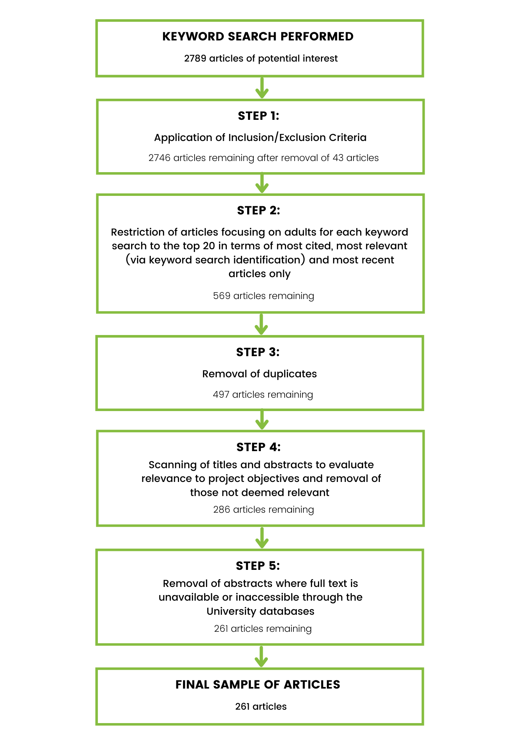
Figure 2: Flow chart summarising the reduction process to determine the number of academic articles included in the final sample
Policy-Relevant Literature Search
The Google search engine was selected for running a keyword search to identify policy-relevant or ‘grey’ literature. The same keywords were used as for the academic literature to ensure that the searches were consistent. The searches generated lists of reports, websites, and other information of potential relevance, with an initial total of 1467 search engine hits being identified. Reductions using the methodology outlined in Figure 3 resulted in 86 hits being subjected to detailed scrutiny. This keyword search was then supplemented by consultation between the authors and members of the wider project team using an abridged version of the Delphi Technique to a) evaluate the quality of the reports generated from the keyword search, b) identify additional relevant reports, and c) to reach a consensus on what constitutes best practice in research focusing on children, adolescents, and young people. The Delphi Technique is a research technique that involves seeking and drawing on the extensive knowledge, skills, and expertise of academic experts and/or practitioners working on the issue of relevance, with the aim of reaching a consensus on a specific question (Barrett and Heale 2020). From this, five additional sources were identified , bringing the total number of reports selected for inclusion to 91. Of these 91 reports: 64 focused on children (with 33 of these also being included the numbers focusing on other age group categories due to overlap), 29 focused on adolescents (with 27 also being included in other age categories due to overlap), 8 focused on young people/young adults (with all 8 also being included in other age categories due to overlap), and 32 focused on adults (with 13 also being included other age group categories due to overlap).

Composition of the Final Sample
The total number of documents included in the final sample was 352. This consisted of the 261 academic articles and the 91 policy-relevant reports.

Coding and Analysis of Articles and Reports
Analysis and coding were undertaken using qualitative descriptive analysis (Sandelowski 2000). Articles and reports were coded: 1) according to each of the key thematic strands addressed, 2) for each of the different factors associated with an intersectional perspective according to the analytical framework, 3) according to how they examined the interactions between factors, and 4) according to the extent to which they addressed the lived experiences, the agency and decision-making capacities of those affected.

Citation Analysis and Development of a Diagram of Linkages between Climate Risk Factors and their Importance for Child Health Outcomes
The findings of the systematic literature review were used in conjunction with the environmental and socio-economic factors identified by the Pillar 1 and Pillar 2 workstreams of the CCRI project to develop a diagram showing the linkages between the diverse environmental and socio-economic factors in influencing children’s health risk in the climate change context and to identify the limitations of or gaps within the existing knowledge. The weighting or importance that the existing literature attributed to each linkage between the factors was derived by using the total number of citations for each of the academic articles referring to each linkage as a proxy of importance. A Table of Citations was compiled to showcase the importance that the cited articles gave to each linkage.

Developing the Child-Centered Systems-Based Iterative Loop Model
Development of a child-centred, holistic chart of the relationships between variables for children’s climate change risk was undertaken using a systems-based approach. Development of this Model drew upon what is known from the wider social science literature about: 1) children’s agency, 2) the power relations between children and adults that affect children’s agency, and 3) the diverse different factors that affect children’s decision-making abilities, together with the findings from the systematic literature review and Pillar 1 and Pilar 2 evidence of the links between the different environmental and socio-economic factors influencing climate risk.

Figure 3: Flow chart summarising the policy-relevant literature search and reduction process
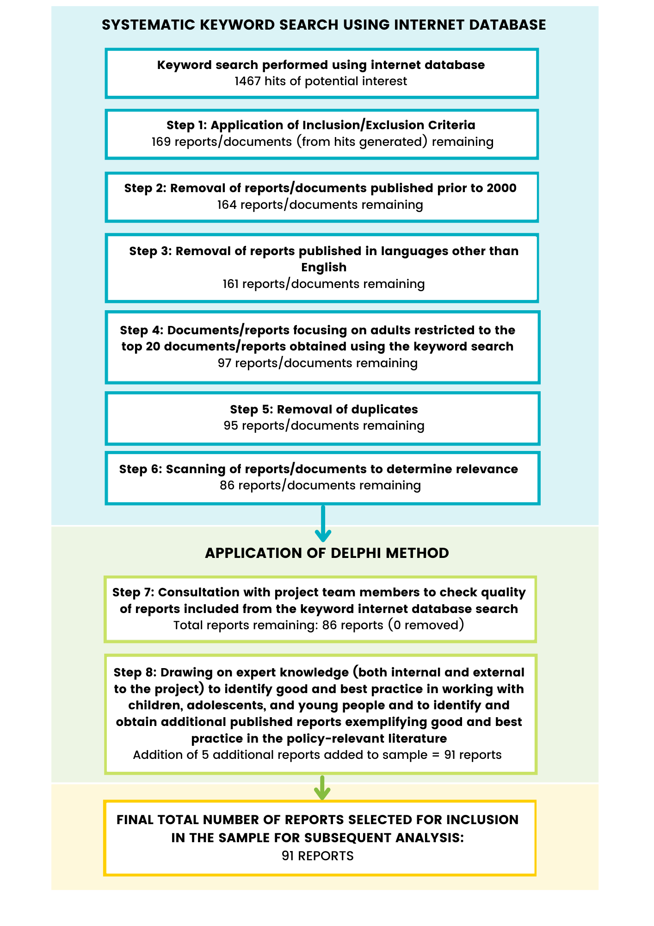

FINDINGS, OUTCOMES AND DISCUSSION

Findings and Discussion of the Systematic Literature Review
The systematic literature review revealed that very little of the existing academic and policy-relevant literature examined the interplay and intersectionality between the multiple and multi-layered factors that influence the differentiated experiences of climate risks, hazards, and related-disaster for children. This means little is known about how the full array of multi-layered factors come together to influence differences in risk. Most of the literature did not draw upon in-depth qualitative information to examine children’s lived experiences of climate change risk within different local contexts. Instead, it presented generalized conclusions drawn from quantifiable data. This means that little is known or understood about how the risks associated with climate change manifest in the day-to-day realities of children living in different geographic settings, or for groups living within the same setting but who have different lived experiences because they reside in different circumstances. Thus, this provides an area for future research. Moreover, most of the policy-relevant literature, as well as a sizeable proportion of the academic literature, did not differentiate between the impacts of risk among children of different ages. In addition, the relatively limited research available focusing on adolescents and young people highlights another area where further research ought to be undertaken to identify the specific experiences, perspectives and needs of these age groups for developing strategies, policies, and practices appropriate for these age groups.

There also remains a distinctive notable absence of children’s agency and decision-making capacities within the existing research. While evidence of direct consultation with children is included in some of the literature, this is primarily utilized to provide a narrative to support the views and conclusions of scientific, ‘adult’ experts, thereby highlighting the necessity of developing a primary evidence-base predicated upon children’s lived experiences of climate change risk and engaging them to reconceptualize risk as they envisage it. While a limited amount of the policy-relevant literature showcases examples of collaborative participation with children in vulnerability mitigation activities, no examples evidenced children exercising their full agentic capacities as the protagonists of change, i.e., people with the capacity to make decisions and act upon them. The following sub-sections detail the findings for each of the seven thematic strands (strings).

Thematic Strand 1: Climate change, Risks, Hazards and Related Disasters
Sixty-five academic articles and 60 reports addressed the issue of climate risk for children. Three types of risk are identified: direct risks, indirect risks, and indirect projected risk due to the long-term consequences in the degradation of planetary health. The majority of the direct risks discussed focus on the health risks. Indirect risks stem from ecological alterations triggered by climate change that can, in turn, increase rates of malnutrition, allergies and exposure to mycotoxins, vector-borne diseases (Malaria, Dengue, Encephalitis, Lyme disease), and emerging infectious diseases, as well as changes in exposure to chemical and other toxicant hazards (Bolton et al. 2018, Delahoy et al. 2021, Garcia and Sheehan 2016, McMichael 2014, Sheffield and Landrigan 2011). The other types of direct risk discussed are educational and social impacts, which included risks from disruption to education and risks resulting from displacement and/or forced relocation (Bennett and Friel 2014, Burke et al 2018, Peek and Stough 2010). Table 1 summarises the findings for thematic strand 1 for children, adolescents, young people, and adults.

Although children are understood as being more vulnerable to climate risks on the basis of being more ‘sensitive’ by virtue of their physical development stage and dependency on parents or carers to adapt or take precautions to minimise exposure to hazards, a number of important dimensions are lacking. These include a paucity of: detailed information and case studies about how the risks manifest in the lived experiences of children, examination of how the risks are differentiated specifically for children and, importantly, articles reflecting children’s own agencies in experiencing and dealing with climate risk from their own perspectives. Only a limited number of articles and reports discuss how individual, structural, cultural and policy factors influenced the differentiated experience of risk and even fewer discuss the interplay of the relations between the different factors. Of those that do, only one academic article and one report attempts to capture the complexity of the interplay by examining the intersections between the full range of factors in a holistic analysis. However, the article does so only in relation to the mental health risks, suggesting a dearth of academic research focusing on complexity and the intersection of factors in relation to the differentiated experiences of other forms of risk. While the report from Plan International (2020) explains that in the poorest communities with the fewest resources risk arises from the intersection of different inequalities including that of education, ethnicity, disability, age, and culture, it does not differentiate between the risks to children aged 10 and over and young people (up to age 24).

Table 1: Findings – Thematic Strand 1

Thematic strand 1: Climate Change risk, hazards, and related disaster
Number of academic articles and grey literature reports that mention/discuss each of the following | Children  (n=169) |  | Adolescents  (n=61) |  | Young People  (n=24) |  | Adults  (n=142)
 | Articles  n=105 | Reports  n=64 | Articles  n=32 | Reports  n=29 | Articles  n=16 | Reports  n=8 | Articles  n=111 | Reports  n=32
Climate change risk (general) | n=65 | n=60 | n=30 | n-27 | n=11 | n=7 | n=109 | n=30
Risk pathways (e.g., direct, and indirect and projected) | n=9 | n-49 | n=0 | n=19 | n=0 | n=7 | n=101 | n=30
Forms of risk (e.g., health, educational and social risks) | n=25 | n=52 | n=17 | n-27 | n=4 | n=4 | n=109 | n=30
Specific type(s) of environmental risks, hazards, and disaster | n=22 | n=38 | n=11 | n=26 | n=10 | n=5 | n=90 | n=27
Differentiation/ differentiated experience of risk | n=18 | n=50 | n=20 | n=27 | n=3 | n=7 | n=71 | n=29
- Influence of individual level factors (numbers of articles mentioning the following. (Note that many articles referred to more than one of these factors)  - Gender  - Disability  - Race and ethnicity  - Health status  - Migration status | n=2  n=4  n=1  n=2  n=1 | n=38  n=4  n=6  n=2  n=3 | n=3  n=0  n=1  n=0  n=0 | n=23  n=3  n=3  n=2  n=0 | n=0  n=0  n=2  n=0  n=1 | n=4  n=1  n=2  n=0  n=1 | n=56  n=6  n=15  n=5  n=4 | n=28  n=8  n=8  n=13  n=3
- Influence of structural factors  - Socio-economic factors  - Social relationships (inc. household)  - Technology and communication | n=1  n=1  n=1 | n=39  n=5  n=0 | n=2  n=2  n=1 | n=25  n=2  n=0 | n=3  n=2  n=1 | n=6  n=2  n=1 | n=30  n=59  n=9 | n=25  n=19  n=9
- Influence of institutional factors  - Education  - Health and social care | n=3  n=12 | n=38  n=5 | n=2  n=2 | n=16  n=5 | n=2  n=0 | n=2  n=2 | n=6  n=10 | n=6  n=7
- Influence of cultural context, norms, and beliefs | n=2 | n=10 | n=2 | n=9 | n=2 | n=2 | n=18 | n=12
- Influence of policies in place | n=1 | n=3 | n=0 | n=3 | n=2 | n=0 | n=20 | n=8
- Wider geographic domain/environment  - Built environment  - Ecological environment | n=2  n=6 | n=17  n=35 | n=0  n=0 | n=10  n=22 | n=0  n=2 | n=3  n=7 | n=7  n=19 | n=14  n=23
- More than 1 factor from each of the different categories (above) | n=15 | n=19 | n=6 | n=13 | n=4 | n=2 | n=39 | n=19
Lived Experience and Agency  - Lived experience reflecting agency (to some degree)  - Consultive participation = limited agency and lived experience  - Collaborative participation = Some degree of agency, decision-making capacities and/or lived experience  - Child-led (research subject-led participation) = Stronger degree of above + leadership capacities  - Protagonistic approach = Agents of change, full agency, decision-making capacities and leadership capacities, ground in lived experience | n=8  n=4  n=4  n=0  n=0 | n=27  n=8  n=0  n=0  n=0 | n=6  n=3  n=3  n=0  n=0 | n=14  n=14  n=0  n=0  n=0 | n=2  n=1  n=1  n=0  n=0 | n=6  n=3  n=0  n=0  n=0 | n=48  n=35  n=13  n=0  n=0 | n=6  n=6  n=0  n=0  n=0
Intersectionality  - Intersectional approach to the analysis (non-additive)  - Five or more factors in intersectional analysis  - Intersectional approach incorporating agency (at least evidencing agency via consultive participation) | n=9  n=0  n=1 | n=1  n=1  n=0 | n=0  n=0  n=0 | n=2  n=2  n=1 | n=0  n=0  n=0 | n=1  n=1  n=0 | n=19  n=2  n=6 | n=0  n=0  n=0
- Differentiation of specific age group (differentiates between children and adolescents and young people, adolescents, and young people, and/or adults and older age adults) | n=22 | n=0 | n=14 | n=0 | n=2 | n=0 | n=79 | n=17

Very few articles or reports drew upon evidence that incorporates and represents children’s views and agency. Instead, many articles and reports were based on primary or secondary quantifiable data, rather than qualitative evidence that focuses on how the risks manifest in the lived experience of children. Furthermore, the limited number that drew on qualitative information mostly drew upon consultive participation with children. Although this meant that children’s views were captured in the form of interview quotations or evidence from surveys conducted with children, the degree of agency captured was limited by the way that quotations were used to support arguments made by researchers. None of the documents reviewed drew on children’s experiences or views to critically assess or rethink conventional and ‘adult’ understandings of risk. In most cases, no direct attempts were made to differentiate children’s own understandings or experiences of risk according to age and development stage or even to differentiate between the understandings of children, adolescents and young people.

However, the analysis also revealed that more is known about how the intersections between the complex, multi-layered factors that influence outcomes affect adult experiences of climate risk. This is important when considering children’s risk as what affects adults also affects children by virtue of their dependency on adults. However, the voice of children themselves largely remains absent, representing a huge gap in this literature that requires rectification.

Thematic Strand 2: Vulnerability Mitigation Activities Associated with Climate Change, Hazards, Risks, and Related Disasters
The 48 academic articles and 31 reports that discussed vulnerability mitigation either directly in relation to children’s climate risk or indirectly in relation to vulnerable groups within which children are grouped identified two forms of action and decision-making as being important for mitigating children’s vulnerability. These were: 1) actions taken by adults, including actions and decisions taken at the strategic level by policy makers and practitioners down to actions and decisions taken by practitioners and professionals working with children, to actions and decisions taken by parents at the ‘ground level’, and 2) decisions and actions taken by children themselves, whether through formal organisations or campaign groups, through collective decisions and actions taken in their day-to-day lives, or through individual decisions and actions. The literature identified following the adult led key activities/attributes as important for mitigating children’s vulnerability to the risks and the impacts associated with climate change: children’s status within their families and communities (Cocco-Klein and Mauger 2018), the promotion of children’s leadership and engagement in policy advocacy and community activities (ibid), promotion of and uptake of vaccines for infectious diseases (Delahoy et al. 2021), healthcare availability (ibid), regional planning and mitigation strategy development for climate change risk (ibid), investment in the benefits of adaptation for child health and consideration of climate change and child health within the UN Sustainable Development Goals (Hellden et al. 2021). A summary of the findings for thematic strand 2 is available in Table 2.

A number of articles and reports call for greater effort by the climate change community to incorporate the needs and capacities of children into core agendas (see Towers et al. 2016). However, none of the articles offered clear solutions as to what children may do themselves to mitigate their own vulnerabilities or the vulnerabilities of others. Only a very limited number of reports discussed the actions and decisions that can be taken by children to help mitigate their vulnerability to the risks associated with climate change. For example, the National Environmental Justice Advisory Council (2018) explains that children can help to disseminate information to other members of the community and can help communicate traditional knowledge from the elders in their communities that may be effective for mitigating vulnerabilities more widely. However, although these reports examine ways in which children can be involved in activities seeking to mitigate vulnerabilities, none focused specifically on children as distinct from adolescents and, in some cases, young people. This means that it is not possible to distinguish what strategies might be more or less helpful for mitigating vulnerabilities in younger children versus older children, or to ascertain what activities children of different ages have successfully undertaken as part of child and youth efforts to help develop and embed climate vulnerability mitigation reduction strategies in their daily lives.

Table 2: Findings - Thematic Strand (string) 2

Thematic strand 2: Vulnerability mitigation activities associated with climate change risk, hazards, and related disaster
Number of academic articles and grey literature reports that mention/discuss each of the following | Children  (n=169) |  | Adolescents  (n=61) |  | Young People  (n=24) |  | Adults  (n=142)
 | Articles  n=105 | Reports  n=64 | Articles  n=32 | Reports  n=29 | Articles  n=16 | Reports  n=8 | Articles  n=111 | Reports  n=32
Vulnerability mitigation | n=48 | n=31 | n=4 | n=14 | n=9 | n=5 | n=73 | n=12
Type of activity | n=31 | n=28 | n=4 | n=11 | n=7 | n=4 | n=51 | n=12
Differentiated experience | n=9 | n=5 | n=1 | n=4 | n=4 | n=4 | n=58 | n=7
Analysis of influence of more than 1 factor in influencing differentiation | n=5 | n=5 | n=1 | n=3 | n=4 | n=3 | n=53 | n=6
Differentiation between age categories (e.g., between children and adolescents or adolescents and young people) | n=9 | n=0 | n=1 | n=0 | n=0 | n=0 | n=40 | n=3
Lived experience reflecting agency (at least to some degree):  - Consultive participation = limited agency and lived experience  - Collaborative participation = Some degree of agency, decision-making capacities and/or lived experience  - Child-led (research subject-led) participation = Stronger degree of above + leadership capacities  - Protagonistic approach = Agents of change, full agency, decision-making capacities and leadership capacities, ground in lived experience | n=0  n=0  n=0  n=0  n=0 | n=14  n=6  n=4  n=4  n=0 | n=0  n=0  n=0  n=0  n=0 | n=4  n=1  n=2  n=1  n=1 | n=4  n=2  n=2  n=0  n=0 | n=4  n=1  n=2  n=1  n=0 | n=20  n=18  n=2  n=0  n=0 | n=8  n=4  n=3  n=1  n=0
Intersectional approach to the analysis (non-additive):  - Full range of factors (at least one in all categories)  - Intersectional approach incorporating agency | n=0  n=0  n=0 | n=0  n=0  n=0 | n=0  n=0  n=0 | n=0  n=0  n=0 | n=0  n=0  n=0 | n=0  n=0  n=0 | n=13  n=0  n=7 | n=0  n=0  n=0

Although 9 articles and 5 reports discussed how children’s vulnerability mitigation efforts and outcomes were affected by one or more individual factors such as gender, disability, or race and ethnicity, structural factors such as socio-economic factors, cultural, geographic or policy-factors, none did so by utilising an intersectional lens to examine the complexity between multiple factors that may link to their effectiveness. None of the academic articles discussed the lived experience of children regarding their involvement in vulnerability mitigation activities in ways that directly reflected their agency and decision-making capacities. Nor did these articles reflect the ways in which children may conceptualise vulnerability in ways that differ from adults, especially adult experts, and
professionals. In contrast, 14 reports within the policy-relevant literature sample reflected at least some evidence of the voices, agency and lived experience of children in the form of interview statements and survey findings. However, only four of these drew on evidence from case studies reflecting children’s involvement in vulnerability mitigation initiatives where children were able to engage on a more collaborative level in devising and implementing strategies at the ground level through collective action aiming to tackle the causes. The limited numbers of examples reflecting children’s agency and decision-making capacities reveals a largely top-down approach to children’s vulnerability mitigation efforts and a need for further research to develop child-centric mitigation activities that incorporate their agencies, understandings, and decision-making capabilities. Furthermore, none of the reports available differentiate between the contributions made by children of different ages or between children and adolescents.

Thematic Strand 3: Stages of Climate Change-Related Disasters
Climate change-related disasters involve several stages: 1) mitigation (Bullock et al. 2013), 2) prevention (Torani et al. 2019), 3) adaptation (Nojavan et al. 2018), 4) immediate relief (Kimberly 2003), 5) recovery (ibid), and 6) reconstruction (Temin et al. 2016). Each of these stages are important for managing the range of risks associated with disaster for children, adolescents, young people, and adults (Nojavan et al. 2018). Table 3 highlights how the articles and reports discuss the different stages of the disaster cycle:

Table 3: Findings – Thematic Strand 3

Thematic strand 3: Stages of climate related disaster
Number of academic articles and grey literature reports that mention/discuss each of the following | Children  (n=169) |  | Adolescents  (n=61) |  | Young People  (n=24) |  | Adults  (n=142)
 | Articles  n=105 | Reports  n=64 | Articles  n=32 | Reports  n=29 | Articles  n=16 | Reports  n=8 | Articles  n=111 | Reports  n=32
One or more stages of disaster | n=23 | n=17 | n=7 | n=11 | n=6 | n=2 | n=41 | n=23
All six stages of disaster | n=5 | n=4 | n=1 | n=1 | n=0 | n=0 | n=0 | n=7
Mitigation stage | n=3 | n=6 | n=4 | n=4 | n=4 | n=1 | n=14 | n=8
Preparedness/prevention stage | n=5 | n=12 | n=1 | n=8 | n=0 | n=1 | n=13 | n=16
Immediate relief | n=2 | n=1 | n=0 | n=0 | n=0 | n=0 | n=12 | n=2
Adaptation stage | n=5 | n=8 | n=5 | n=5 | n=0 | n=2 | n=20 | n=16
Recovery stage | n=8 | n=7 | n=5 | n=7 | n=0 | n=1 | n=36 | n=14
Reconstruction stage | n=2 | n=5 | n=1 | n=2 | n=0 | n=0 | n=6 | n=6
Differentiation in any one or more stages | n=5 | n=10 | n=5 | n=8 | n=0 | n=3 | n=32 | n=23
Intersectionality in differentiation | n=1 | n=0 | n=0 | n=0 | n=0 | n=0 | n=5 | n=0
Lived experience and/or agency (at least to a limited degree) | n=0 | n=8 | n=4 | n=8 | n=0 | n=2 | n=26 | n=14
Differentiation between different age group category | n=7 | n=0 | n=4 | n=1 | n=0 | n=0 | n=33 | n=10
Displacement and resettlement | n=6 | n=6 | n=4 | n=5 | n=0 | n=1 | n=15 | n=10
No articles and only four reports discussed how children were involved in all of the six stages of the disaster cycle. The four reports described how children were more disadvantaged at each stage of the cycle. While a number of articles and reports examined children in relation to one or more of the six stages, stressing the need for future research to incorporate children’s agency in mitigation, prevention, immediate relief, recovery, and reconstruction-related activities, none provide examples of how this has been successfully incorporated into formal policy and practice to date. This suggests that existing strategies are not child-centric in nature, but instead focus on safeguarding children through decisions made and actions taken by adults. Of the documents that focused on the experiences that children face at one or more stages of the disaster cycle, over half did not reflect children’s own agency and relied on information from research, expert opinion, and quantifiable data to draw conclusions. Five included evidence from consultive forms of participation and included quotations, case studies or evidence from having consulted children, thus reflecting a limited amount of the agency of children. None of the articles or reports reflected evidence of where children represented the protagonista or agents of change. In addition, only one article and one report differentiated the experiences of children from an intersectional perspective (Osofsky and Osofsky 2018, Global Centre on Adaptation 2021). However, neither of these acknowledged the intersections between full array of the different individual, structural, cultural, policy and geographic factors. This representation suggests another area requiring further exploration.

Thematic Strand 4: Climate Stresses and Shocks
None of the articles within the sample focused directly on the hazards, risks and impacts associated with climate shocks on children. Instead, the majority considered the risks associated with gradual planetary warming processes and the resultant changing environmental conditions or specific climatic ‘events’ such as droughts and rainstorms where the impacts experienced tend to be sudden in terms of onset and of greater magnitude than that of the norm. Within the academic literature, three articles refer to climate stressors in relation to children. However, one of these (Cutter 2017) does not focus specifically on children’s risk, but rather women and children’s risk. Another acknowledges how the additive or cumulative effect of indigeneity, rural residence, low education, and low household income affect outcomes in children but does not specifically look at the intersectional relations between the different factors in contributing to these outcomes (Nicholas et al. 2021). The third article (Vanos 2015) acknowledges the increased vulnerability of children to the health impacts associated with exposures to increased air temperature, air pollution, and radiation within urban microclimates, but again does not explore the intersections between the different factors regarding outcomes. None of the academic articles discussed the impacts of climate shocks or stresses on adolescents or young people. None discussed climate shocks or stresses in terms of children’s own lived experience and none acknowledged children’s own agency or decision-making capacities for ameliorating these risks.

Within the policy-relevant literature, 16 reports mentioned climate shocks and stresses in relation to children. However, none were specifically concerned with climate shocks and stresses alone, as each of these were primarily focused on major climate-related hazards and disasters. The lack of specific attention given to climate shocks and stresses associated with gradual planetary warming processes, or expansion of what can be considered to be ‘extreme events’, suggests that this is an area that has received less focus compared to major disasters, where the impacts experienced tend to be sudden in terms of onset and of greater magnitude than that of the norm. Like with the academic literature, none of the policy-relevant literature discussed the relationships between the different factors involved in differentiating outcomes of climate shocks and stresses via an intersectional perspective. Although six reports within the sample include adolescents within the category of ‘children’, none of these differentiate the experiences of adolescents from that of younger children. While four of the reports in the policy-relevant literature sample included evidence of the lived experience and agency of children, none of these evidenced child-led forms of participation or protagonistic approaches.

In contrast, twenty-eight articles and 21 reports discussed the risks and impacts associated with climate stressors and shocks on adults, with five of the articles doing so from an intersectional perspective (Bahadur er al. 2013, Carr et al. 2014, Cutter 2021, Ravera et al. 2016, and Wood et al. 2021). Although the information available focusing on climate shocks and stresses in adults is relatively limited compared with the literature that focuses on acute, large-magnitude events, these findings show that greater amounts of information on adults is available than on children, adolescents, and young people. Table 4 summarises the key differences in the findings for thematic strand (string) 4 on risks linked to climate shocks and stresses for children, adolescents, young people, and adults.

Table 4: Findings – Thematic Strand 4

Thematic strand 4: Climate Shocks and Stresses and Associated Risks and Impacts
Number of academic articles and grey literature reports that mention/discuss each of the following | Children  (n=169) |  | Adolescents  (n=61) |  | Young People  (n=24) |  | Adults  (n=142)
 | Articles  n=105 | Reports  n=64 | Articles  n=32 | Reports  n=29 | Articles  n=16 | Reports  n=8 | Articles  n=111 | Reports  n=32
Climate shocks and/or stressors | n=3 | n=16 | n=0 | n=6 | n=0 | n=0 | n=28 | n=12
Climate shocks | n=0 | n=9 | n=0 | n=3 | n=0 | n=0 | n=9 | n=9
Climate stresses | n=3 | n=12 | n=0 | n=6 | n=0 | n=0 | n=17 | n=11
Differentiated experience of risk and impacts of one or both of climate shocks and stresses | n=2 | n=11 | n=0 | n=6 | n=0 | n=0 | n=22 | n=9
Intersectional perspective | n=0 | n=0 | n=0 | n=0 | n=0 | n=0 | n=5 | n=0
Lived experience inc. agency | n=0 | n=4 | n=0 | n=5 | n=0 | n=0 | n=3 | n=5
Lived experience and agency through intersectional lens | n=0 | n=0 | n=0 | n=0 | n=0 | n=0 | n=0 | n=0

Thematic Strand 5: Health and Wellbeing and Climate Risk
Twenty-four articles and 50 reports discussed the health risks associated with climate change on children. Three types of health risks were discussed: 1) the direct health risks associated with climate-related disasters, 2) the direct health risks associated with long term temperature increases as a result of anthropogenic climate change and/or the impacts of climate shocks and stresses, and 3) the indirect health risks that result from the impacts of disasters and climate change on aspects of the wider social system. The articles and reports covered both physical and mental health risks and specifically included: 1) increased risk of malaria and other types of vector-borne diseases in high risk countries, 2) respiratory health risks associated with decreased air quality, including greater frequency and severity of asthma symptoms in children, 3) risk of undernutrition from inadequate access to safe food, 4) risks induced by inadequate, crowded and unsanitary living conditions which can also increase risk of exposure and impacts of harm, 5) risks posed by a lack of clean water supply and sanitation, 6) increased risk of heat stress, 7) increased risk of contagious disease such as diarrhoea and hand, foot and mouth disease, 8) risks posed by interruptions to health care or inadequate access to health care, 9) risk of poor cognitive development, 9) increased risk of stress related illness, trauma, the development of Post-Traumatic Stress Disorder and mental ill-health.

Fourteen articles and 26 reports looked at how health risks were differentiated in children according to individual, structural, institutional, cultural, policy and geographic factors. The factors most commonly associated with differences in health outcomes were geographic location, poverty, and gender. However, only three of the articles examined relationships between factors through an intersectional lens. Of these three, one focused only on the mental health risks rather than the other types of health risks (Gislason et al. 2021) and the other two did not discuss all the other individual, structural, cultural, policy, institutional or geographic factors that may affect outcomes to present a holistic perspective of the differentiated health risks. None of the academic articles specifically discussed the lived experience of the health risks via the perspective of children and nor did these emphasise children’s agency or decision-making capacity in the analysis of the relationship between climate change and health. This reveals that little is understood from an academic perspective about how children themselves understand the health risks associated with climate change or how they live with these risks and their impacts upon the course of their day-to-day lives.

Unlike the academic literature which did not reflect children’s own agency in relation to health in the climate risk context, a small amount of the policy-relevant literature acknowledged the agency of young people in discussions of the evidence of the health risks associated with climate change. However, the number of reports that did so was small, with only a quarter of the 50 reports focusing on health in children evidencing consultation with children which revealed a limited degree of their agency. Moreover, none of the reports showcased examples where the children had taken on the role of the agents of transformative change, reflecting their full agentic potential. In addition, over half of the reports did not evidence the views or agency children of children at all, instead relying on the observations and opinions of adult experts, including both professionals and scientists and/or quantifiable, measurable data of morbidity and mortality rates. Exactly how children themselves perceive, understand, or act upon the known health risks or attempt to ameliorate these risks, for example, through behaviour adaptation or by sourcing out information of their own accord, remains poorly understood. It also suggests that the health risks for children are primarily defined by adults and emphasises the lack of child-centric approaches to understanding how climate change affects children. In addition, much less attention was given to discerning the health risks associated with climate change for adolescents than for younger children in both the academic and policy-relevant literatures. Furthermore, the majority of documents that refer to adolescents do so within the category of children and thus do not differentiate between the health impacts on those under 12 and those aged 13 to 18. A comparative summary of the findings for thematic strand (string) 5 in relation to children, adolescents, young people and adults is presented in Table 5.

Table 5: Findings – Thematic Strand 5

Thematic Strand 5: Health Risks and Climate Change Risk, Hazards and Related Disaster
Number of academic articles and grey literature reports that mention/discuss each of the following | Children  (n=169) |  | Adolescents  (n=61) |  | Young People  (n=24) |  | Adults  (n=142)
 | Articles  n=105 | Reports  n=64 | Articles  n=32 | Reports  n=29 | Articles  n=16 | Reports  n=8 | Articles  n=111 | Reports  n=32
Mention health risk (general or specific) | n=24 | n=50 | n=10 | n=20 | n=2 | n=2 | n=101 | n=28
Specific type of risk(s) rather than general health risk (one or more) | n=22 | n=49 | n=5 | n=20 | n=2 | n=2 | n=30 | n=16
Physical health risk | n=13 | n=42 | n=4 | n=18 | n=2 | n=2 | n=30 | n=16
Mental health risk | n=5 | n=17 | n=6 | n=8 | n=0 | n=2 | n=23 | n=8
Psychosocial and behavioural health risks | n=2 | n=1 | n=2 | n=2 | n=0 | n=0 | n=0 | n=0
Health risks associated with displacement | n=3 | n=3 | n=0 | n=3 | n=0 | n=1 | n=7 | n=3
Differentiation of health risk | n=20 | n=26 | n=5 | n=16 | n=0 | n=2 | n=34 | n=26
Multiple factors examined (2 or more) | n=8 | n=12 | n=4 | n=6 | n=0 | n=1 | n=22 | n=10
Intersectional perspective | n=2 | n=0 | n=0 | n=0 | n=0 | n=0 | n=2 | n=0
Agency and/or lived experience (at least to a limited extent) | n=0 | n=17 | n=0 | n=11 | n=0 | n=1 | n=4 | n=10

Thematic Strand 6: Discrimination and Oppression in Relation to Climate Change
None of the articles or reports focusing on children mentioned the issue of discrimination or oppression in relation to children and climate change. However, a small number (5 articles and 17 reports) suggested that the exclusion of children from vulnerability mitigation activities could be viewed as discriminatory, both in terms of opportunities to participate in policy-making discussions and development, and in terms the effects that the exclusion of some will have in terms of impact in the long-term (see Attallah 2016, Lopez et al. 2012, Osborne 2015, Ronoh et al. 2015, Sanz-Caballero 2013 for examples). Four reports implied that children’s capacities to be able to contribute effectively to interventions to mitigate the risks are currently oppressed by standard approaches and practices (see World Vision Asia Pacific 2013 and Back et al. 2008 for examples). These reports also explain that even when children are provided with opportunities to raise their concerns and ideas, their ideas are less likely than those of adults to be translated into policy and action. Several reports discuss how children from the most marginalised groups in society are not only even less likely than others to have their views heard, but they are also less likely than others to receive support to enable them to be able to participate in climate actions discussions or formal disaster intervention strategies.

Five articles and three reports allude to the notion of the oppression of children in research without directly articulating it, relying instead on describing how children’s voices become oppressed through dominant and preferred research approaches that prioritise objectivity and generalisability over subjectivity and their lived experience (for examples, see Plan International Australia 2021 and World Vision 2014). However, only a very limited number of articles and reports within the sample directly discuss the lived experiences of children in relation to discrimination and oppression and acknowledged their perspectives directly. None directly discussed the issue of exclusion from the perspective of children themselves. Thus, the extent to which children are aware of whether or not they are being excluded remains unknown, and remains a subject for future research.

Only two articles and three reports mentioned social justice theory in relation to children (Atallah 2016 and Osborne 2015) and none of the reports or articles directly refer to environmental justice theory in relation to children and climate change. This suggests the relationship between social and environmental justice in relation to climate change for children represents another area where future research could be undertaken. Six of the reports and only 3 academic articles discuss children’s climate risk in relation to the concept of Human Rights. Only 8 articles and 1 report mention the concept of children’s rights (see Unicef 2014, for an example). The exploration of children’s participation in climate discussions should be viewed within the context of children’s rights. Not doing so can be considered especially problematic given that the United Nation’s Convention on the Rights of the Child emphasises the importance of children’s agency and right to be heard in decisions that affect them. For children’s rights to be fully realized, their voices and agencies need to be both heard and incorporated in climate risk mitigation decision-making.

Furthermore, only 2 of the articles and 7 of the reports addressed issues of discrimination, oppression, social justice, and children’s rights in relation to climate change among adolescents. This further highlights the extent to which this age group remain largely invisible in the existing research. In contrast, a greater number of articles and reports discuss the issues of discrimination, oppression, and exclusion for adults in relation to climate change. Of the academic articles that did so, three quarters adopted an intersectional perspective despite the intersectional literature representing only a small part of the available literature on adults. This reveals the importance of utilising this perspective for highlighting these issues, and calls for this approach to include children.

Table 6: Findings – Thematic Strand 6

Thematic Strand 6: Discrimination, Oppression, Exclusion and Climate Change Risk, Hazards and Related Disaster
Number of academic articles and grey literature reports that mention/discuss each of the following | Children  (n=169) |  | Adolescents  (n=61) |  | Young People  (n=24) |  | Adults  (n=142)
 | Articles  n=105 | Reports  n=64 | Articles  n=32 | Reports  n=29 | Articles  n=16 | Reports  n=8 | Articles  n=111 | Reports  n=32
Direct discrimination | n=0 | n=0 | n=0 | n=0 | n=0 | n=1 | n=9 | n=5
Direct oppression | n=0 | n=0 | n=0 | n=0 | n=0 | n=0 | n=4 | n=0
Implication of possible discrimination or oppression via exclusion | n=5 | n=17 | n=0 | n=7 | n=1 | n=0 | n=8 | n=0
Differentiation of exclusion (and discrimination/oppression) | n=3 | n=6 | n=0 | n=4 | n=1 | n=1 | n=8 | n=5
Intersectionality in discussion of discrimination, oppression and/or exclusion | n=2 | n=0 | n=0 | n=0 | n=0 | n=0 | n=6 | n=0
Social Justice/Injustice | n=2 | n=3 | n=0 | n=2 | n=1 | n=1 | n=2 | n=0
Environmental Justice/Injustice | n=0 | n=1 | n=0 | n=0 | n=0 | n=0 | n=3 | n=0
Human Rights and/or Children’s Rights | n=9 | n=7 | n=2 | n=2 | n=0 | n=1 | n=6 | n=0

Thematic Strand 7: Resilience and Climate Risks, Hazards, and Related Disasters
Within the sample literature, resilience is predominately defined and understood in three ways: 1) as an individual attribute that fosters abilities to respond or recover from adverse events and/or which helps to prevent the onset of trauma (Masten 2020, Worldvision Asia Pacific 2013), 2) a collective attribute referring to the capacity of communities and/or society as a whole to recover from or to be able to successfully adapt in the event of a disaster (Wisner 2006), or 3) in terms of the ability of a whole social system to adapt successfully to the challenges that threaten the function, survival or development of that system (Jabry 2002). As such, it is commonly discussed as a form of vulnerability mitigation which helps foster adaptive capacity (for example, see Cadamuro et al. 2021).

Sixty-four articles and 16 reports referred to resilience in children in relation to climate change. Of these, the majority understood resilience as an individual attribute rather than a social, collective, or systematic one. This can, however, be influenced and differentiated by social and institutional factors such as families, education, culture, and gender, and also by the outcomes of policy factors. Other articles and reports referred to resilience within the context of community resilience and as a form of vulnerability mitigation to describe how this may be affected by a range of multi-levelled factors.

However, although the articles and reports identify how individual, structural, cultural, institutional, policy and geographic factors may affect children’s resilience at the individual or community level, only five of the academic articles discussed the relations between factors in terms of an intersectional perspective (for example, Bongo et al. 2018 and Cadamuro et al. 2021). None of these articles and only half of the reports that discussed resilience in relation to children and climate risk included any evidence reflecting even a limited amount of children’s lived experience or agency. Only three reports included evidence from collaborative participation with children, reflecting both the lived experience and agency of children in relation to community activities designed to help bolster resilience to the impacts of climate change and climate related disaster. However, none of the reports draw on evidence from child-led approaches where children have taken on the role of the protagonists for change. In addition, none of the articles which discuss resilience and children via an intersectional perspective include any evidence of children’s own agency or decision-making capacities. This suggests that international understandings of resilience in children remain restricted to adult understandings of resilience in children, rather than being based on children’s own understandings and experiences. None of the articles or reports in the whole sample attempted to conceptualise or understand resilience from the perspective of children and within the context of their own lives. Instead, they draw on conventional, expert-led understandings of resilience. This can be argued to reveal that a top-down approach to the promotion of resilience in relation to children’s climate change risk continues to exist, with adult defined and adult led interventions rather than a child-centric approach grounded in the perspectives of children.

Furthermore, only 6 articles and 8 reports discussed adolescents and resilience in relation to climate change and only one of these differentiated between adolescents and children (Powell et al. 2019) in their discussion of how the multiple factors mediated the relationship between resilience and climate risk. In contrast, 74 articles and 22 reports discussed resilience in relation to climate change for adults. However, these findings draw attention to the importance of considering inequalities in resilience in adults as distinct from those which draw upon children’s dependencies on adults to strengthen top-down approaches to children’s wellbeing. Moreover this analysis highlights how the experiences of adults are themselves mediated by uneven power dynamics between adults, especially between men and women.

Table 7: Findings - Thematic Strand 7

Thematic Strand 7: Resilience and Climate Risk
Number of academic articles and grey literature reports that mention/discuss each of the following | Children  (n=169) |  | Adolescents  (n=61) |  | Young People  (n=24) |  | Adults  (n=142)
 | Articles  n=105 | Reports  n=64 | Articles  n=32 | Reports  n=29 | Articles  n=16 | Reports  n=8 | Articles  n=111 | Reports  n=32
Resilience (general) | n=64 | n=16 | n=6 | n=8 | n=5 | n=0 | n=74 | n=22
Relationship between resilience and vulnerability and/or vulnerability mitigation | n=36 | n=12 | n=5 | n=8 | n=5 | n=0 | n=50 | n=12
Differentiation of resilience (whether at individual, community, or social system level) | n=12 | n=11 | n=1 | n=8 | n=3 | n=0 | n=62 | n=15
Multiple factors in differentiated experience (2 or more) | n=6 | n=0 | n=1 | n=0 | n=3 | n=0 | n=21 | n=7
Intersectionality between factors | n=5 | n=0 | n=1 | n=0 | n=0 | n=0 | n=3 | n=0
Agency | n=0 | n=5 | n=0 | n=6 | n=3 | n=0 | n=0 | n=0

RELATIONS BETWEEN CLIMATE RISK FACTORS LINKED TO CHILD HEALTH OUTCOMES

Pillar 1 of the CCRI project examined climate and environmental hazards, shocks, and stresses. Data analysis conducted by other members of the project team identified the following forms of hazards, shocks, and stresses as important for child health outcomes within the climate risk context.

Table 8: Forms of hazards, shocks and stresses identified by Pillar 1

Pillar 1
Forms of climate hazards, shocks, and stresses
Coastal floods
Water scarcity
Riverine floods
Air pollution
Tropical cyclones
Vector-borne diseases
Heatwaves

Pillar 2 of the CCRI project examined data on child vulnerability and coping capacity, as reflected in children’s rights outlined in the Convention on the Rights of the Child to capture the child-specific dimensions that make children particularly susceptible to the climate risks in Pillar 1. The project team identified the following socio-economic and institutional factors as important for influencing child health outcomes in relation to the different forms of climate and environmental risks identified in Pillar 1 (Table 9).

Table 9: Factors linked to child vulnerability to the health risks associated with climate change

Pillar 2
Factors influencing child vulnerability to climate health risks
Education
Water, sanitation, and hygiene (WASH)
Nutrition
Maternal health
Child health
Poverty
Social protection
Communications

Discussion and data analysis by the authors of this report and other members of the project team working on Pillars 1 and 2 revealed that the factors identified in Pillar 2 as important for influencing outcomes were linked to the forms of hazards, stresses and shocks identified by Pillar 1 in the following ways (Figure 4):

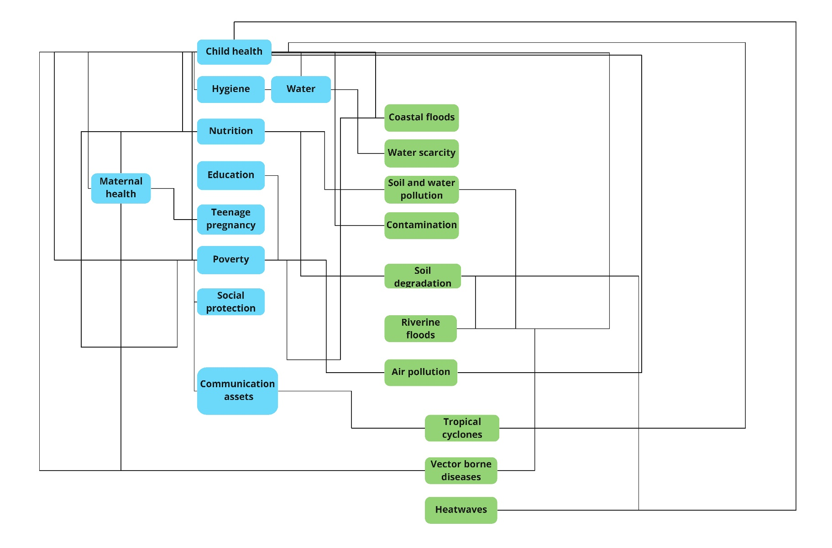
Figure 4: Diagram showing Relational Linkages between Pillar 1 and Pillar 2 Factors for Child Health Outcomes

CITATION ANALYSIS RESULTS

Table 10: Summary of Findings of the Citation Analysis of the Academic Literature
Number | Linkage between Pillar 1 and Pillar 2 Factors | Citations
1 | Poverty and child health | 1857
2 | Education and child health | 1508
3 | Poverty and education | 985
4 | Heatwaves and child health | 894
5 | Social protection and child health | 822
6 | Education and poverty | 783
7 | Heatwaves and water scarcity | 758
8 | Poverty and nutrition | 728
9 | Nutrition and child health | 696
10 | Heatwaves and water, sanitation, hygiene, and waste management (WASH) | 651
11 | WASH and child health | 630
12 | Heatwaves and poverty | 616
13 | Heatwaves and nutrition | 610
14 | Communication and child health | 591
15 | Air pollution and child health | 586
16 | Heatwave and air pollution | 570
17 | Heatwaves and vector borne diseases | 525
18 | Vector borne disease and child health | 519
19 | Tropical cyclones and child health | 446
20 | Water scarcity and child health | 411
21 | Education and communication | 410
22 | Nutrition and maternal health | 405
23 | Maternal health and child health | 405
24 | Poverty to maternal health | 399
25 | Poverty and air pollution | 381

The findings of the citation analysis of the academic literature in the sample for each of the linkages between the Pillar 1 and Pillar 2 factors as indicated by each of the arrows in Figure 4. This revealed that the three relationships most commonly identified as important influencers of outcomes were: 1) poverty and child health, 2) education and child health, and 3) poverty and education. Subsequent analysis of the academic literature revealed additional linkages between the Pillar 1 and Pillar 2 factors that could not be ascertained on the basis of the Pillar 1 and Pillar 2 data alone, thus indicating gaps in the existing physical science data sets. A summary of the findings of the citation analysis is presented in Table 10, which shows the top 25 linkages identified from the literature on the basis of the total numbers of citations of all the articles that refer to each of the relationships. Relationships between factors not identified in the Pillar 1 and Pillar 2 but identified from the literature review are highlighted in yellow.

DIAGRAM OF LINKAGES BETWEEN CLIMATE RISK FACTORS AND THEIR IMPORTANCE FOR CHILD HEALTH OUTCOMES

The findings of the citation analysis were used to map the importance that the existing literature attributed to each linkage on the diagram of relational linkages between the Pillar 1 and Pillar 2 factors for child health outcomes. Figure 5 shows the importance given to each of the linkages between the factors with citation numbers being used as a proxy of importance. The thickness of the arrows represents the importance of the relationships and whether the relationship is positive or negative in terms of outcomes has been indicated.

However, it is important to note that given the lack of research data and literature examining children’s climate change risk from children’s perspectives, the links drawn between these factors can only be said to reflect adult understandings of children’s health risk rather than children’s own understandings or experiences of health risk associated with climate change.
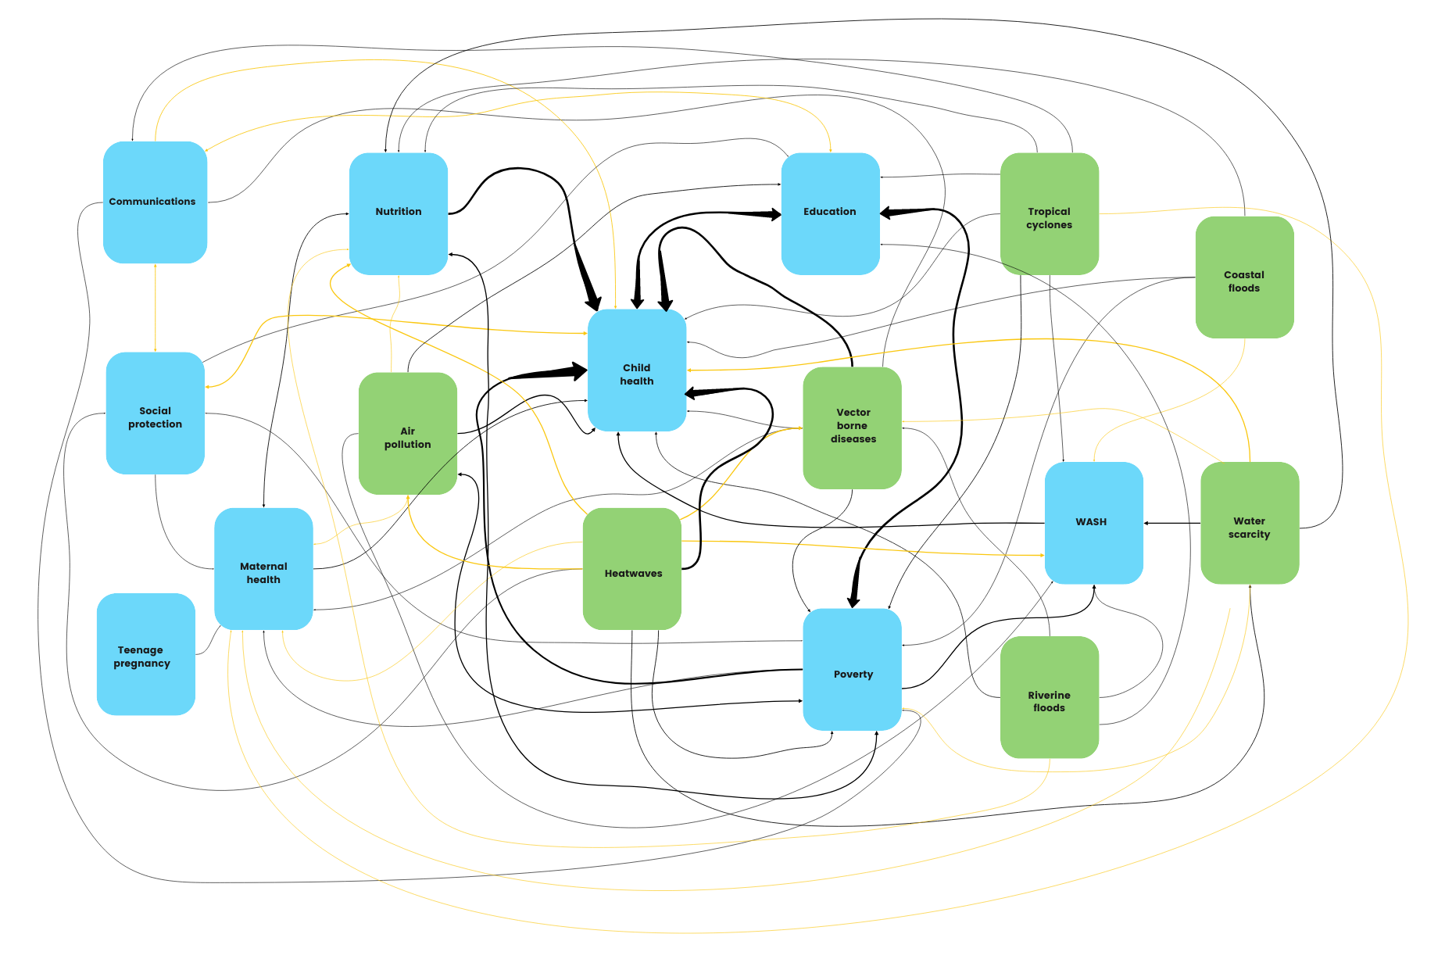
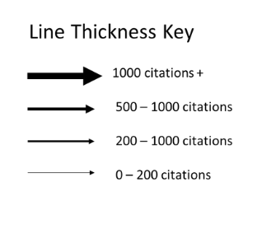

Figure 5: Diagram of Linkages between Climate Risk Factors and their Importance for Child Health Outcomes
Child-Centred Systems-Based Iterative Loop Model
To address the existing short-coming in the lack of child centeredness in understanding children’s climate risk, a child-centered model of children’s responses to climate risk was devised that not only reflects the findings from the systematic literature review and Pillar 1 and pillar 2 evidence of the links between the different environmental and socio-economic factors influencing risk, but which also reflects children’s agency and decision-making abilities, the power relations between children and adult’s that mediate children’s abilities to exercise their agency, as well as the range of different factors that influence children’s agency and decision-making abilities. Analysis of the evidence and findings together with the wider social science literature focusing on conceptualising children’s agentic responses in practice (Dominelli 2002), led to the production of a Holistic Chart of Relationships between Variables for Child-Centred Climate Change Risk Index Using Systems-Based Approach (Figure 6).

The model positions the child at the centre. Starting with the child at the centre, the policymakers, researchers and practitioners using the model work their way through the inner nest of squares which represent the institutions. These include the family, peer group, schools (educational services), health services, and religious institutions in which the child is embedded, and which interact with the child and with which the child also interacts. This therefore reflects both child and adult agency within the system. The impact of the socio-economic, political, cultural and physical domains are located in the inner circle and provide the contexts within which these institutions are based, as well as the adultist power relations through which these interactions occur. The outer circle represents the exercise of agency as a negotiated process which child can influence and (re)shape. The amber arrow on the left-hand side reflects the current dangerous approach to climate hazards and leads to the arrows at the top. These arrows represent the physical science domains, particularly those reflected in Pillar 1 and Pillar 2. These are followed through using the equation, Risk = Hazard x Exposure x Vulnerabilities which lead to mitigating actions and the development of adaptive capacities to create resilience. Resilience can lead to retention of the status quo (business as usual or BAU) or to transformative change. The reddish arrow going down the side of the diagram on the right-hand side reflects BAU. Only transformative action can lead to transformative change within which children are engaged as joint partners in the building a carbon-neutral world.

Placing children at the centre identifies the complexities of climate risk specifically for children, thus overcoming the problem of the tendency within the existing research to focus on adults’ perceptions of climate risks to children. The child-centric conceptualisation of climate risk also provides an important theoretical hypothesis from which to examine children’s own holistic lived experiences of climate risk. However, given the lack of existing research focusing on children’s own lived experience and incorporating their agency, it is not possible to assess the applicability of this model in practice in the climate risk context using the existing research. Further research focusing on children’s lived experience and agency by engaging them directly as protagonistas in the climate risk context and decision-making tables in policy and practice, therefore, becomes fundamental for testing and refining the model.
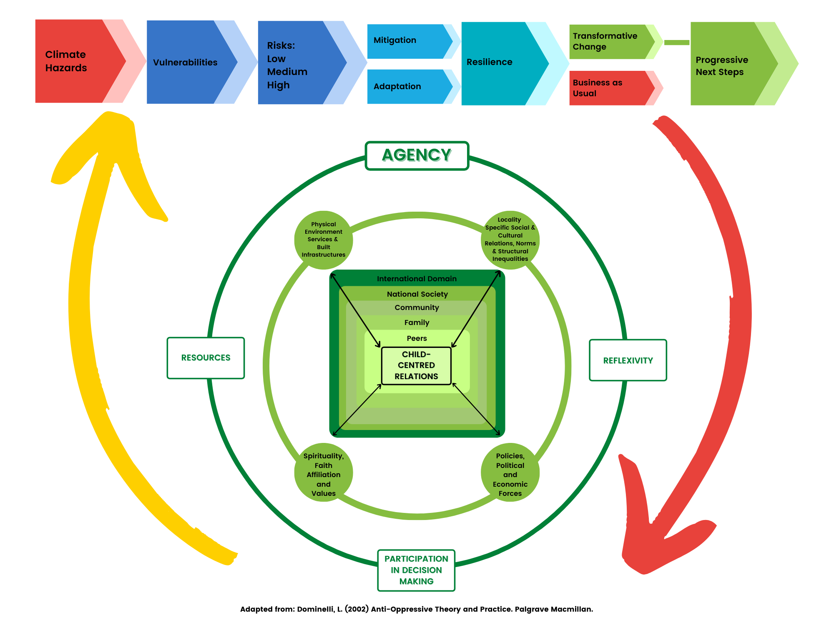

Figure 6: Holistic Chart of Relationships between Variables for Child-Centred Climate Change Risk Index Using Systems-Based Approach
(Adapted from: Dominelli, L. (2002) Anti-Oppressive Theory and Practice. Palgrave Macmillan)

CONCLUSION

At present, the intersections between the multiple and multi-layered individual, structural, cultural, policy factors and geographic domain remain less well understood in relation to the climate change risk factors, and mitigation and adaptation strategies faced by children, adolescents, and young people, than for adults. Only a very limited amount of research specifically captures the perspectives, agency and decision-making capacities of children, adolescents, and young people in relation to understandings of climate risk, vulnerability, and resilience. In addition, a lack of differentiation between children and adolescents and (in some instances) young adults in terms of how they understand and experience climate risk means that exactly how the risks vary according to specific age and differences in physical, cognitive, and social development cannot be fully ascertained.

The agency of children and adolescents is also notably absent in the literature that discusses climate change vulnerability mitigation, the stages of climate change related disaster, and in research examining the lived experience of how inequality manifests in relation to climate shocks and stresses. Also, in instances where the literature reflects their agency, the degree to which they do so remains low, with the majority drawing on evidence from consultation with children, rather than from collaborative or child-led forms of participation which enable greater levels of these qualities to not only be expressed but be used in the development of outcomes. None of the reports or articles evidence where children have taken a protagonistic approach and therefore none can be regarded to recognise the full extent to which children may be capable of being the leading agents of transformative change. The lack of consideration given towards children and adolescent agency reflects the extent to which research and suggestions for intervention are not specifically child-centric but instead adopt a perspective of examining risk for children rather than by children. While the child-centric iterative loop diagram presents an important attempt to overcome the problem the problem of focusing on adults’ perceptions of climate risks to children by placing children at the centre, assessment of this model in the climate risk context for capturing children’s own lived experience of climate risk requires further research that focuses on children’s lived experience and agency in different settings.

This amount of research available focusing on children and adolescents’ contrasts with amount of research that focuses on adults. This discrepancy is especially significant considering that numbers of academic articles included in the sample focusing on adults were restricted to the top 20 in terms of relevance and date of publication and the top 20 reports generated by each internet database keyword search, whereas the literature focusing on children, adolescents and young people represents the totality of information available from the four databases and keyword searches. However, it is important to consider the impact of adult risks on children when seeking to understand how risk is experienced by children, adolescents and young people given their dependencies on adults in restraining their capacities to make decisions and take action.

Key Recommendations
Children’s voices are seldom heard in their own right, and little opportunity has been provided for them to collaborate with adults by taking the lead in the development of new child-centered understandings of climate change risk and vulnerability mitigation interventions. However, as children are the ones disproportionately affected by the impacts of climate change, it is fundamental that they are positioned at the center of all developments in research, decision-making, and practice. Opportunities for children to exercise their agency and decisions must be made available so that they can create the climate-safe futures they envisage for themselves. At present, children’s active participation remains largely restricted to participation in initiatives determined by adults and based upon adult understandings of children’s climate risk. However, these adult-derived agendas are potentially less likely to meet the needs and aims of children than those based upon children’s understandings of risk. For this reason, opportunities for future research conducted in partnership with children and which utilize qualitative forms of inquiry to understand children’s real-life experience of climate change risk in different contexts need to be implemented. Using qualitative data as a primary evidence-base from which to understand risk will also help ensure that subsequent developments in policy and practice are embedded upon the lived, experiences of children and which reveal their differentiated nature. In particular, a ground-up approach to vulnerability mitigation development within which children are active co-participants is highly recommended to ensure that developments are ground upon and responsive to local social and environmental contexts, as well as embedded upon children’s needs, perspectives, and experiences. Improved understandings of how the risks associated with climate change are understood and experienced differently by younger and older children will also help identify how specific risks vary according to age and development stage. Therefore, we recommend an examination of risk along an age continuum instead of according to broad-based age categories.

NEXT STEPS

Action for Policymakers
Action should follow such insights to safeguard children’s futures. Societal efforts in mitigating climate risk must involve children fully as agents as envisaged in the Convention on the Rights of the Child (CRC). Policymakers, acting on behalf of society, should therefore:
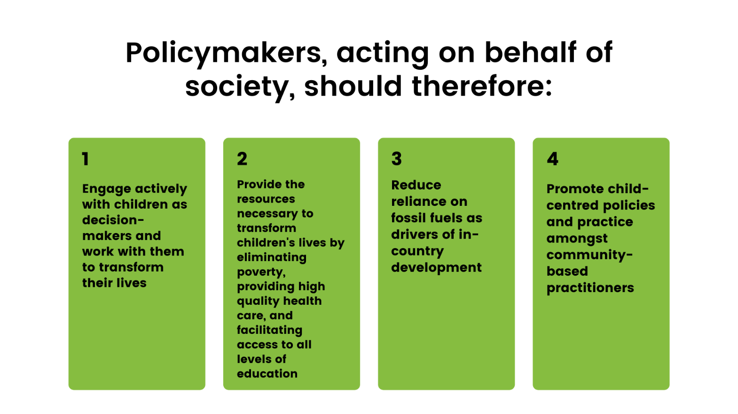

- Engage with children as decision-makers in partnerships aimed at making transformational changes that improve the life chances of children, adolescents, young people and adults.
- Make available the resources necessary for eliminating poverty and hunger as anticipated in the Sustainable Development Goals (SDGs), and in making easily accessible the requisite health care and educational provisions for all genders.
- Promote the use of renewable energies and work towards the elimination of the use of fossil fuels.
- Provide practitioners working with young people in their communities with the resources they need to support the growth of children, adolescents and young people into adult citizens who contribute to society according to their talents and interests
Future Research Directions
The production of the Children’s Climate Change Risk Index (CCRI) should not represent the end of a process, but a starting point for ensuring the collection of child-centred, localised data to further improve the index and to test and refine the Child-Centred Iterative Loop Diagram. While the CCRI pinpoints the locations where children are most at risk, more needs to be done to ensure that children can exercise their rights, voices, agencies, and decision-making capacities in developments designed to mitigate their vulnerability to climate risk. Future improvements should seek to capture and utilise the intersectional complexity of the relationship between climate impacts and the lives of children and ensure that children are directly involved in collaborative processes at every stage – from setting the agenda through to data collection, analysis, development, and dissemination – and as leading agents of change.

REFERENCES

Atallah, D. G. (2016), Toward a decolonial turn in resilience thinking in disasters: Example of the Mapuche from southern Chile on the frontlines and faultlines, International Journal of Disaster Risk Reduction 19: 92-100. https://doi.org/10.1016/j.ijdrr.2016.08.027.

Bahadur, A.V. Ibrahim, M. and Tanner, T. (2013), Characterising resilience: Unpacking the concept for tackling climate change and development, Climate and Development, 5 (1): 55-65. DOI: 10.1080/17565529.2012.762334

Barrett, D., & Heale, R. (2020). What are Delphi Studies? Evidence-based nursing 23(3), 68–69. https://doi.org/10.1136/ebnurs-2020-103303

Bennett, C. M, and Friel, S. (2014) Impacts of Climate Change on Inequities in Child Health. Children, 1(3):461-473. https://doi.org/10.3390/children1030461

Bethel, J. W., Burke, S. C., and Britt, A. F., (2013). Disparity in Disaster Preparedness Between Racial/Ethnic Groups. Disaster Health, 1(2): 110-116.

Bolton, P. Dirks, K. and Neuwelt, P. (2014). Natural hazard preparedness in an Auckland community: child and community perceptions, Pastoral Care in Education, 32(1): 23-41. https://doi.org/10.1080/02643944.2014.881909

Bongo, P. P. Dziruni, G. Muzenda-Mudavanhu, C. (2018), The effectiveness of community-based rehabilitation as a strategy for improving quality of life and disaster resilience for children with disability in rural Zimbabwe, Jàmbá: Journal of Disaster Risk Studies, 10(1): 442. DOI: 10.4102/jamba.v10i1.442

Burke, S. Sanson, A.V. and Van Hoorn, J. (2018) The Psychological Effects of Climate Change on Children. Curr Psychiatry Rep 20(5): 35. https://doi.org/10.1007/s11920-018-0896-9

Cadamuro, A. Birtel, M. D. Di Bernardo, G. A. Crapolicchio, E. Vezzali, L. and Drury, J. (2021), Resilience in children in the aftermath of disasters: A systematic review and a new perspective on individual, interpersonal, group, and intergroup level factors, Journal of Community & Applied Social Psychology, 31(3): 259-275.

Carr, E.R. and Thompson, M.C. (2014), Gender and Climate Change Adaptation in Agrarian Settings: Current Thinking, New Directions, and Research Frontiers. Geography Compass, 8: 182-197. https://doi.org/10.1111/gec3.12121

Cocco-Klein, S.and Mauger, B. (2018). Children's Leadership on Climate Change: What Can We Learn from Child-Led Initiatives in the U.S. and the Pacific Islands? Children, Youth and Environments, 28(1): 90-103. http://www.jstor.org/stable/10.7721/chilyoutenvi.28.1.0090

Cutter, S. L. (2017), The forgotten casualties redux: Women, children, and disaster risk, Global Environmental Change, 42: 117-121. https://doi.org/10.1016/j.gloenvcha.2016.12.010

Cutter, S. L., (2021) The Changing Nature of Hazard and Disaster Risk in the Anthropocene. Annals of the American Association of Geographers, 111(3), 819-827. DOI: 10.1080/24694452.2020.1744423

Cutter, S. L., Boruff, J. B., and Shirley, W., (2003). Social Vulnerability to Environmental Hazards. Social Science Quarterly, 84 (2): 242–61.

Delahoy, M. Cárcamo, C. Huerta, A. Lavado, W. Escajadillo, Y. Ordoñez, L. Vasquez, V. Lopman, B. Clasen, T. Gonzales, G. Steenland, K. and Levy, K. (2021) Meteorological factors and childhood diarrhea in Peru, 2005–2015: a time series analysis of historic associations, with implications for climate change, Environmental Health 20:22.

Dominelli, L. (2002), Anti-Oppressive Theory and Practice. London: Palgrave Macmillan. ISBN 978-0-333-77155-6.

Garcia, D. M. Sheehan, M. C. (2016), Extreme Weather-driven Disasters and Children’s Health. International Journal of Health Services. 46(1): 79-105. doi:10.1177/0020731415625254

Gislason, M. Kennedy, A. and Witham, S. (2021) The Interplay between Social and Ecological Determinants of Mental Health for Children and Youth in the Climate Crisis, International Journal of Environmental Research and Public Health, 18(9): 4573. https://doi.org/10.3390/ijerph18094573

Global Centre on Adaptation, (2021), Global Youth Call to Action: Adapt for Our Future. Rotterdam: Global Centre on Adaptation. https://gca.org/wp-content/uploads/2021/01/GCA-Global-Youth-Call-to-Action1-2.pdf

Helldén, D. Andersson, C. Nilsson, M. Ebi, K. Friberg, P. and Alfvén, T. (2021) Climate change and child health: a scoping review and an expanded conceptual framework, The Lancet Planetary Health 5(3): e164-e175. DOI: https://doi.org/10.1016/S2542-5196(20)30274-6

Jabry, A. (2002), After the Camera’s Have Gone - Children in disasters: Lessons from El Salvador, Sierra Leone, and Vietnam. Plan, 2002, https://reliefweb.int/report/world/after-cameras-have-gone-children-disasters

Jupp Kina, V. (2012). Participant or protagonist? A critical analysis of children and young
people’s participation in São Paulo, Brazil, International Social Work 55(3), 320–336. https://doi.org/10.1177/0020872812437223

Kimberly A., (2003), Disaster preparedness in Virginia Hospital Centre-Arlington after Sept 11, 2001, Disaster Management Response 1(3): 80–86. https://doi.org/10.1016/S1540-2487(03)00048-8

Kuran, C. H. Morsut, C. Kruke, B. I. Krüger, M. Segnestam, L. Orru, K. Nævestad, T. O. Airola, M. Keränen, J. Gabel, F. Hansson, S. & Torpan, S. (2020). Vulnerability and vulnerable groups from an intersectionality perspective, International Journal of Disaster Risk Reduction, 50: 101826. https://doi.org/10.1016/j.ijdrr.2020.101826

Lansdown, G. (2010). ‘The realisation of children’s participation rights: Critical reﬂections’. In Percy-Smith, B., & Thomas, N., (Eds.) A Handbook of Children and Young People’s Participation: Perspectives from Theory and Practice, London: Routledge.

Lopez, Y. Hayden, J. Cologon, K. and Hadley, F. (2012), Child Participation and Disaster Risk Reduction. International Journal of Early Years Education 20(3): 300–308. https://doi.org/10.1080/09669760.2012.716712

Masten, A. S. (2020), Resilience of children in disasters: A multisystem perspective, International Journal of Psychology, 56(1): 1-11. https://doi.org/10.1002/ijop.12737

McMichael, A. (2014) Climate Change and Children: Health Risks of Abatement Inaction, Health Gains from Action, Children, 1(2): 99-106. doi: 10.3390/children1020099

National Environmental Justice Advisory Council, (2018), Youth Perspectives on
Climate Change: Best Practices for Youth Engagement and Addressing Health Impacts of
Climate Change. US Environmental Protection Agency.

Nicholas, K. Campbell, L. Paul, E. Skeltis, G. Wang, W. and Gray, C. (2021) Climate anomalies and childhood growth in Peru, Population and Environment, 10.1007/s11111-021-00376-8

Nojavan, M. Salehi, E. and Omidvar, B. (2018). Conceptual change of disaster management models: A thematic analysis. Jamba (Potchefstroom, South Africa), 10(1): 451. https://doi.org/10.4102/jamba.v10i1.451

Osborne N. (2015), Intersectionality and kyriarchy: A framework for approaching power and social justice in planning and climate change adaptation. Planning Theory 14(2): 130-151. doi:10.1177/1473095213516443

Osofsky, J. D. and Osofsky, H. J. (2018) Challenges in building child and family resilience after disasters, Journal of Family Social Work, 21(2): 115-128, DOI: 10.1080/10522158.2018.1427644

Peek, L. and Stough. L. M. (2010). Children with disabilities in the context of disaster: A social vulnerability perspective. Child Development, 81(4): 1260–1270. DOI: 10.1111/j.1467-8624.2010.01466.x

Plan International (2020), Pathways to Resilience. Plan International. https://plan-international.org/publications/pathways-resilience

Plan International Australia, (2021), Survey Report: Reimagining Climate Education and Youth Leadership. Plan International. https://www.plan.org.au/publications/survey-report-reimagining-climate-education-and-youth-leadership/

Rees, N., Barkhof, M., Burdziej, J., Lee, S., Riley, H., Contributors:, E., Hutchison, A., Macdonald, F., Hutton, C., Bollasina, M., Branson, J., Connon, I., Crispell, J., Dominelli, L., Fassio, A., Harfoot, A., Henley, S., Inall, M., Marcinko, C., Mollard, J., Sargent, K., Watmough, G., & Wilkinson, T. (2021). The climate crisis is a child rights crisis: Introducing The Children's Climate Risk Index. Unicef. https://www.unicef.org/reports/climate-crisis-child-rights-crisis

Rufat, S. Tate, E. Burton, C. G. and Maroof, A. S., (2015). Social Vulnerability to Floods: Review of Case Studies and Implications for Measurement. International Journal of Disaster Risk Reduction, 14(4): 470-486.
Sanz-Caballero, S. (2013) Children’s rights in a changing climate: a perspective from the United Nations Convention on the Rights of the Child, Ethics in Science and Environmental Politics, 13(1): 1-14. DOI: 10.3354/esep00130

Sheffield, P. E. and Landrigan, P. J. (2011), Global Climate Change and Children’s Health: Threats and Strategies for Prevention, Environmental Health Perspectives 119(3):291-298. https://doi.org/10.1289/ehp.1002233

Snilstveit, B., Oliver, S. & Vojtkova, M., (2012), Narrative approaches to systematic review and synthesis of evidence for international development policy and practice, Journal of Development Effectiveness, 4(3): 409-29

Temin, E. S., Bortolin, M., and Venier, A. (2016). Rehabilitation and Reconstruction. Ciottone's Disaster Medicine, 365–368. https://doi.org/10.1016/B978-0-323-28665-7.00059-5.

Torani S, Majd P. M, Maroufi S. S, Dowlati M, Sheikhi R. A. (2019), The importance of education on disasters and emergencies: A review article. J Edu Health Promotion, 8:85

Towers, B. Ronan, K. and Rashid, M. (2016), Child Health and Survival in a Changing Climate: Vulnerability, Mitigation, and Adaptation, Geographies of Global Issues: Change and Threat, 54(5): 279-301. https://doi.org/10.1007/978-981-4585-54-5_34

United Nations Children’s Fund (UNICEF) (2014), The Challenges of Climate Change:
Children on the front line. Florence: UNICEF Office of Research

Vanos, J. K. (2015). Children's health and vulnerability in outdoor microclimates: A comprehensive review, Environment International 76: 1-15. https://doi.org/10.1016/j.envint.2014.11.016.

Wood, A. L. Ansah, P. Rivers, L. and Ligmann-Zielinska, A. (2021) Examining climate change and food security in Ghana through an intersectional framework, The Journal of Peasant Studies, 48(2): 329-348, DOI: 10.1080/03066150.2019.1655639.

World Vision Asia Pacific (2013), Cities Prepare! Reducing Vulnerabilities for the Urban Poor. World Vision Asia Pacific. https://www.preventionweb.net/publication/cities-prepare-reducing-vulnerabilities-urban-poor

World Vision (2014), Humanitarian & Emergency Affairs: Annual Report 2013. World Vision International. https://www.wvi.org/publication/world-vision-humanitarian-emergency-affairs-fy13-annual-report

