ERM User Guide for Undergraduate and Postgraduate Taught Applicants
Contents
Accessing and Navigating the Form 2
Accessing ERM 2
Create Your Application 2
Complete Your Application 4
Sharing your form with your supervisor 6
How to View Comments 7
A Project with Human Participants 8
A Project with Animals 11
External ethics approval granted 13
Projects where there are no human participants or animal involvement 13
Making amendments and modifications following submission 13
Amendments to applications following review 13
Modifications to proposals that have already received approval 14
Projects and Sub-projects 14
System Extras 14

Accessing and Navigating the Form

Accessing ERM
- Access ERM through My Portal (under I want to… Apply for ethics) or at https://www.stir.ac.uk/internal-students/ethics-review-manager-erm/ using your University of Stirling account and click “Access ERM”.
- If you have concerns regarding accessing ERM please contact ethics@stir.ac.uk

Create Your Application
- Create a project using the Create Project tile in the Actions panel to the left of the screen.

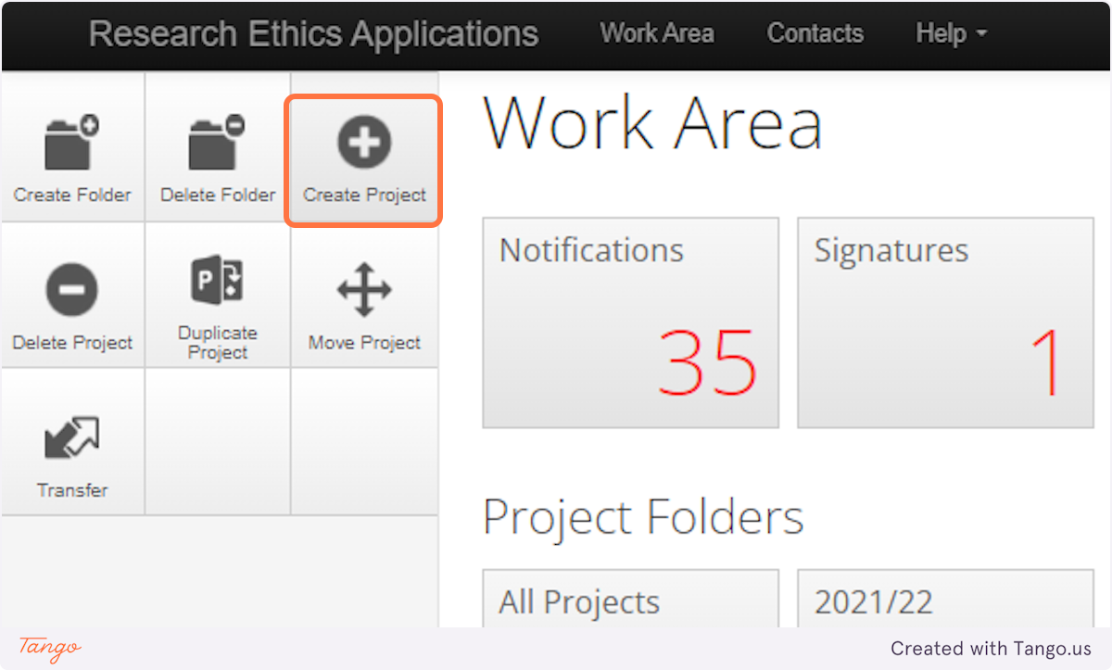

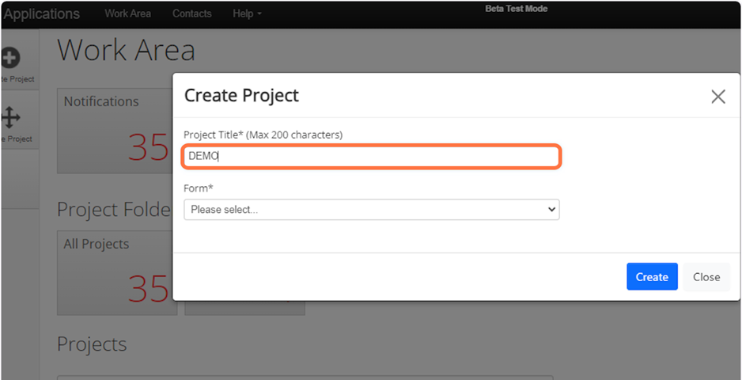
- Enter a short project title – this can be changed later in the form.

- Select “Ethics Application Form”

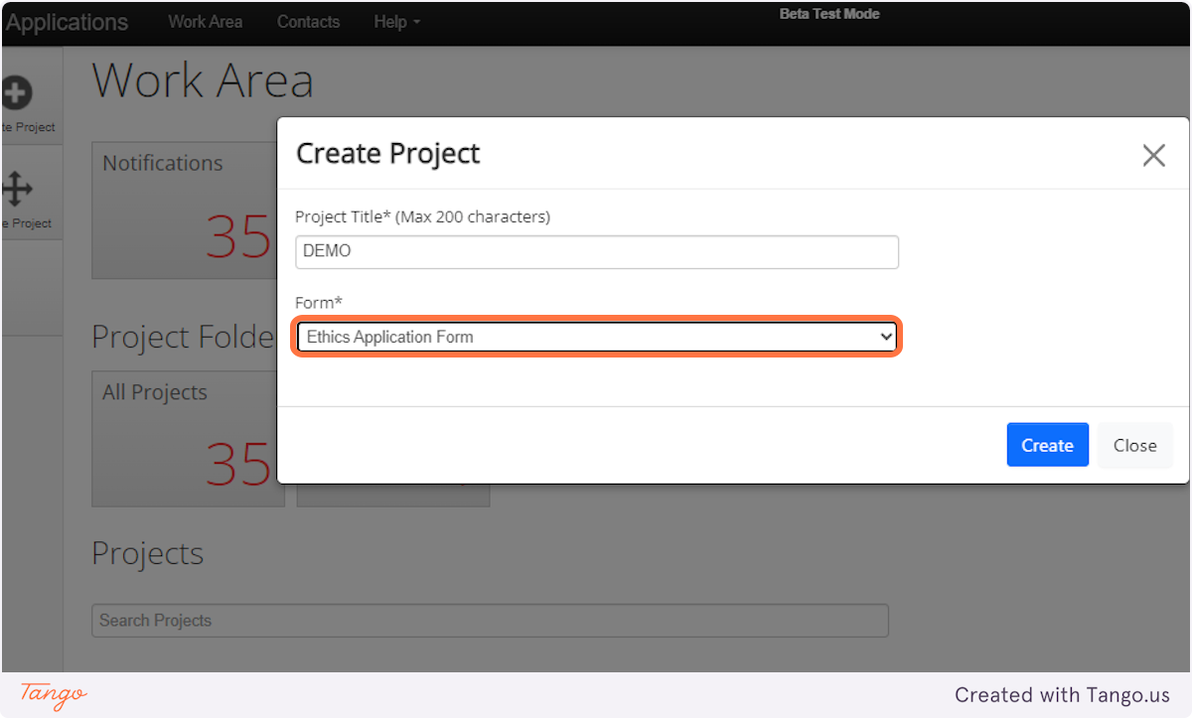

- Click Create.

Complete Your Application
- Click on the “A - Please start here” box to start completing the form.

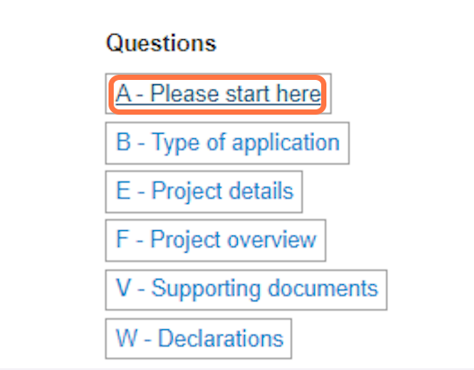

- To move between sections on the form you can either select the Next or Previous arrow tiles at the bottom of each page or in the action panel at the top left. Clicking these buttons will save the contents of the page you have been working on.

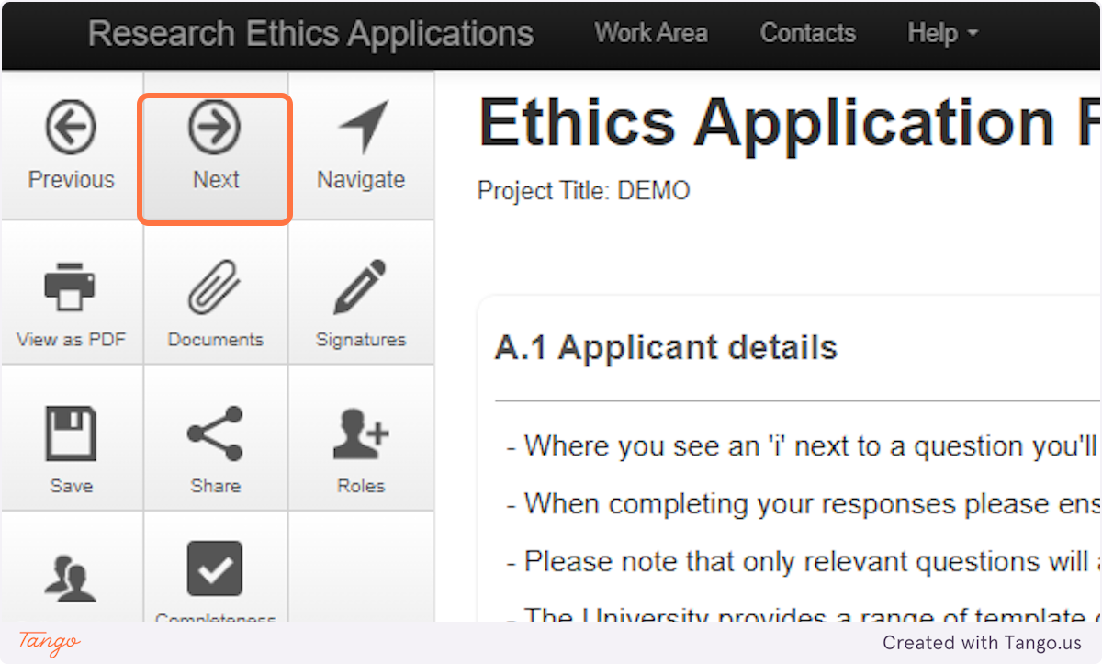

- You can also move through sections of the form by clicking the Navigate tile to return to the overview of the form. Please remember to select the Save tile to save the work you have already completed.

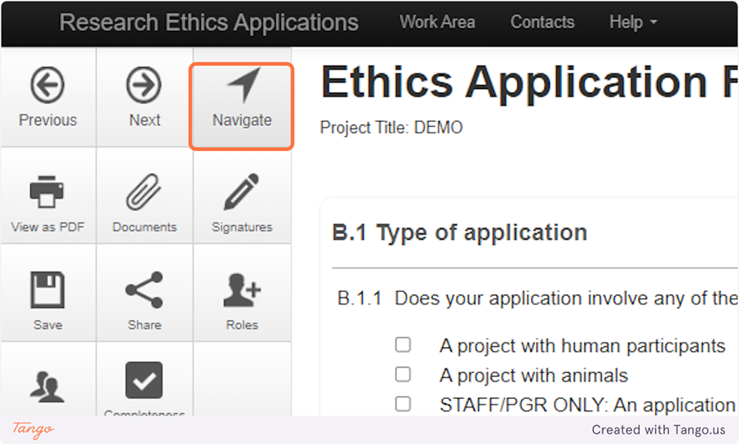

- If you need to close your application at any point without moving onto the next section, you should select the Save tile to save the work you have already completed.

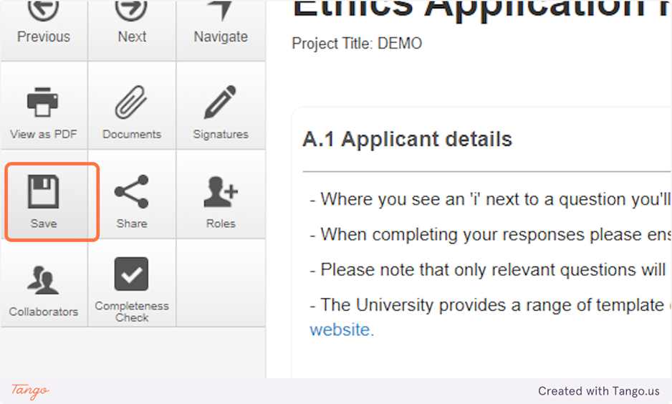

- The answers you provide throughout the form will determine what type of ethics review is required.

Sharing your form with your supervisor
- We strongly advise students to seek input from their supervisors as early as possible in the drafting process.
- Start searching for your supervisor in the “A.2.1 Supervisor details” box. If their name does not appear, they may not have activated their account. They can do this by logging into the system via My Portal (under I want to… Apply for ethics)
- Select their name from the drop-down menu

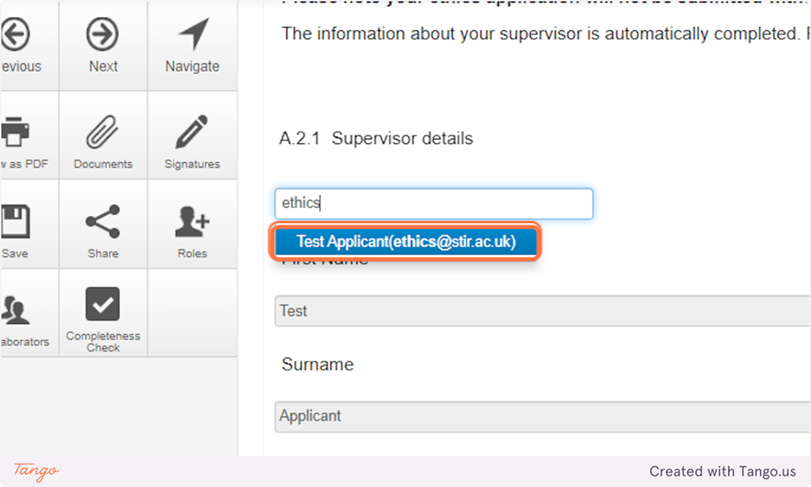

- Click “Assign Role”

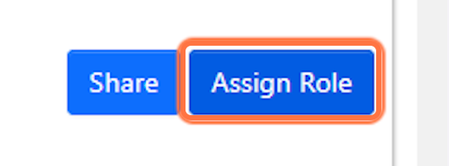

- Select “Supervisor” and select “Share Role”.

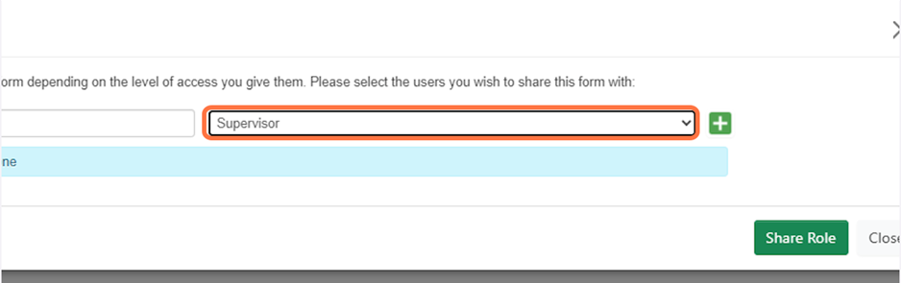

- This will provide your supervisor with read, write and share permissions. Your supervisor will receive an email telling them that you have shared your application with them.
- Once your supervisor has finished reviewing your application, they will need to contact you to let you know, as there is currently no automatic alert in the system for this.

How to View Comments
- When your supervisor has made comments on your form the number of comments made on the page will show in the speech bubble.

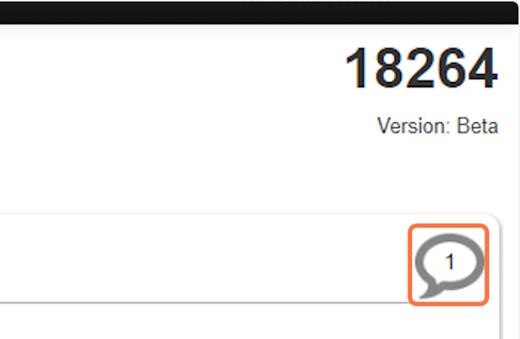

- The total number of comments on the form will also show in the Comments tile in the Actions panel.

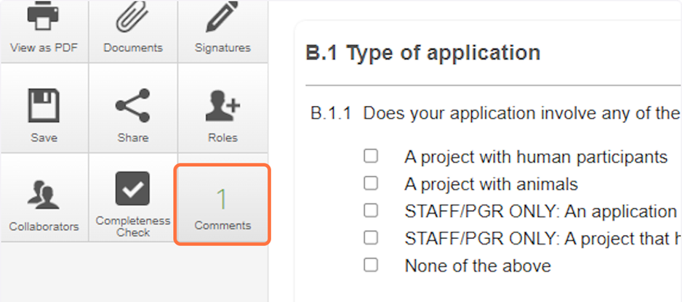

A Project with Human Participants
If you have ticked “A project with human participants”, in the NHS Invasive or Clinical Research (NICR) section (C.1) you will be asked to complete a checklist to determine whether your proposal requires review by NICR or GUEP (General University Ethics Panel), the two Research Ethics Panels at the University of Stirling that review research involving human participants.
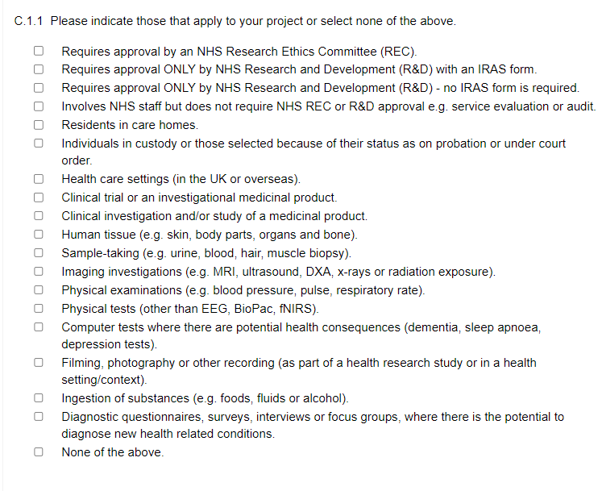
Complete the remaining sections of the form that are available to you. Attach all relevant documents in the V – Supporting Documents section. When you upload each document, you will be prompted for a Version Date and Version Number. Please enter today’s date and a Version number of 1 the first time you upload the document. If you are uploading a revised version of the document, please increase the Version number accordingly.
You must sign the application in the W – Declarations section to submit your application.
When you try to sign the form, the system will tell you if you have not completed any mandatory questions and will prompt you to complete any that are missing. You will not be able to sign the form until all questions are completed.
Students must also request a signature from their supervisor. You can either sign the form and then request your supervisor’s signature or the other way round, but both of you need to sign the application for it to be submitted.
Please note in order for your supervisor to authorise your application they must have an activated ERM account. If they have not yet activated their account, they will need to do this by logging into the system.
They do this via My Portal (under I want to... Apply for ethics) or clicking on: https://stirling.forms.ethicalreviewmanager.com/
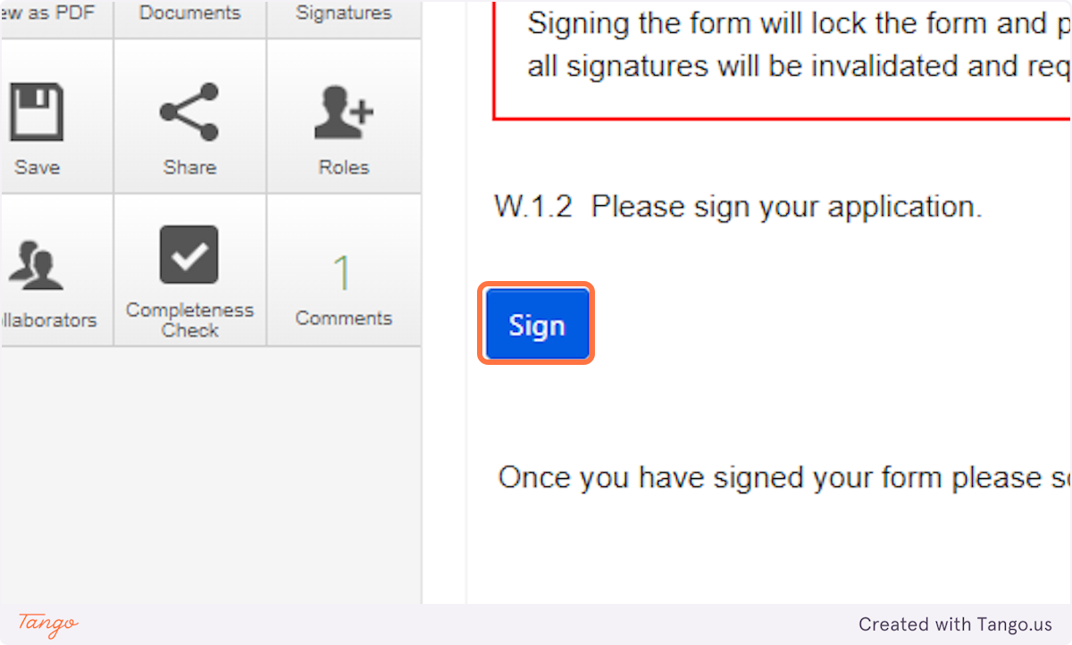
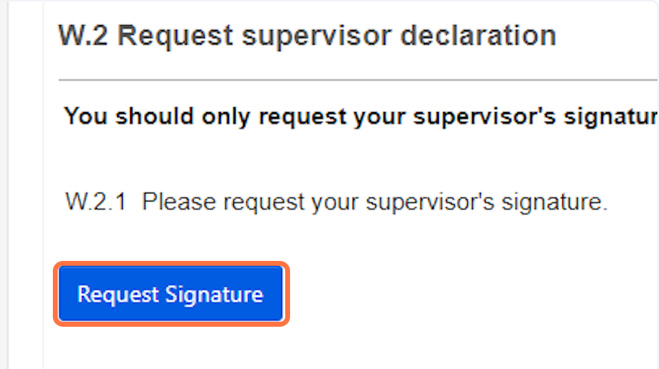
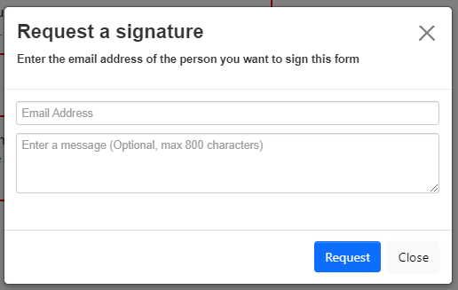

If your supervisor requires you to make any changes once you have requested their signature, they may reject the application and return it to you. If this happens you will need to unlock it in order to make any changes to the form. To do this, go into any section of the form and click on the Unlock tile in the Action panel on the left.
Depending which Panel, you are applying to further signatures and approvals may be required. Your supervisor will complete these sections of the form. The form will automatically be submitted once all the required signatures have been received.
The Panel to which you have applied will check your application and will let you know if any further information is required before it can proceed to review. You will receive an email notification with the outcome of your application when the review is complete.

A Project with Animals
If you have ticked “A project with animals”, Complete the remaining sections of the form that are available to you. Attach all relevant documents in the Documents section. When you upload each document, you will be prompted for a Version Date and Version Number. Please enter today’s date and a Version number of 1 the first time you upload the document. If you are uploading a revised version of the document, please increase the Version number accordingly.
If you are conducting an ASPA regulated study you will need to request the signatures of the Project Licence Holder and the Primary Personal Licence Holder and the site NACWO. Please add their details using the same method as adding your supervisor and share the form with them using the “assign role” function in sections M.1 and M.2.

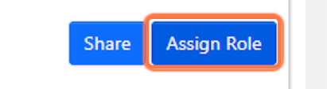
In Section X.1, please select “request signature” for both the Project Licence Holder and Primary Personal Licence Holder.
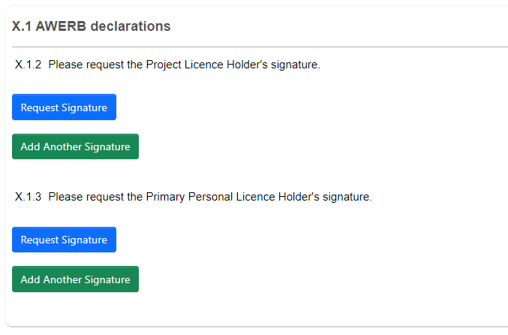
Use the green “Add Another Signature” buttons if the project is taking place at more than one site and if the project is taking place under more than one Project Licence.
You must sign the application in the Signatures Section to submit your application. When you sign the form, the system will tell you if you have not completed any mandatory questions and will prompt you to complete any that are missing. You will not be able to sign the form until all mandatory questions are completed. The form will automatically be submitted once all the required signatures have been received.
Students must also request a signature from their supervisor. You can either sign the form and then request your supervisor’s signature or the other way round, but both of you need to sign the application for it to be submitted.
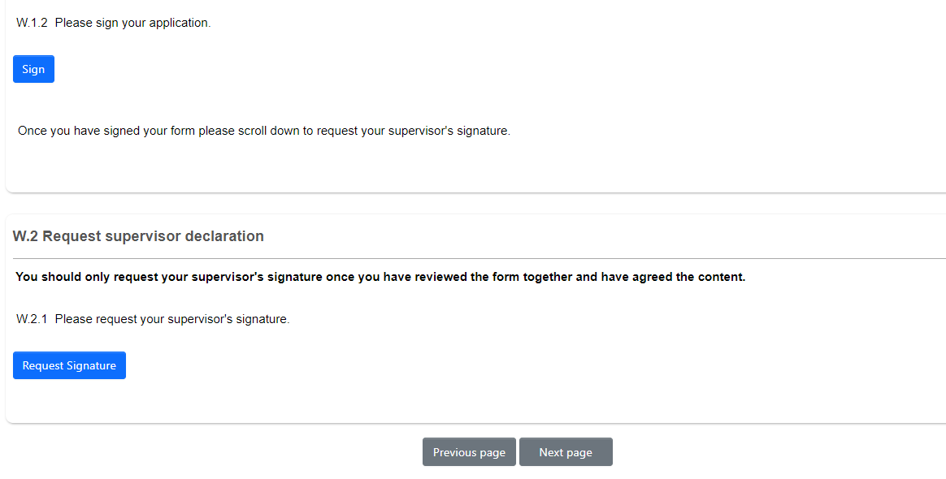
Please note in order for your supervisor to authorise your application they must have an activated ERM account. If they have not yet activated their account, they will need to do this by logging into the system.
If your supervisor requires you to make any changes once you have requested their signature, they may reject the application and return it to you. If this happens you will need to unlock it in order to make any changes to the form. To do this, go into any section of the form and click on the Unlock tile in the Action panel on the left.
The form will automatically be submitted once you have both signed the form.
The AWERB Panel to which you have applied will check your application and will let you know if any further information is required before it can proceed to review. You will receive an email notification with the outcome of your application when the review is complete.

External ethics approval granted
Only in exceptional circumstances will the University accept the external review for a student project. Please contact ethics@stir.ac.uk if you feel you meet this exception. Students who will submit to NHS Research Ethics Committee must first apply through ERM, please tick the Project with Human Participants field.

Projects where there are no human participants or animal involvement
If you have ticked “None of the above “. As per the University’s Research Ethics Policy all staff involved in research are required to seek ethical approval or establish positively that such approval is not necessary.
You will be asked to provide minimal details on your project, a project description and briefly describe any potential ethical implications.
You must sign the application in the Signatures Section to submit your application. When you sign the form, the system will tell you if you have not completed any mandatory questions and will prompt you to complete any that are missing. You will not be able to sign the form until all mandatory questions are completed. The form will automatically be submitted once all the required signatures have been received.
Students must also request a signature from their supervisor. You can either sign the form and then request you supervisor’s signature or the other way round, but both of you need to sign the application for it to be submitted.
Please note in order for your supervisor to authorise your application they must have an activated ERM account. If they have not yet activated their account, they will need to do this by logging into the system.
If your supervisor requires you to make any changes once you have requested their signature, they may reject the application and return it to you. If this happens you will need to unlock it in order to make any changes to the form. To do this, go into any section of the form and click on the Unlock tile in the Action panel on the left. Your supervisor will then request the signature of a second reviewer.
Your application will be checked, and you will receive an email notification with the outcome of your application when the review is complete.

Making amendments and modifications following submission
Amendments to applications following review
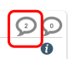
Following review if you are required to make any amendments, you will be sent an email notification and will be able to re-access your form.
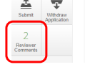
If an application is returned to you, you should make your changes and/or upload updated documents as requested. A cover letter must be included as well as track changes visible on all edited documents.
Any comments made by the reviewers will be visible by clicking on the Reviewer Comments tile in the Actions panel to the left of the screen, or by clicking on the speech bubbles at the top of each section of the form. Please ensure you have read and responded to the comments. Please resubmit in exactly the same way as your initial submission.

Modifications to proposals that have already received approval
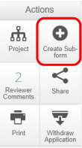
Once you have received ethical approval, if you wish to modify your study at any point you must submit a Change Request form. To do this open your project and select the Create Sub-form tile and select Change request form. You should complete this, provide a signature and submit in the same way as a full application.

Projects and Sub-projects
If your project has a number of sub-projects or there are a number of work packages within the project where you would like to apply for ethics approval separately it is possible to do this through ERM. Apply for ethics approval for the main or initial project first as per the steps above. Once you are ready to create the next stage of the project, open your project and select the Create Sub-Form tile and select Sub-project Ethics Approval Form. You should complete this, provide a signature and submit in the same way as a full application.

System Extras
- When navigating through the application, the action of hitting next will automatically save your work on that page. However, if you need to close your application at any point without moving onto the next section, you should select the Save tile to save the work you have already completed.
- You can create a folder in which to save multiple projects by selecting the Create Folder tile. Once created you can create new projects within this folder, or you can file existing projects by dragging and dropping them from the project list into the designated folder. We would recommend that you create a folder for those applications that have been approved.
- If you are working on multiple similar projects, you can duplicate a project by selecting the Duplicate action. If you are using this function, it is advised that you carefully check the filter questions to ensure that the duplicate project does not present any issues which the initial project did not. This will lead to the required complement of questions not being made available and upon submission your application may be invalidated.
- You can share your application at any time with a collaborator by selecting the Assign Roles tile. This allows others to review, amend or comment on your application. You will need to ensure that the person with whom you wish to share your application has already logged on to ERM, so they are recognised by the system. They do this via My Portal (under I want to... Apply for ethics) or clicking on: https://stirling.forms.ethicalreviewmanager.com/
- You can select the rights which you want to give to the user you are sharing with:
  - Read: the user can view but not amend your application
  - Write: the user can view and amend your application
  - Submit: the user can submit your application
  - Share: the user can share your application with other ERM users
  - Create all sub forms: the user can create a sub form (i.e. modification request for this application)
  - Receive notifications: the user will receive all notifications received by you as the applicant in relation to the processing of this application.
- You can create a PDF of your full application at any stage by selecting the View as PDF tile. This will generate a PDF of your full form (excluding attached documents) which you can either save or print. If you want to print the form and the uploaded documents as one file, select the Documents tile and click Download all as PDF.
- Throughout the form you can find helpful information and links to additional guidance which will open up in new tab. Information sections are in blue and have an Information icon in the top right corner.
- You can use the Completeness Check button to check what information is still missing at any time while completing your application.
- You can use the Transfer button to transfer a project to a colleague who may be taking over as Principal Investigator. Select which project you wish to transfer and provide an email message to the person that the project is going to.
If you have any questions or concerns regarding use of ERM, please contact the Research Integrity and Ethics Team at ethics@stir.ac.uk

