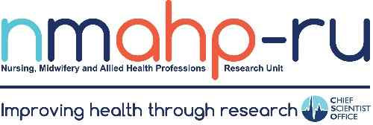
The Nursing, Midwifery and
Allied Health Professions Research Unit

Final Report to the
Chief Scientist Office

April 2024
 |  | 

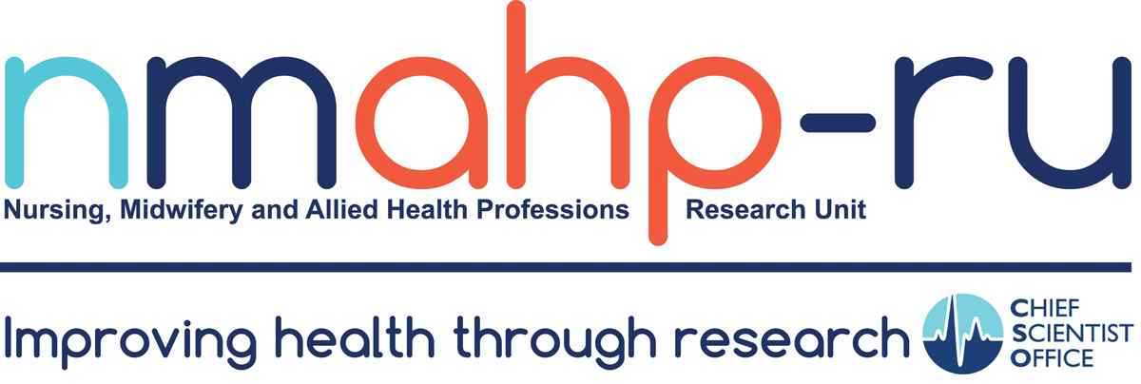

Contents

Director’s statement 1
About the NMAHP Research Unit 3
Remit of the Unit 4
Core funded staff achievements 6
Impact on NHS and Public Health 10
Stroke Rehabilitation 12
Evidence Synthesis 14
Mental Health, Suicide Prevention and Addictions 15
Maternity and Maternal Care 16
Pre-hospital Emergency Care 16
Public Health and Health Improvement 17
Further evidence of impact 18
Impact on Scottish Research Environment 18
Contribution to inward investment to research portfolios in Scotland 18
Capacity and Capability Building for NMAHP Research 19
Patient and Public Involvement 21
Beyond April 2024 22
Final thanks 22

Director’s statement
This report provides a general overview of work of the Nursing, Midwifery and Allied Health Professions Research Unit (NMAHP-RU) over 30 years from its inception in 1994 to March 2024.
During the last three years (2021-2024), the total value of the Unit’s research portfolio has been approximately £30 million (£34.9 in 2021-2022, £29.2 million 2022-2023, £28 million 2023-(April) 2024). The Unit has active project collaborations with over 300 international partners, demonstrating our international reach and reputation.
The Unit has addressed key challenges facing Scotland and its NHS over the past 30 years. This has included providing early evidence-based practice change e.g. from reviewing the evidence base for pre-operative fasting, to establishing evidence for fundamental service re-design e.g. for pre-hospital, emergency, unscheduled care provision, and improving time critical responses to cardiac events. We have contributed significantly to rehabilitation and managing the long-term impacts of long-term conditions e.g. from Stroke and other neurological conditions and now more recently Covid and explored and developed responses to more public health challenges such as developing and delivering interventions tackling obesity, mental illness, drug deaths and the wider societal impacts of addictions. We have also led much of the research into Midwifery and Maternal care in Scotland, providing a continual link between evidence for practice and policy development and implementation in maternity care within Scottish Government.
Our staff numbers have grown considerably from our early days when staff were counted in single figures to our more recent years when we have supported and developed the research careers of around 40-50 staff per annum. Our contributions to the Research Excellence Framework (for our institutional submissions) have also increased as we have grown, with 5 Unit impact case studies being submitted in the most recent REF2021. In 2023, four of our seven CSO funded staff members (including Prof. Doreen McClurg recently retired) were cited as being in the top 2% of international scientists in their fields (Urogynaecology, Urology and Nephrology, Rehabilitation, and Neurology and Neurosurgery). This is an outstanding achievement for NMAHP researchers and a testament to our world-leading reputations.
We have a compelling reputation for supporting the development of capacity and capability for Nursing Midwifery and Allied Health Professions (NMAHP) research through our support to PhD and Clinical Doctorate students. This currently stands at supporting 42 Clinical Doctorate and PhD students. Additionally, the NMAHP RU at the University of Stirling has supported the Master of Research (MRes) and the Master's in Public Health degree programmes, primarily with research dissertation supervision. Similarly, staff at GCU lead the Master of Research (MRes) degree and support dissertation supervision. We have supported the Chief Nursing Office in promoting, managing, implementing, and providing supervision/mentoring to several NMAHP research capacity building schemes over the past 30 years.
We were among the first researchers to advocate for Patient and Public Involvement in research, including being one of the first presenters at the Innovate INVOLVE conference almost 20 years ago. Our PPI panel, known as our Research in Partnership Group (RPG) has been exemplary, and our efforts to involve, create and sustain this group have been taken as the blueprint for our host HEI’s to follow for their own PPI plans going forward. Our RPG has had over 20 members consisting of patients, public and healthcare practitioners who have provided input to developing research proposals and at a strategic level to the direction and priorities of the Unit. The RPG has had representation on our Unit Executive Committee and members have been welcomed to attend our Unit Quarterly Meetings (full day learning and development events). We have become leading experts in co-creation of research and co-production of interventions with patients and the public.
In brief, over the past 30 years, the NMAHP Research Unit has developed from a very small-scale, embryonic unit which was established to support fledgling NMAHP research interests, to an internationally recognised and unique NMAHP research Unit with a renowned Professoriate supporting the delivery of its large portfolio of research, at the same time as fostering the capabilities of the next generation of NMAHP researchers for Scotland. At our last (final) CSO Scientific Review, the panel concluded that “NMAHP RU is a very highly regarded centre of academic excellence in NMAHP research and is clearly focussed on and actively addressing the objectives set out in the contract with CSO.”
Our report provides a detailed picture of who we are, how we have developed what we have achieved over the past 30 years to enhance the evidence base for NMAHP practice in response to new and long-standing challenges in delivering health and social care.

About the NMAHP Research Unit
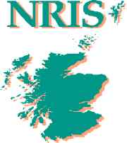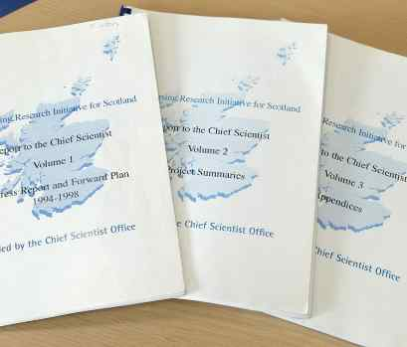
The Nursing, Midwifery and Allied Health Professions Research Unit (NMAHP-RU) was established in 1994, with core funding from the Chief Scientist Office (CSO), as the Nursing Research Initiative for Scotland (NRIS), hosted by Glasgow Caledonian University (in partnership with the Victoria Infirmary in Glasgow) with Prof. Jenny Hunt as its first Director (1994-1998). Prior to its first review, the Unit’s focus was on responding to research ideas from NMAHP staff all over Scotland, providing advice and support, rather than on Unit initiated research activity. Important work looking at key nursing issues such as nurse patient ratios, 12-hour shift working patterns, pre op fasting, and catheter care was supported. The 1998 review recommended that the Unit’s activity become focussed within programmes of research and reflect work within the NMAHP community; the name of the Unit was then changed from NRIS to the Nursing, Midwifery and Allied Health Professions Research Unit (NMAHP-RU).

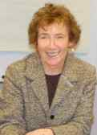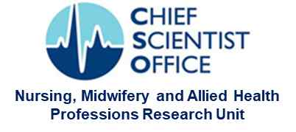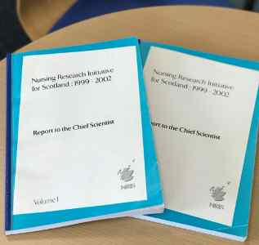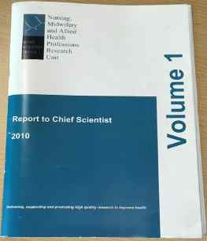
In 2000 Glasgow Caledonian University, with the agreement of Chief Scientist Office, approached the University of Stirling to request that Professor Niven, then head of the Department of Nursing and Midwifery, take on the post of Unit Director, with a Unit base being established at the University of Stirling. Prof. Kate Niven was Director from 2000 to 2010, seeing the Unit through two successful full reviews (2002, 2010) and one interim review (2007).


Prof. Brian Williams took over in January 2011 until leaving in July 2016. He created new branding for the Unit and initiated many of the operational policies which helped to improve Unit governance and staff development as we expanded significantly during this time, with increasing investment from our host universities.

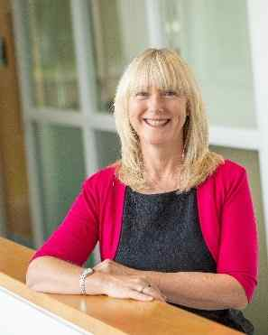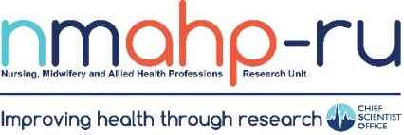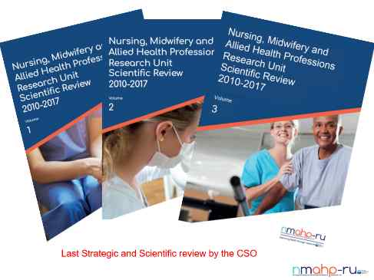
Prof. Margaret Maxwell was Deputy Director (2009-2016), interim Director from 2010 to 2011 and was appointed as Director of the Unit from 2016 to 2024. She led the Unit through its review in 2017 and through its most successful years in terms of external grant capture and growth in its extensive international collaborations.
Prof. Maxwell shared the role of Director with Prof. Helen Cheyne for its final 6 months from October 2023 to end of March 2024. Prof. Cheyne was Deputy Director at University of Stirling from 2016-2023 alongside Prof. Suzanne Hagen at Glasgow Caledonian University who was Deputy Director from 2013-2024.

Remit of the Unit
The CSO funded the NMAHP-RU to:
• develop high-quality research which is useful and relevant to staff delivering health and social care throughout Scotland
• provide a strong national focus for health and social care research
• involve nurses and other direct care staff where appropriate in its research

Based on this remit, staff within the Unit established its own vision and aims for what it would achieve:

Since 2000, NMAHP RU has been co-located at two bases at the University of Stirling and Glasgow Caledonian University (GCU). Both Universities have a critical mass of strong, research-active Nursing and Allied Health Professional staff, with expertise in areas of clinical priority to the NHS, as well as world-leading researchers in social, behavioural, and natural sciences.
From 2013-2021, the annual award to the Unit from the CSO has been £731,836. As staff costs have increased, this funding has supported less and less of the actual annual running costs which have increasingly been absorbed by the host HEIs. By 2021, when CSO began to taper its funding contribution, the host institutions were already contributing approximately 1/3 each of the Unit running costs. Funding from CSO for the final year of the Unit (April 2023-March 2024) was £182,960 (£77,020 for University of Stirling and £105,940 for Glasgow Caledonian University) and this mostly covered the costs for administrative staff support to the Unit and its awards.

Core funded staff achievements
The value of core funding for an NMAHP research unit has enabled individuals to train and develop strong research careers, supporting many from PhD level, and early and mid-career development, to professorial positions of international standing. This allowed the Unit to develop and sustain a critical mass of high-quality research talent. It provided the security and stability needed to enable NMAHPs to compete on a level playing field with medically qualified (and other) researchers. Most of the core funded staff have remained within the NMAHP-RU throughout their careers with ALL CSO core funded staff achieving professorial status. The Unit has supported 7 NMAHPS to professorial level (1 midwife, 2 nurses, 4 AHPs), and an additional 5 non-NMAHP Professors (1 Statistician, 2 Sociologists, 1 Psychologist, and 1 General Practitioner). Further demonstration of the impact of this stability for achieving international reputation and excellence is exemplified in the summaries of their careers and achievements below:

Professor Margaret Maxwell (2009-2024), MA(Hons), PhD.
Margaret was initially appointed as Deputy Director of the NMAHP-RU and as Professor of Health Services and Mental Health Research in 2009, and then as Director of the NMAHP-RU in 2016. From 2006-2011 she was also Director of the Scottish Government funded Scottish Primary Care Mental Health Research and Development Programme. She has been involved in health services research for over 30 years, focusing on quality and delivery of primary care and common mental health problems. She has been involved in several European research collaborations spanning 20 years tackling suicide, depression, and more recently, mental health in the workplace. She has evaluated several national programmes for improving mental health, tackling depression, suicide and psychological distress. She was a founding member of the European Alliance Against Depression and the online iFightDepression (CBT) intervention which has been translated into 15 languages. Her work on psychiatric emergencies in Scotland (along with E Duncan below) underpinned the case for a specialist mental health response that was embedded within NHS 24’s 111 service in 2019. She also collaborated on the development of the Distress Brief Intervention which is a key national response to mental health distress in Scotland.


Professor Helen Cheyne (2001-2024), PhD, MSc (Med Sci), RM, RGN.
Helen became Professor of Maternal and Child Health in the NMAHP-RU in 2012 and the Royal College of Midwives (Scotland) Professor of Midwifery in the same year. Her research has a focused on maternity service policy and delivery, women’s experiences of maternity care, perinatal mental health and postnatal care. She has designed and led several large-scale trials and evaluations of complex interventions in maternity care. She became Deputy Director of the NMAHP-RU in 2016 and was Deputy Director of the Stirling Centre for Child Wellbeing and Protection (2016/17), focussing on infant and child health and wellbeing and integration of health and social care in the early years. She was appointed as an Honorary Fellow of the Royal College of Midwives in May 2020. She has previously established and led the Scottish Midwifery Research Collaboration and is also a co-founder and current chair of the CoDH affiliated UK Network of Professors of Midwifery and Maternal and Newborn Health. Research forum. She has been a long-standing advisor on Midwifery to the Scottish Government’s Chief Midwife and staff.

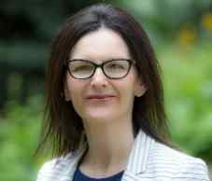
Professor Suzanne Hagen (1996-2024) BSc, MSc, CStat, PhD.
Suzanne is a researcher with an international reputation in pelvic floor disorders. She has over 30 years’ experience as a statistician and health services researcher. Suzanne joined the NMAHP Research Unit in 1996 and obtained her PhD in the clinical application of repeated measures statistical models at GCU in 2006. She was awarded a personal Chair as Professor of Health Services Research at GCU in 2009, the year she was also the Alberta Heritage Foundation for Medical Research visiting Scholar, which was awarded for her Cochrane review on catheter management. She became a Deputy Director within the NMAHP-RU in 2012. Suzanne has received many international awards and invitations based on her research: BMJ top 3 UK research paper 2015, for the POPPY trial published in the Lancet; appointed as Adjunct Assistant Professor of Nursing in the Associated Faculty of the School of Nursing at the University of Pennsylvania 2019-2022; Invited speaker to Continence Foundation Australia Sydney 2017 & Brisbane 2024; International Continence Society Best Clinical Abstract for trials 2011, 2014, 2021; Scientific Chair, UK Continence Society Conference, 2021. Suzanne has recently been cited as being in the top 2% of scientists in the field of Urogynaecology.

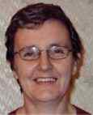
Professor Doreen McClurg (2008-2022), PhD MCSP.
Doreen joined NMAHP RU in 2008 as a Research Fellow after obtaining her PhD from the University of Ulster in 2006. Doreen is a leading academic Physiotherapist with a large and consistent portfolio of research in areas such as: abdominal massage for constipation and particularly for people with neurological disorders such as MS (Multiple Sclerosis) and Parkinson’s; self-catheterisation; UTIs; pelvic organ prolapse and pelvic floor muscle training, among others. Doreen has Chaired several high profile national and international organisations such as: the Association for Continence Advice; the Association for Chartered Physiotherapists in Women’s Health; the Bowel, Bladder and Sexual Dysfunction Group; the Physiotherapy Committee of the Multi-Disciplinary International Continence Society; and the Pelvic, Obstetric and Gynaecological Physiotherapists Group, among others. Doreen also sat on the NICE Guideline Development Group for Urinary Incontinence and Pelvic Organ Prolapse and took on a final role on the most recent (2022) Research Excellence Framework (REF) as a panel member. In addition, Doreen’s work has had a significant impact on the education of physiotherapists and nurses across the UK in the fields of pelvic health and continence. Doreen has recently been cited as being in the top 2% of scientists in the field of Urology and Nephrology.


Professor Marian Brady (2000-2024) BSc(Hons), PhD, FRCSLT.
Marian, an experienced speech and language therapist, joined the NMAHP-RU while completing her PhD at University of Strathclyde. She established the Unit’s Stroke Rehabilitation Research programme in 2000 which has contributed significantly to international evidence and practice for multidisciplinary stroke care and rehabilitation. Marian received Honorary Life Membership of the Stroke Society of Australasia (2015) and the Robin Tavistock Award, an international honour for outstanding contribution to the world of aphasia (2016). She holds an Honorary Chair at the University of Queensland, Australia (2015-date) and was awarded the Royal College of Speech and Language Fellowship from Sophie, the Countess of Wessex at the RCSLT 2019 Awards Ceremony. Outputs from the stroke programme have been referenced in UK, Irish, Australian, Norwegian, Canadian, New Zealand and Dutch clinical guidelines. She is the founding Chair of the Virtual International Stroke Trials Archive for rehabilitation trials (VISTA Rehab) which includes data from 10,000 Stroke survivors. In 2013 she established the Collaboration of Aphasia Trialists which has supported collaborative projects spanning 41 countries. Marian was appointed to join the World Health Organisation (WHO) World Rehabilitation Alliance (WRA) research workstream (a global network that aims to implement the WHO Rehabilitation 2030 Initiative), the rehabilitation package panel for Parkinson’s Disease, Chair of the International Association of Communication Sciences and Disorders, Aphasia Committee; Trustee (Research and Development) for the Royal College of Speech and Language Therapists (2022-date);and was the first AHP invited to Chair a European Stroke Organisation Guideline working group. (2022-2024). A regular international keynote speaker, she has published extensively (including one of the top 10 most accessed Cochrane reviews), Marian was recently identified as one of the top 2% of highly cited scientists in the field of Neurology and Neurosurgery).

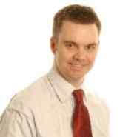
Professor Edward Duncan (2006-2024) PhD, BSc(Hons), DipCBT.
Edward received his PhD (2004) whilst still working in clinical practice. In 2006 Edward was appointed as a Research Fellow in the Unit. This followed his award of the first Nursing Midwifery and Allied Health Professions Research Training scheme's post-doctoral research fellowship (2004-2006), which he undertook at The University of Stirling. He is a founding member of the Royal Society of Edinburgh's Young Academy of Scotland. Edward’s clinical background is in occupational therapy and cognitive behavioural therapy, His current research investigates unscheduled and emergency care, with a specific focus in pre-hospital emergency care. He holds an honorary research appointment with the Scottish Ambulance Service and sits on their Research and Innovation Group, providing academic advice. He has developed an international profile for his work in road traffic related trauma in sub-Saharan Africa. Edward was promoted to Professor in Applied Health Research in 2022 and shortly thereafter became Associate Dean for Research within the Faculty of Health Sciences and Sport.

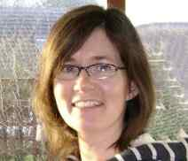
Professor Alex Todhunter-Brown (2008-2024), PhD.
Alex was awarded her PhD in 1998 and had developed a strong reputation carrying out Cochrane systematic reviews of complex Stroke rehabilitation interventions and promoting evidence-based practice to allied health professionals working in Stroke rehabilitation. Since joining the Unit, Alex has continued to develop her expertise relating to systematic reviews of complex interventions and leading the development of methodological work in this field. She was an associate editor with the Cochrane Stroke Group and an author on 11 Cochrane systematic reviews and 2 Cochrane overviews. Two of her Cochrane systematic reviews were both within the top 50 most accessed reviews in the whole Cochrane Library, and in the top 3 most accessed Cochrane Stroke reviews, in 2015, 2016 and 2017. She became Co-ordinating Editor of Cochrane Stroke in 2020, leading the international Cochrane stroke editorial board.
She has published work relating to the use of GRADE in overviews, and instigated and co-leads an international GRADE overviews project group. Alex has an active interest in public involvement in research and has led and contributed to a number of research prioritisation projects, including two with the James Lind Alliance (JLA). She led the ACTIVE project, funded by Cochrane Training, aimed at supporting review authors have meaningful involvement of patients and the public in systematic reviews. She became a co-PI on the NIHR funded Evidence Synthesis Collaboration (NESSIE) which reflects her status in the field of evidence synthesis. Alex was promoted to Professor at GCU in December 2022 and has recently been cited as in the top 2% of scientists in the field of rehabilitation research.

Our host institutions have core funded additional Professorial and Associate Professor/Reader level posts, filled at March 2024 by:

Professor Pat Hoddinott (2013-2024), BSc, MB BS, DCH, DRCOG, FRCGP, MPhil, PhD. Pat’s research focuses on preventative interventions. Her PhD investigated group-based interventions to support breastfeeding. She held a Chief Scientist Office Primary Care Career Award and has twice won the RCGP/Boots research paper of the year award. She applies mixed method approaches to the design and delivery of complex intervention trials which support people to adopt and sustain behaviours which improve health and wellbeing. She has gained an international recognition particularly for her work on breastfeeding, incentives for behaviour change and how qualitative research methods are applied in randomised controlled trials. Her research aims to address health inequalities and applies ecological approaches to understanding behaviour. Her latest trial is Game of Stones which has been an exemplary community based public health trial tackling obesity in men. She has sat on the NIHR-HTA Commissioning Board and School of primary Care Funding Panel.
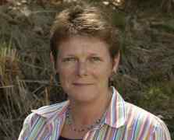
Professor Anne Whittaker (2018-2024). Anne gained her Chair in Nursing Research on joining the Unit in 2018. As a mental health nurse specialising in alcohol and drug addictions, she has led several large-scale national studies and trials in the field. She was recently appointed a member of the ESRC Peer Review College and is also a member of the Chief Scientist Office HIPS committee, the CORRA Foundation Partnership Drugs Initiative (PDI) children & families fund panel, and a Trustee of the Addiction in the Family International Research Newtork (AFINet).


Dr Myzoon Ali, Reader (2008-2024). Myzoon has become a leading expert in aggregating Individual Patient Data from across international trials to answer new research questions. She has also developed methods for standardisation of outcome assessment in Stroke clinical trials. Her PhD and early career saw her establish and promote the Virtual International Stroke Trials Archive (VISTA), a resource consisting of patient data from acute Stroke clinical trials. She joined the NMAHP Research Unit in 2008 to develop VISTA-Rehab, an expansion of VISTA to aid the planning of Stroke rehabilitation trials. She has since gone on to collaborate on the Collaboration of Aphasia Trialists (CATS) and associated projects such as RELEASE (see below).


Dr Emma France, Professor (2012-2024). Emma France joined the unit in 2012 as a lecturer and has since led several prestigious awards. She has become an internationally renowned expert in qualitative evidence synthesis who is regularly invited to deliver seminars and workshops across the world. For example, she delivered 11 seminars and workshops since 2019 including to the USA Government Agency for Healthcare Research and Quality, University of Oslo, Evidence Synthesis Ireland, and Cochrane South Africa. She led a high profile WHO-commissioned systematic review and qualitative evidence synthesis that directly informed the WHO 2020 global guidelines on children’s chronic pain management. She was appointed as a convenor for the Cochrane Qualitative and Implementation Methods Group, joining a group of 9 international convenors who are highly respected methodologists with expertise and experience in specific areas of qualitative methodology. She is co-authoring 4 chapters of the forthcoming Cochrane & Campbell qualitative evidence synthesis handbook and has been appointed as one of its Associate Scientific Editors. The handbook is a prestigious, innovative international methodological publication which is a key reference for systematic reviewers globally. She has won many awards in presenting her work (e.g. NIHR-funded CHAMPION project won Cochrane’s Thomas C. Chalmers award for the best poster presentation at the Cochrane Colloquium in 2023; and her CSO-funded SCooP project on increasing children’s adherence to chest physiotherapy for cystic fibrosis won the Award for Innovation at the Scottish NMAHP Research Awards 2017. Emma was promoted to professor in 2024.

Impact on NHS and Public Health
We have conducted work of vital importance to the NHS in Scotland and particularly in response to requests by the Chief Nursing Office for research evidence to enable strong decision making. Recent examples include producing reviews of evidence to support policy decisions relating to the clinical supervision of midwives, the roles of school-based and practice nurses, evidence for safe staffing, and the role of and evidence for implementation of Advanced Nurse Practitioners (among many more).
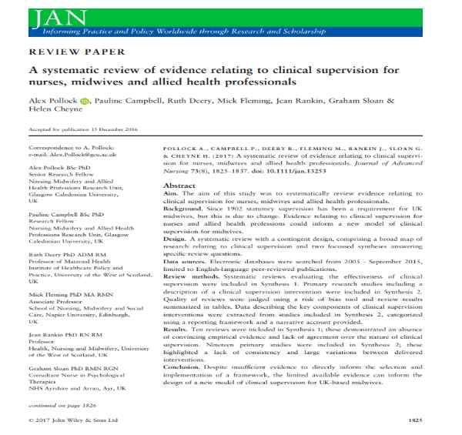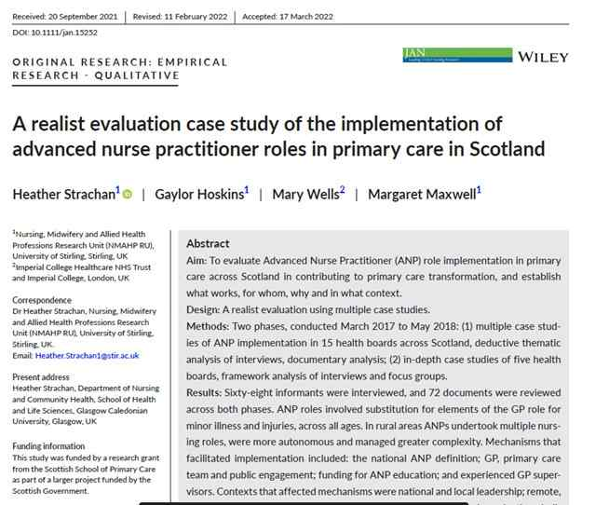
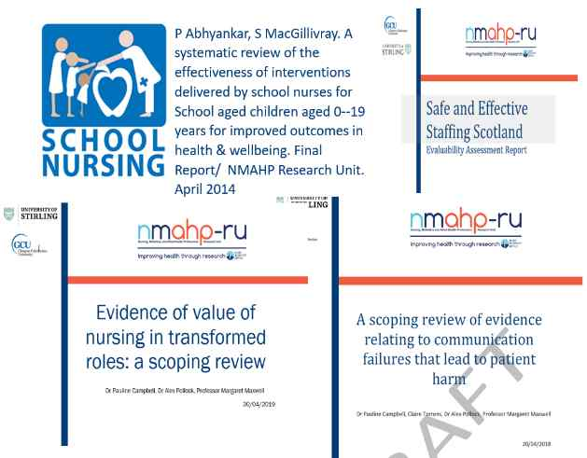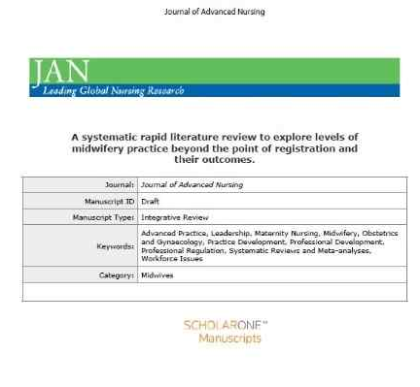

We have also delivered bespoke evaluations of large-scale intervention or policy roll-out such as: the Keeping Childbirth Natural initiative; quasi-experimental evaluations of the Releasing Time to Care, and the Caring Behaviours Assurance System, as ward-based interventions to improve quality of patient care; and evaluation of the national pilot of the Distress Brief Intervention (DBI). Each of these has helped to shape policy and determine what is working (or not) and why so that decisions on investment and expansion (or disinvestment) of interventions could be evidence based.
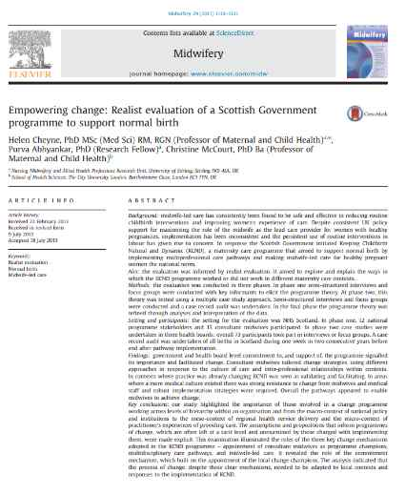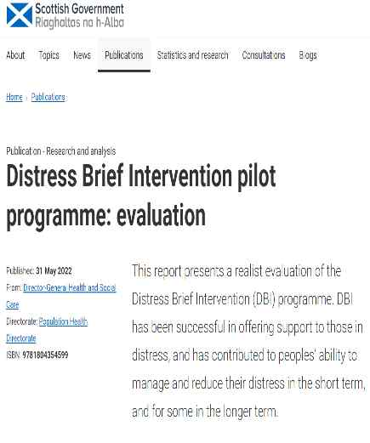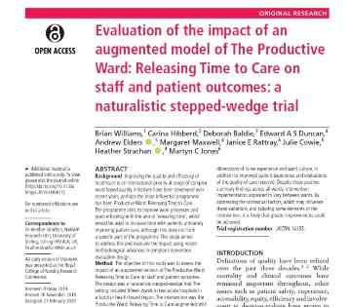
Each of our several hundred studies conducted over our 30-year history have had an impact on either our NHS or on patient or public health (oftentimes all three). As an example of the impact of our work in Stroke related pelvic health, we previously documented (in our 2017 review) that we had identified over 30 publications which had demonstrated our influence on policy across the following organisations: RCP and SIGN Guidelines, European Agency for Safety and Health at Work, World Health Organization, National Institute for Health and Care Excellence, UK Government (GOV.UK), Australian Clinical Guidelines Acute Rehab Management, Australian Clinical Guidelines for Stroke Management, Australian Policy Online, NZ Clinical Guidelines Stroke Management, USA VA and DOD Management of stroke rehabilitation, Canadian Best Practice Recommendations for Stroke care, Dutch SLT guidelines, and the Publications Office of the European Union.
Below we highlight some further achievements in our specific areas of expertise and the impacts these have had for policy and patient care.
Pelvic Health
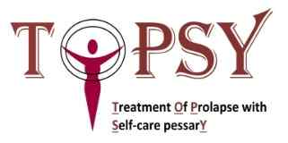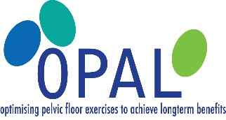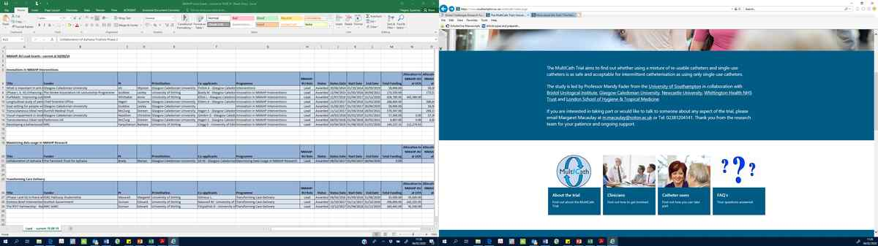
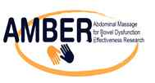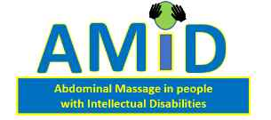


Our pelvic health workstream has conducted several multi-centre clinical trials and has established the evidence base for Pelvic Floor Muscle Training (PFMT) as an effective treatment for women with prolapse. As one of the leading centres internationally for research into non-surgical treatment of urological and Uro- gynaecological problems in women, the prolapse research programme has significantly informed international health policy and guidelines including the WHO International Consultation on Incontinence expert committee which functions to promote improvements in the management of incontinence and prolapse worldwide. Recommendations must be suitable for use in all parts of the world, recognising that the health services’ resources differ widely between countries.
The resulting clinical manual is updated every four years and is vital to clinicians in the field of incontinence and prolapse, providing algorithms to guide practice. Professor Hagen has been an expert committee member on the 3rd, 4th and 5th editions of the manual and the publication includes findings from the Unit’s research studies, facilitating reach to a worldwide audience of practitioners. Dr Pauline Campbell and Professor Suzanne Hagen co-authored a chapter on conservative management of prolapse in the 7th edition of International Consultation on Incontinence’s evidence review textbook (Cardozo, L, Rovner, E. Wagg, A, Wein, A, Abrams, P. (Eds) Incontinence 7th Edition (2023). ICI-ICS. International Continence Society, Bristol UK, ISBN: 978-0-9569607-4-0.)
The Pelvic health workstream has also successfully developed a Prolapse Symptom Scale and further tested a Prolapse Staging System to improve outcome measurement for women’s health physiotherapists in the UK. The research has informed local, national and international guidelines and changed practice in 48% of UK physiotherapists (as evidenced in our REF 2014 Impact case study).

Stroke Rehabilitation
Similarly, led by Prof Brady, our aphasia research has been instrumental in changing aphasia rehabilitation policy and standards for stroke survivors across 23 countries including Australia, Brazil, Canada, Germany, Morocco, Norway, South Korea and the UK. The UK recommendations directly inform NHS Speech and Language Therapy (SLT) service delivery standards. National stroke service-delivery guidance was informed by Cochrane systematic reviews and NIHR funded international IPD network meta-analyses, providing ground-breaking, conclusive evidence that SLT benefits aphasia recovery, informing specialist aphasia service development and education within 19 countries including the emergent SLT profession in Croatia, Iran, Lithuania and Turkey. UK survey respondents (speech and language therapists) indicated that following the Cochrane reviews findings, SLT was now delivered earlier, at a higher intensity, dosage and over a longer duration (see REF2021 Impact case study No3 below).

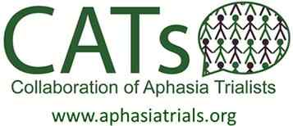
Under Prof. Marian Brady and Dr Myzoon Ali, NMAHP-RU established and led the Collaboration of Aphasia Trialists with initial EU COST funding (2013-17) and more recent Tavistock Trust for Aphasia, UK awards (2017-24). Supporting >300 multidisciplinary researchers across 41 countries and 43 languages, the collaboration has established consensus on a research agenda, a core outcome set, reporting criteria, informed innovative trials of effectiveness, the creation of non-English assessment tools and through >£8M research grant awards, collaborators have advanced the quality of support and rehabilitation available for people with aphasia and their families. The collaboration has published >90 academic papers in addition to producing several linguistic assessments in non-English languages. The Collaboration was awarded the international Robin Tavistock Award in 2023 reflecting its impact on aphasia research and services. It was also shortlisted for the Times Higher Education International Collaboration of the Year in 2022.

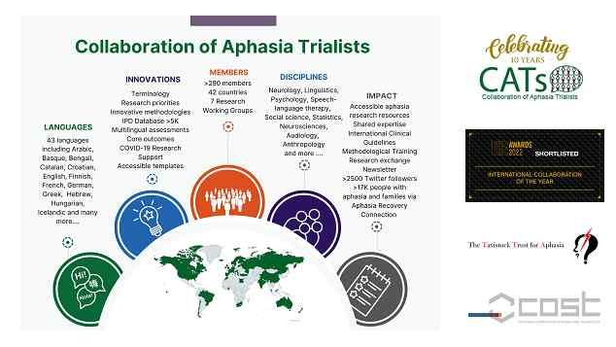

Evidence Synthesis
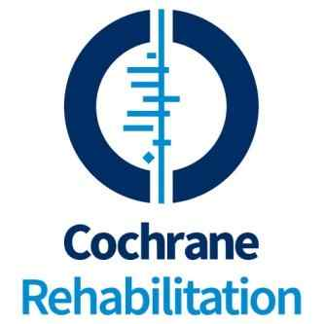
NMAHP-RU has been a major player in the Cochrane Collaboration including being a co-lead for the Cochrane Stoke group. NMAHP-RU staff are authors on 15 high impact Cochrane stroke reviews alone. This includes being the lead authors on the top 3 most highly accessed stroke reviews across several years. These reviews are all cited in multiple clinical guidelines. Prof. Alex Todhunter-Brown authored a paper “How to do a systematic review”, published in the international Journal of Stroke, which was in the top 10 most downloaded articles from the journal in 2018; was presented at a webinar of the World Stroke Academy (2020); and has been integrated in a World Stroke Organisation training course on “how to do good quality research”. Additional Cochrane reviews have been conducted by the Unit in Pelvic Health and mental health topics.



More recently, Prof. Todhunter-Brown has become a co-leader of a new NIHR Evidence Synthesis Scotland Initiative (NESSIE) with other Unit staff (from both GCU and University of Stirling) as collaborators in this initiative. NESSIE aims to provide best evidence to support decision-making across health, public health and social care in all four nations of the UK.
This adds to the Units leading reputation in qualitative evidence synthesis (QES) for producing the international guidelines for the conduct and reporting of the most commonly used QES methodology – Meta-ethnography. At the time of writing this final report, Prof. E France has also been awarded funding from the MRC-NIHR Better Methods, Better Research programme to develop a PRISMA reporting guideline and standards for qualitative evidence synthesis (PRISMA QES), which is further testament to our international leadership in the field of qualitative evidence synthesis.

Mental Health, Suicide Prevention and Addictions
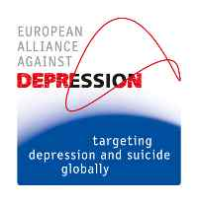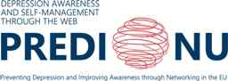
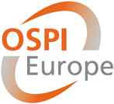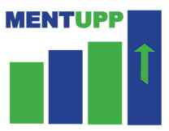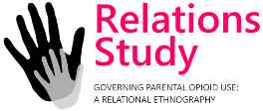
The NMAHP-RU has enabled continued collaboration in the award-winning European Alliance Against Depression (of which Prof. M Maxwell was one of the founding members) and its 5 linked EU funded large-scale international studies and clinical trials. This work has spanned 16 years within NMAHP-RU and has established the Unit as a leading home for mental health, depression and suicide prevention research. The latest MENTUPP and PROSPERH studies include a focus on improving mental health and wellbeing within the healthcare sector, especially those working outside the NHS in smaller healthcare organisations such as nursing homes. The resources to support mental health and wellbeing were being created during the pandemic when the needs of this sector became even more critical.
Prof. Anne Whittaker has also led a programme of work to improve the lives of people with drug and alcohol addictions, such as the Parents Under Pressure Programme for drug dependent fathers and their children, which has now been adopted and rolled out by many agencies across Scotland (Circle, Action for Children, Aberlour, Pheonix Futures, East Lothian, Edinburgh and Highland Councils, and by the Welsh Government in Wrexham, Wales. The Relations study (which involved collaborators from Canada, Australia and USA) sought to improve service delivery for people experiencing drug addiction and has delivered numerous outputs in accessible (arts-based) formats for professionals and those with experience of addictions. These are just some examples of this programme of work.
Professor Edward Duncan led a collaborative programme of work evaluating the Scottish Government’s Distress Brief Intervention (DBI) Programme which led to the DBI programme being included in the Scottish Government's Programme for Government and embedded across each of Scotland’s 14 territorial Health Boards. This has led to over 50,000 people being referred to the DBI service across Scotland. Evaluation work by the team continues through an NIHR grant and the expansion of the DBI programme into young people and schools.

Maternity and Maternal Care
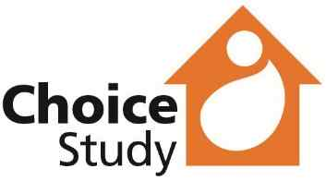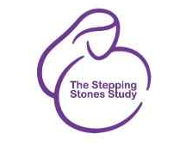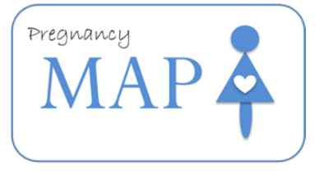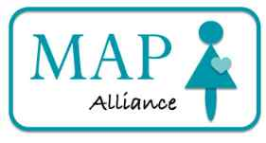
Our maternity and maternal mental health work has contributed to key policy development in Scotland and beyond. For example, from our initial studies into managing early labour to more recent work on determining whether it is safe, effective, cost-effective and acceptable to women to carry out home cervical ripening during induction of labour (Choice Study). We have also led the way internationally in the field of postnatal service re-design (PRAM) and partnered with the Scottish Government to lead the first two iterations of the Scottish National maternity survey in 2013 and 20125.
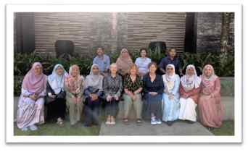
More recently, we have been at the forefront of maternal mental health research as a key partner in the largest cohort study of maternal mental health worldwide (Maternal Anxiety in Pregnancy: Pregnancy MAP and its follow-up study MAP Alliance) as well as leading an international partnership in South East Asia to improve maternal mental health (the South East Asia Perinatal Mental Health Collaboration) which has resulted in the development of resources for women and healthcare practitioners as well as several collaborative grant proposals and awards.
We have also been co-leading a large study to understand and better respond to the needs of women who use opioid drugs during pregnancy to improve their outcomes and those of their babies (Stepping Stones). These are only some examples of one of the most concerted programmes of midwifery research in the UK.
To enhance and build capacity for maternity and maternal research across Scotland and the UK, Prof. H Cheyne brought together the lead midwife researchers from across Scotland (SMART) with the aim to provide and develop strategic midwifery research leadership and a coordinated approach to midwifery research in Scotland. More recently she was a co- founder and currently chairs the Council of Deans for Health (CoDH) affiliated UK Network of Professors of Midwifery and Newborn Health.

Pre-hospital Emergency Care
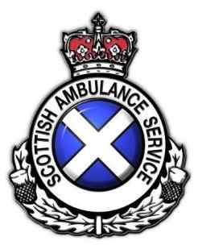
The NMAHP-RU has been leading the majority of pre-hospital emergency care research in Scotland as part of a key strategic partnership with the Scottish Ambulance Service over the past 20 years; and is a major partner in UK collaborative research. This has included 5 studies focusing on improving the intervention and follow-up of people who experience a pre-hospital hypoglycaemic emergency, as well as work on SAS involvement in managing Psychiatric emergencies. The systematic review on improving post-hypoglycaemic patient safety in the pre-hospital environment was awarded the Royal College Ambulance Service Liaison Committee (JRCALC) Award for the ‘Research Most Likely to Influence Practice’ (2009) in recognition of the Systematic Review of post-hypoglycaemic patient safety in the pre-hospital environment. The review went on to change JRCALC national clinical guidelines on the treatment of pre-hospital treatment of hypoglycaemia. These guidelines are used by all ambulance services in the UK and guide practice internationally. The Mental Health and Self-harm Emergency Care linked data findings have also influenced health policy and health service delivery, informing the Mental Welfare Commission’s statutory service evaluation and the Scottish Government Mental Health Improvement Program. The study findings won the research award for “Highest Quality Research” at the UK national 999 EMS Research Forum in 2017.
The pre-hospital emergency care work has expanded into our global health programme in conducting several studies in sub-Saharan Africa in relation to road traffic related trauma and initiatives to improve road safety in the region. This has included working with police, schools, communities and Emergency Department staff in Malawi and using innovative (arts-based) methods for conducting and communicating research.

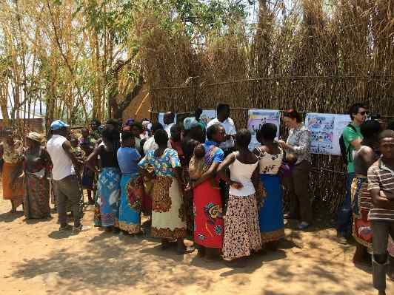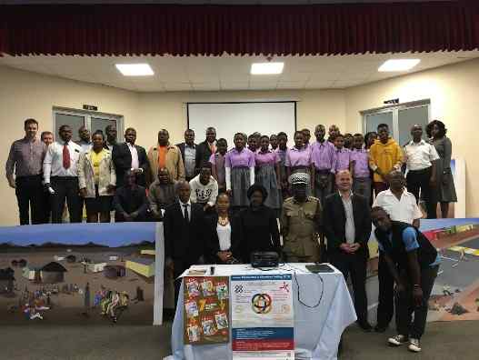

Public Health and Health Improvement
The NMAHP-RU has also contributed to specific areas within public health, namely in promoting smoking cessation in women during pregnancy and more recently in tackling obesity (particularly in males). Both programmes have drawn on our expertise in behaviour change mechanisms and in novel ways to achieve behaviour change such as ‘incentives’ and the use of digital technology.
Our work on incentives for smoking cessation in pregnancy was used in the Khan report to make policy changes to Smoking Cessation Services for pregnant women in England to include £400 of incentive vouchers for quitting smoking. The Khans report cites a Cochrane systematic review https://www.cochranelibrary.com/cdsr/doi/10.1002/14651858.CD004307.pub6/epdf/full which includes 4 papers authored by Prof. P Hoddinott’s NIHR HTA commissioned BIBS study. This study was also cited in NICE guidance that recommends incentives are offered to pregnant women who are smoking (https://www.nice.org.uk/guidance/ng209/chapter/recommendations-on-treating-tobacco-dependence-in-pregnant-women.

More recently the Game of Stones trial worked with men to design a text messaging and incentives intervention to encourage men to lose weight. This has been a highly successful trial whose findings now have potential to impact on obesity across Scotland and further afield, particularly around health inequalities. (Study findings were published in JAMA just as we completed this report: Journal of the American Medical Association (JAMA) (doi:10.1001/jama.2024.7064).

Further evidence of impact
The impact of much of our current work will be forthcoming (and will be reported in the Research Excellence Framework planned for 2029 (REF2029). It is difficult in this summary report to document the significant impact that many of our projects and programmes of research (on-going over many years) have had on our NHS, patients, and the public. Much of this has been documented and done justice in several Volumes submitted at each CSO scientific review (as described above) and in the REF2014 and REF2021 exercises as Impact Case Studies. As a result, we signpost our 2017 review reports (Vols 1-3 available on request) and our 5 REF2021 Impact Case studies as a record of some of our existing impact.
- Improving the management of pelvic organ prolapse through effective treatment and monitoring: international impact on policy, healthcare professionals and outcomes for women. Suzanne Hagen, Sylvia Dickson, Andrew Elders, Doreen McClurg, Nicole Sergenson
- Increasing awareness and intervention strategies to tackle depression, suicide and other psychiatric emergencies. M Maxwell, E Duncan, F Harris, D Fitzpatrick, C Best
- Improving services for people with aphasia after stroke through enhancing evidence-based policy and service standards. M Brady, M Ali, P Campbell
- Enhanced support for stroke rehabilitation and long-term recovery through improved training and educational resources. M Brady, A Pollock, C Hazelton, B Davis.
- Improving pre-hospital emergency care. D Fitzpatrick, E Duncan.

Impact on Scottish Research Environment

Contribution to inward investment to research portfolios in Scotland
With an annual income of c£6-8million per annum (since 2018) the NMAHP-RU has seen a return of investment for the Chief Scientist Office in the region of £7-9 for every £ invested in the Unit. The majority of our research portfolio funding has been obtained outside of Scotland, mainly from the National Institute for Health and Care Research (NIHR) and European Union (Framework 7, Horizon and Horizon Europe) but also including United Kingdom Research and Innovation (UKRI) funding from the Economic and Social Research Council (ESRC), Medical Research Council (MRC) as well as a host of charitable organisations (British Heart Foundation; Chest, Heart and Stroke; Tavistock Trust, Stroke Association, to name a few).
The overall portfolio of research which the NMAHP-RU has been delivering has also included many partners across Scotland and areas of the UK, as well as some international recipients including several low- and middle-income countries via our global health work in Southeast Asia, sub-Saharan Africa and the South Pacific. Most of the research which we have led has included other HEI’s in Scotland and as the majority of our studies are funded by NIHR and UKRI these have attracted Full Economic Costs (FEC) to the institutions. A significant amount of the tens of trials we have conducted has benefitted clinical trials units across Scotland. It is difficult to provide an exact figure on the contribution we have made to other HEI research income across Scotland, but we would conservatively estimate that one third of our return of investment has been shared with other HEI’s in Scotland.

Capacity and Capability Building for NMAHP Research
The NMAHP-RU has delivered and supported many national initiatives for developing research capacity and capability among NMAPS in Scotland. The Unit was involved in the 2005 NMAHP Research Training Scheme, and supported two post-doctoral fellows, one of whom has remained with the Unit and is now a professor. From 2010 to 2014 we contributed to the National Guidance for Clinical Academic Careers for NMAHPS and took part in the CNO’s NMAHP’s Clinical Academic Careers Summit. In 2010 we successfully completed a CNO funded project to re-engage NMHAPs in research, this resulted in fellowships for two nurses, one of whom (Dr Barbara Farquarson) returned to the Unit and is now an Associate Professor.

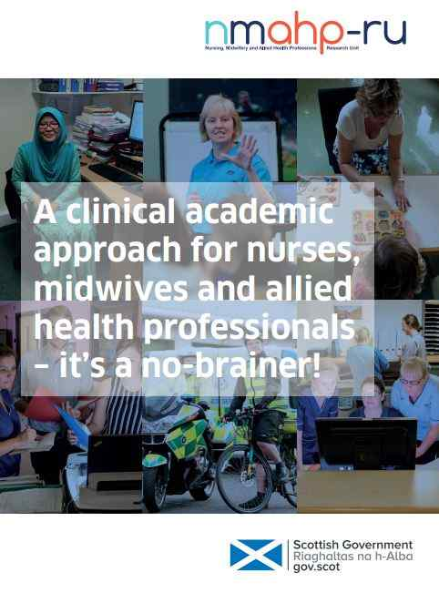
From 2014 to 2018 we delivered an extensive programme of work to support NMAHP clinical academic careers in Scotland. The activities of the programme included (i) the establishment of a forum with responsibility for taking forward the development of (a framework for) clinical academic NMAHP roles and clinical academic NMAHP careers in Scotland; (ii) administering support for the development, management and implementation of a range of research training award schemes for NMAHP clinical academics, including 12 Masters level studentships and three post-doctoral clinical –academic fellowships; (iii) the development of a model of support for NMAHP consultants in delivering the research component of their roles; (iv) and the dissemination and promotion of NMAHP clinical academics through awards and publications.
We produced a booklet to positively promote clinical academic careers among NMAHPs.
During 2017 to 2019 the Unit provided support for the administration of the Scottish Government’s Vale of Leven Scholarship Scheme (a scheme designed to improve patient care in line with the recommendations from the Vale of Leven Hospital Inquiry); and support for the administration of the Gordon Aikman Scholarship Scheme (a scheme designed to improve care for those who live with motor neurone disease). This included promoting the schemes to NMAHPs across Scotland as well as managing the peer review/judging process and administration of the awards. This also included providing research advice to applicants to enable robust applications and conduct of their research.

The NMAHP-RU has supported many individuals to obtain their Doctorate and Clinical Doctorate qualifications over the past 30 years. We mention here in particular only those for whom we helped to secure funded PhD Studentships and PhD Fellowships:
CSO Fellowships: Andrea Sinesi, Gill Moncrieff, Bridget Davis, Sian Russell, Lesley Scobbie

ESRC Studentships: Avril Nicoll, Lynne Gilmour, Clare Jouanny, Nicola Glennie

Other PhD Funded Studentships/Fellowships: Mary Ross-Davey (Royal College of Midwifery), David Fitzpatrick (Scottish Ambulance Service), Angela Kerrigan, Maggie Lawrence (Stroke Association) Christine Hazelton (Stroke Association), Theresa Ikegwuonu (Diabetes UK), Keir Liddle (Chief Nursing Office, Scottish Government), Sally Boa (Strathcarron Hospice), Katherine VandenBerg, Atharva Bhagwat (The Tavistock Trust for Aphasia), Eleanor Brown (GCU), Kris McGill (GCU), Kate Lough (GCU), Julie Duncan Millar (GCU), Rachel Frost (GCU), Jay Webster (GCU), Ebere Ugwuodo (GCU).

We have also helped individuals to obtain highly competitive Post doctoral fellowships:

Dr Myzoon Ali obtained a CSO Postdoctoral Fellowship. In 2019 Dr Lesley Scobbie became the first Stroke Clinical-Academic AHP in Scotland with support from NHS Lanarkshire following the award of a Stroke Association HRH Princess Margaret Clinical Lectureship. The Unit was then successful with a second Stoke Association award to Dr Christine Hazelton who was the first AHP in the history of this award to receive their prestigious 5-year funding support. Dr Barbara Farquharson was awarded a 3-year Career Development Research Fellowship by the British Heart Foundation which commenced May 2020, and she was also successful in gaining a Leadership Scholarship of the Florence Nightingale Foundation in 2022.

The question remains as to how NMAHPs in Scotland will continue to receive the support that is needed to be able to compete with other researchers and other disciplines for research funding, whether this is for early career development (PhD studies etc.) or post-doctoral level awards. There is no doubt that NMAHPs in Scotland currently have less opportunities than those elsewhere in the UK to establish research interests and research careers and the loss of the support to the NMAHP Research Unit may have long-term consequences for the future of NMAHP research and NMAHP research careers in Scotland.

Patient and Public Involvement
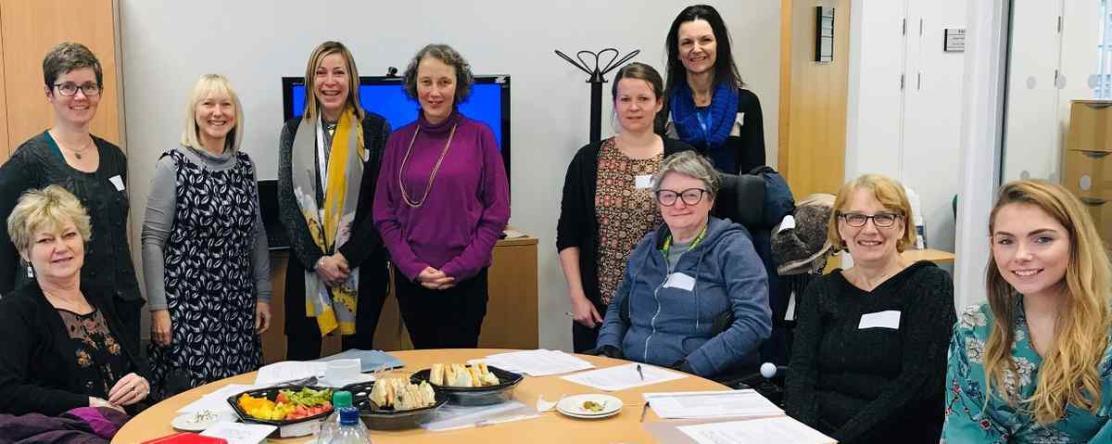

We briefly introduced our Research Partnership Group (RPG) above, which has over 20 active members. Our blueprint for the establishment and running of our RPG has been seen as exemplary in both our host institutions and members of our group and Unit staff supporting our group have helped to develop a university wide patient and public involvement (PPI) policy and new PPI group at Glasgow Caledonian University. We have many individual examples of award-winning PPI work in the Unit. Dr Christine Hazelton was awarded the UK Stroke Forum’s Patient, Carer and Public Involvement prize (2022) for her work on the PIONEER project, exploring effective interventions for disorders of perception after stroke. The prize was judged on several aspects including how stroke survivors were involved, including methods to build effective communication and teamwork, and how this improved the research. Ground-breaking work was conducted by Dr Kirsteen Goodman to enable one of our PPI partners (Margaret Spice) to lead author a publication. This included negotiating solutions with journal editors to re-align journal policies and change the status quo. This publication has been highly accessed. Our RPG has commended the Unit in the way we have worked with them and for the high standards we aimed to achieve in PPI and research quality and integrity.

Beyond April 2024
The NMAHP-RU as a partnership between Glasgow Caledonian University and University of Stirling will cease to exist. However, the legacy of its programmes of work and its investment in staff capacity and capability will continue to be supported within each former host institution. The NMAHP-RU at University of Stirling will be re-named as the Centre for Healthcare and Community Research (CHeCR) in the Faculty of Health Sciences and Sport, with a similar focus on developing the evidence base for health and social care delivery. The NMAHP-RU staff at Glasgow Caledonian University will become part of the existing Research Centre for Health (ReaCH), in the School of Health and Life Sciences. ReaCH is currently home to 10 different health research groups focused on enhancing the lives of people with long-term health conditions as well as developing and evaluating public health and lifestyle interventions.

Final thanks
We hope this report has provided a flavour of some of the NMAHP Research Unit’s prestigious work over the past 30 years. It is not easy for current staff to recall all the achievements of past colleagues or to briefly summarise all that we have achieved in a single brief report. We apologise in advance if we have omitted to include any specific awards and individuals involved.
We wish to thank all those who have supported the Unit over the years and contributed to our research as funders, collaborators, partners, and participants. We aimed to do the best quality research to improve patient and public health and healthcare delivery and we believe we delivered this and more for the people of Scotland and beyond.

The Nursing, Midwifery and Allied Health Professions Research Unit 1994-2024

Ioannidis, John P.A. (2023), “October 2023 data-update for "Updated science-wide author databases of standardized citation indicators"”, Elsevier Data Repository, V6, doi: 10.17632/btchxktzyw.6
https://assets.publishing.service.gov.uk/government/uploads/system/uploads/attachment data/file/1081366/khan-review-making-smoking-obsolete.pdf

