
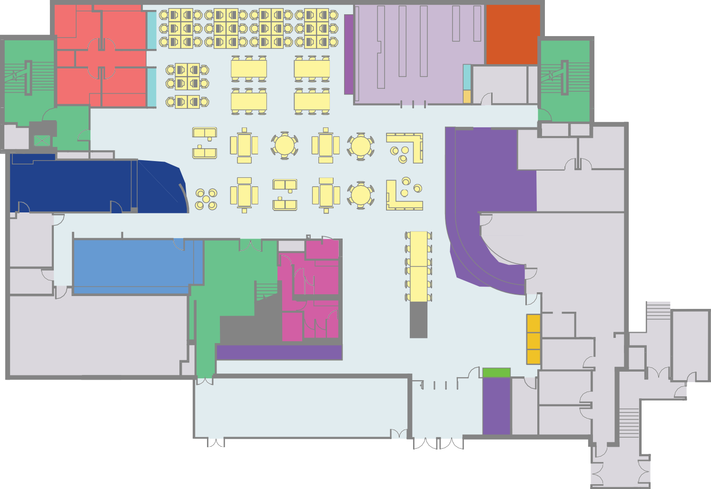
Facilities
Level 2: Enquiry
- Stairs/Lifts
- Toilets
- Information Centre Reception
- Self Issues/Self Return
- Print/Photocopy
- Open and Group Study Area
- Disability Team Rooms
- Archive
- Catalogue Terminals
- Well-being Space
- Click and Collect Shelves

Loan Types
- Short Loan
- Laptop Loan


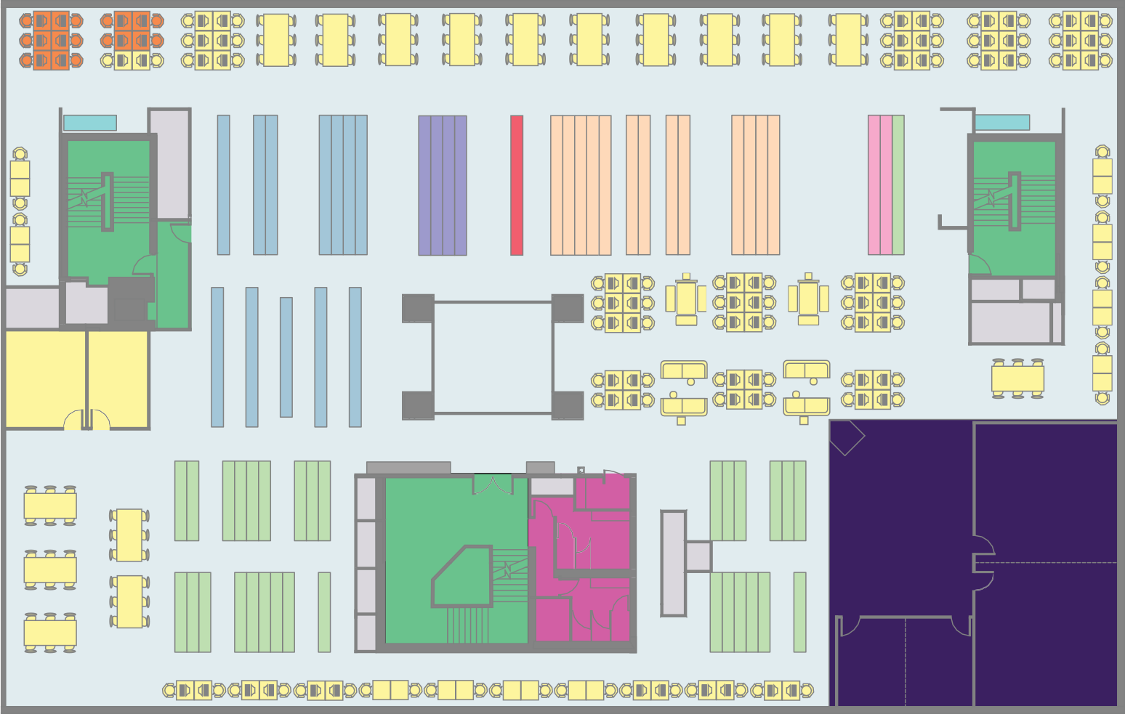
Facilities
Level 3: Quiet study
D-G
Law
Ref
Journals
Quarto A-B
A-D
1
2
LP-MA
D-G
G-LP
B-D
- Stairs/Lifts
- Toilets
- Print/Photocopy
- Open and Group Study Area
- Catalogue Terminals
- Library Training and
Study Suite
- Dual Monitor PCs

Loan Types
- Popular Loan
- Long Loan
- Quarto
- Journals
- Law Collection


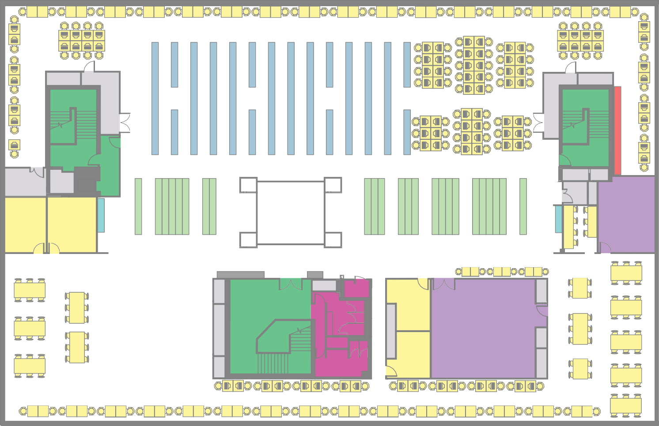
Facilities
Level 4: Silent study
GS-Z
MA-MJ
MM-Z
3
4
Training room 2
9
Training room 1
10
- Stairs/Lifts
- Toilets
- Training Rooms
- Print/Photocopy
- Open and Group Study Area
- Catalogue Terminals

Loan Types
- Popular Loan
- Long Loan
- Statistics/Reference
- Abstracts

6 | 5
7 | 8




This publication can be made available in different formats.

