
THE TRUMPET
Stirling Law School’s Bulletin 4/2022
This bimonthly bulletin is for sharing Stirling Law School’s achievements in research, teaching, and citizenship. In these difficult times, it’s crucial to celebrate, strengthen our sense of community, and create opportunities for cross-Faculty and cross-University collaborations. We hope you’ll enjoy this wee snippet of Stirling Law School’s recent successes.
Contents

Impact and engagement 1
Income generation 2
Publications 3
Books 3
Journal articles 4
Reporters 6
Employability News and Teaching Excellence 7
Esteem and network 8
Citizenship and service 9
Dissemination and media presence 9
Internationalisation 11
Events organised 12
Get in touch 14

Impact and engagement

Associate Professor Guido Noto La Diega has been working with the European Commission – as a member of its Expert Group on AI and Data in Education and Training – to help deliver the EU’s Digital Education Action Plan (2021-2027). As a key deliverable of the Expert Group’s work, the Ethical Guidelines on AI in Education have now been published.

They aim to help teachers address misconceptions about AI and promote its ethical use. They come with the executive summary of the final report, this useful video, as well as an infographic and factsheet.

For further information, you may want to check out the European Commission’s press release, the article on Europa.eu, and the article on DEAP. A longer report will follow, once the AI Act is adopted.

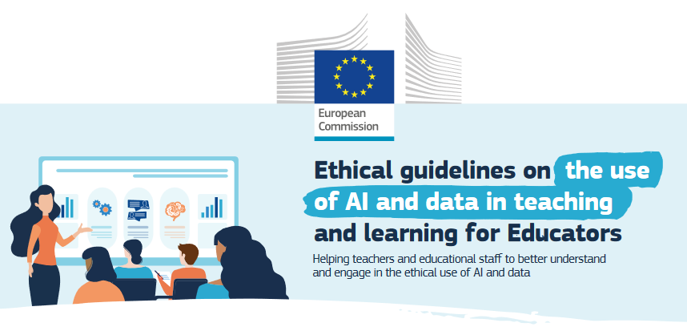
Figure 1. Image taken from the infographic accompanying the EU Guidelines on AI in Education

Professor Beaumont continued to represent the EU in the global multilateral negotiations on Jurisdiction at the Hague Conference on Private International Law. After the first in-person meeting of the Working Group on Jurisdiction in The Hague in late September 2022 Paul has been involved in informal negotiations between the EU and the US, the EU and Australia, and the EU and Japan with a view to developing proposals before the next Working Group meeting in The Hague in February 2023.

Earlier this year, Dr Jonathan Brown was invited to the Jersey Institute of Law to provide students on the English Law LLB and those enrolled on the Jersey Law Course insights into the utility of comparative legal study. While at the Institute, Dr. Brown met with Sir Philip Bailhache, the Institute’s founder, to discuss the interesting links that could be forged between two small mixed legal systems, and was invited by the Institute’s Dean to act as a judge for the internal moot competition set to be hosted in January 2022.

Income generation

The EU’s data protection authority (European Data Protection Board or EDPB) has appointed Associate Professor Guido Noto La Diega to its Pool of Experts, with the task to support national and international data protection authorities (the equivalent of the UK’s Information Commissioner Office) in their investigation and enforcement activities. The EDPB has recognised both Guido’s legal expertise in new technologies and technical understanding of information security. The appointment will constitute the basis for future consultancy agreements between the University of Stirling and the EDPB, and it will provide opportunities for impact as it will practically contribute to the better protection of the fundamental rights to privacy and data protection, as well as enhancing the cross-border cooperation between authorities.

Publications

Books

On Friday 14th October 2022, Routledge published Guido Noto La Diega’s book Internet of Things and the Law: Legal Strategies for Consumer-Centric Smart Technologies.

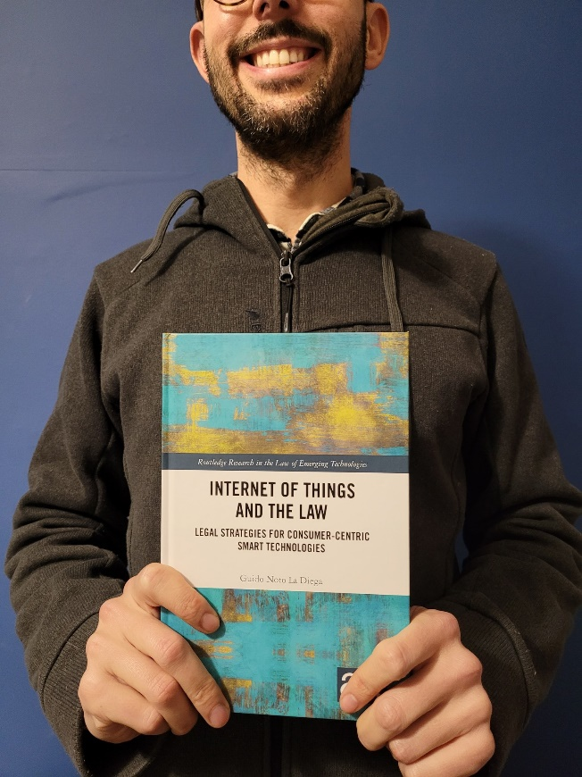
Figure 2 Guido holding a physical copy (sic!) of their book "Internet of Things and the Law".
The book has been welcomed as “a model for future work in the law and political economy of technology policy” (Professor Frank Pasquale, Brooklyn Law School, author of the bestseller The Black Box Society), “a timely and brilliant addition to scholarship that should inform forward-thinking regulatory approaches” (Professor Caroline B Ncube , Professor and SARChI Research Chair in Intellectual Property, Innovation and Development, University of Cape Town), “a wonderfully informative and deeply reflective study” (Professor Megan Richardson, Professor of Law, University of Melbourne, and Chief Investigator in the ARC Centre of Excellence for Automated Decision-Making and Society), and “the only comprehensive and thorough legal analysis of IoT” (Professor Marco Ricolfi , Co-Director of the Nexa Centre for Internet & Society; Professor of Commercial Law, Università degli Studi di Torino; Equity Partner at Weigmann Studio Legale). The book was also positively reviewed in some of the leading journals in the field (GRUR International, The Journal of World Intellectual Property, International Review of Law, Computers & Technology, Law & Digital Technologies).

The Italian launch of the book was hosted by the Nexa Centre for Internet & Society, while the UK one by The Royal Society of Arts and the Faculty of Advocates (with support from the Italian Institute of Culture of Edinburgh, the Centre for Research into Information, Surveillance & Privacy, the Scottish Society for Computers & Law, and the Scottish Research Centre for IP and Technology Law), the Australian one by the UNSW Allens Hub for Technology, Law and Innovation and the IEEE Society for Social Implications in Technology. The Belgian launch will be hosted by DRAILS (UCLouvain and USL-Bruxelles).

The acknowledgements – including to the Open Access team at Stirling for making one of the chapters open access – can be read here.

Journal articles

Dr Pontian Okoli’s article (“Former British Colonies: The Constructive Role of African Courts in the Development of Private International Law”) was recently published in (2022) 7(2) University of Bologna Law Review 113-146.

Significant strides have been made in efforts to facilitate the resolution of international disputes in Africa. However, cross-border issues that concern private litigants have remained challenging. One major reason is the legal history of relevant countries which often makes it difficult to contextualise legal principles inherited before independence. It is sometimes unclear how African courts determine the current law and how their discretionary powers should be used. This challenge is complicated where scholars focus on what they consider that the law ought to be without first accepting what the law is. Any sustainable growth of private international law requires a systematic approach to legal developments. Using the main comparators of South Africa and Nigeria, this article examines the connections between legal traditions and the legal methods that are required to ensure that there is a sustainable development of private international law in Africa. The core enquiry is set on a tripartite structure. Law in context, fidelity to context and functionalist approaches are essential elements that should drive the resolution of disputes in private international law matters. A dominant theme is how the recognition and enforcement of foreign judgments should be examined through appropriate interpretational mechanisms.

Brown J (2022) Medical Intervention and Incapax Patients: The Place of Negotiorum Gestio in Law's "Fundamental Structural Language". Edinburgh Law Review, 26 (3)

Drawing on work prepared for the Law Society of Scotland, in the course of their report on Advance Choices and Medical Decision-Making in Intensive Care Situations, this article argues that the institutional idea of negotiorum gestio is, in Scotland, under-utilised and could be fruitfully employed in the context of medico-legal matters. It suggests that in addition to creating a free-standing obligation to repay expenses outlaid in the course of benevolent intervention, negotiorum gestio could – and should – also be understood as a ‘shield’ protecting a legitimate gestor from claims of prima facie delictual wrongdoing.

Dr Benjamin Clubbs Coldron has co-authored ‘VBAC-Autoetnography The role of (mid)wife: Exploring the challenges of positive birth experience during vaginal birth after c-section...’ (with S. Irlanda, M. Tabib). The article is due to be published online by The Practicing Midwife journal in March.

The Scottish government in their guidelines states that healthcare services have a duty to embed human rights principles and standards in everyday practice. The right to self-determination as embodied by the PANEL principles, requires medical practitioners to respect patient autonomy even if their decisions are considered unwise. The recent case of Montgomery v Lanarkshire, by rejecting medical paternalism in favour of patient autonomy, signals to health care professionals that medical preference should not override informed consent. The Bolam test and Hunter v Hanley principles are therefore modified so that negligence is assessed not only in relation to what a reasonable medical practitioner would do in the circumstances, but also in relation to what the patient wanted and expected and asked for. The right to a private and family life also implies positive duties on medical practitioners. In midwifery care this might imply that the effective enjoyment ECHR article 8 rights, as implemented in the UK by the Human Rights Act 1998, may also include an obligation for healthcare practitioner to provide facilities that allow women to give birth in the manner of their choosing (Von Hannover v Germany [2004] ECHR 294 (24 June 2004), European Court of Human Rights, para 57).
Highlighting some of the practical challenges in implementing these rights, our article discusses and reflects on the ways in which empowerment can contribute to successful Vaginal Birth After C-section (VBAC) and even reduce certain medical risks. We use an auto-ethnographic approach that foregrounds the service users voice. The discussion stems from the personal experience of the primary author and aims to provide rich insights drawn directly from the perspective of women who have gone through VBAC.

Dave’s latest article, on the European Court of Justice’s decision in TopFit & Biffi v DLV, is about to be published in the inaugural issue of the Sports Law, Politics and Diplomacy Journal (where he serves as an editorial board member).

The case was a preliminary reference which concerns direct nationality discrimination against an amateur athlete, and although it has largely slipped under the academic radar it illustrates that the potential ramifications of the EU’s sports competence as laid down in Article 165 TFEU might be greater than they first appear. Contrary to the Advocate General’s Opinion, the Court held that direct nationality discrimination laws were applicable to amateur sporting activities – there was no need to establish the existence of economic activity which, fortuitously, Biffi possessed but which previously been the ‘irreducible minimum’ before the Court would engage with sports-related free movement cases. It thus needs to be considered alongside the wider caselaw on EU citizenship, rather than being a case on the concept of ‘purely sporting interest.’ The paper points out that sport’s nationality restrictions can still be legitimate if they are deemed to be a proportionate response to a legitimate sporting concern. While that makes sense in the context of elite sport and selection for national representative sides, Dave argues that in any other cultural sphere, the idea that one’s desire to take part in an amateur event might be lawfully ended by ‘proportionate’ discrimination would seem ludicrous. He suggests that sport’s privileged position within the European Union is a reflection of its ability to leverage its financial muscle and ubiquity, and its concomitant ability to influence policymakers; contrary to the well-worn arguments, sport does not possess any ‘inherent’ qualities that make it ‘special’ in comparison to other cultural fields and there should be no scope for ‘proportionate’ discrimination in respect of amateur players. The journal is available on Freeview.

Guido Noto La Diega expanded on the conclusion of their book and published their first Italian article in a long time: ‘I beni comuni nell’era della rimaterializzazione. L’Internet delle Cose fra apertura e resistenza collettiva’ (The Commons in the Age of Rematerialisation. The Internet of Things between Openness and Collective Resistance), in "Ragion pratica" 2/2022, pp. 361-387, doi: 10.1415/105374

The Internet of Things (IoT) heralds an era of unprecedented opportunities for capitalists to deploy new extractive practices leading to a third enclosure of the commons. The reason for that is what we call rematerialisation, namely the incorporation of immaterial goods (software, data, digital contents, even services) into material ones, which gives rise to a new category of hybrid good: the smart device. As the world – including its most private spaces i.e., the home and the body – becomes embedded with sensors and actuators, IoT companies can extend their techno-legal power (stemming from a combination of contracts, Intellectual Property Rights, technological protection measures, and factual controls) to each component of our smart devices and systems. Knowledge being a commons, these powers lead to a tragedy of the anti-commons well illustrated by the transformation of our entire existence into data flows that are appropriated, re-used, and monetised by the smart capitalists. Against this backdrop, this article sets forth a strategy to counter the third enclosure by relying on the commons in the twofold sense of openness and alliances to collectively subvert smart power.

Reporters

Brown J (2022) The mouse and the snail: reappraising the significance of Donoghue v Stevenson: Part 1 - a case worth celebrating?. Scots Law Times, 2022 (35), pp. 229-234; Brown J (2022) The Mouse and the Snail: Reappraising the Significance of Donoghue v Stevenson: Part 2 - the "intellectual superstructure" of Scots delict. Scots Law Times, 2022 (36), pp. 235-242; Brown J (2022) The mouse and the snail: reappraising the significance of Donoghue v Stevenson Part 3 - wrongfulness, blameworthiness and "loss". Scots Law Times, 2022 (37), pp. 247-255; Brown J (2022) The Mouse and the Snail: Reappraising the Significance of Donoghue v Stevenson Part IV - "Remoteness", not "Duty". Scots Law Times, 2022 (38).

A four-part article series, this collection casts a critical eye on what is regarded to be ‘the most famous case in the history of the Common law’. Recognising that the case itself was decided in Scotland, which is not in fact a Common law jurisdiction, the series considers whether or not the ‘snail in the bottle’ case – Donoghue v Stevenson – should in fact be celebrated (as it was earlier this year) by Scots lawyers. In critically considering the place of the case in the history of Scots law, the articles note that the principles of Scots delict differ considerably – in fact much more than is commonly realised – from those of Anglo-American tort law, particularly given the fact that delict, unlike tort, is possessed of a systemic ‘intellectual superstructure’. Within this intellectual superstructure, the tools to allow for the realisation of the outcome of Donoghue were in fact always present, and that consequently it can be suggested that the ostensibly foundational ‘duty of care’ concept is in fact otiose. This suggests that far from being a case worth celebrating, Donoghue – and the earlier case of Mullen v AG Barr – in fact did considerable damage to the fabric and development of Scottish jurisprudence.

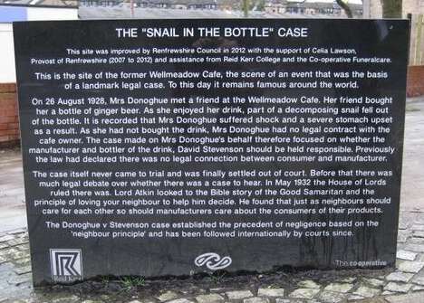
Figure 3. Memorial to Donoghue v Stevenson instituted in Paisley

Employability News and Teaching Excellence

Dr Jayne Holliday has spent a very busy semester as LLB Programme Director and LLB Adviser of Studies helping many students who were adversely affected by the delays in enrolment, a seemingly ever increasing number of students struggling with mental health issues, a significant number of students who have struggled to adapt to in-person teaching after the pandemic (notably in third year), and, thankfully, also many happy examples of students enjoying their studies, thriving academically and socially, and being excellent ambassadors for Stirling Law. In particular, she has been meeting regularly with Stirling’s student carers, child students, i.e. those not yet 18 years old, and also hosting accountability meetings for students with diagnosed/undiagnosed ADHD.

Paul and Jayne also organised three Staff/Student walks between September and December which were well attended, with everyone enjoying a hot chocolate at the end of the final walk to celebrate the end of the teaching term.

The University of Stirling has partnered with Europe’s leading Intellectual Property organisations to offer paid traineeships opportunities to our students: this is called the Pan European Seal. In December 2022, Dr. Zoi Krokida flew to Alicante to participate in the Annual Meeting of the IP Academies Network, where she made suggestions on the further development of the Pan-European Seal Programme and its benefits for Stirling students. This network consists of an impressive 109 universities coming from 37 different European countries, 27 Talent Bank Associate Partners and the 27 National IP Offices.

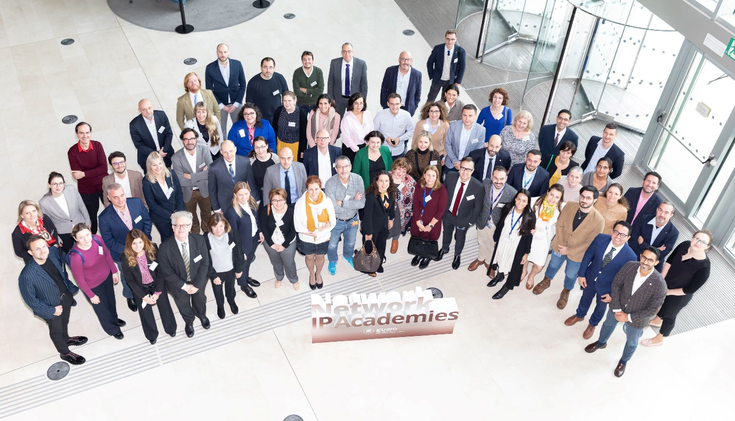
Figure 4. Dr Zoi Krokida (3rd row, 2nd from the left) with the other member of the IP Academies Network

Check out this blog post about “Language Learning: Logical or Ludicrous” by Kirstin, who is in Year 2 on the LLB but also taking French modules this semester.

Esteem and network

Professor Paul Beaumont attended his first meeting of the Society of Legal Scholars (SLS) Executive in London on 11 November 2022 as the Convener for Scotland. His role is to represent the interests of all Scottish legal academics on the SLS Executive. SLS has around 3000 members and it is the learned society for academic lawyers in the UK and Ireland.

Paul continues to serve on the Royal Society of Edinburgh’s nomination group for new Fellows of the RSE who are under 50. If anyone in any discipline under the age of 50 has achieved the excellence, over a sustained period, expected of a Fellow of the RSE and has sufficient connections with Scotland, please feel free to recommend that person to Paul for consideration.

In November Dr Savaresi joined the advisory board of the project “Global Perspectives on Corporate Climate Legal Tactics” at the British Institute of International and Comparative Law.

The Program Chairs of the leading ACM Conference on Fairness, Accountability, and Transparency (FAccT) invited Guido (previously programme committee member) to serve as Area Chair for Law. They have described it as “a powerful leadership role in shaping the intellectual substance of this year’s conference and the field more generally.” Check out FAccT 2023’s call for papers here, deadline on 30th January 2023!

Citizenship and service

In October, Guido joined the Board of Trustees of Scottish Families Affected by Alcohol and Drugs (SFAD). Winner of the GSK Impact Awards 2022, SFAD is a national charity supporting anyone concerned about someone else’s alcohol or drug use in Scotland. The charity’s four national Family Support Services are Helpline, Bereavement Support, one to one Telehealth Support and Holding On. The Local Family Support Services include one to one support and group support in Aberdeenshire, East Dunbartonshire, Forth Valley, Fife, and Inverclyde. Among the innovative and impactful services, ‘Click and Deliver Naloxone’ deserves a special mention and it rightly led to the charity winning the 2021 Scottish Charity Awards in the Pioneering Project category.

Dissemination and media presence

On the invitation of the Kathmandu University School of Law, Nepal, Pontian Okoli delivered a lecture on “Investments, Climate Change, and the Evolving Prospects of International Commercial Dispute Resolution in Developing Countries”. The lecture took place on 13 December 2022, and it explored the emerging trends in dispute resolution considering international commercial contracts that concern certain categories. These categories include contracts that are used to implement adaptation or mitigation measures; and contracts that are impacted by 1.5˚c systems transition. The participants included academics, industry professionals, international consultants, and the postgraduate community.

In October, Dr Jonathan Brown has given a presentation to the 18th Century Reading group on the subject of ‘William Forbes and the Crime/Delict of “Rape”’. The pre-2009 common law definition of the actus reus of ‘rape’ in Scotland was ‘the carnal knowledge of a female by a male person obtained by overcoming her will’. It was really quite interesting to find, therefore, that William Forbes, the first Regius chair of law at the University of Glasgow (in office between 1714-1745) defined ‘rape’ rather differently; as ‘the carnal knowledge of the body of a woman or man by force and against the person’s will… For by our law a woman may commit a rape upon a man, as well as a man may upon a woman’ (Inst., at 125).

In October, Dr Dave McArdle gave an online presentation for the Centre of Sport Law, Policy and Diplomacy at the University of Rijeka, Croatia. The Centre is part-funded by the European Commission and every autumn it hosts a summer school (!) which is funded by an Erasmus+ grant. Dave is a visiting fellow at the CSLPD, and he gives an annual guest lecture as part of that.

This year’s session covered two ECtHR judgments concerning fair hearings and sports tribunals – Mutu and Pechstein v Switzerland 40575/10 and Ali Riza v Turkey 30226/10, which arose from doping disputes and football disciplinary hearings respectively. Both cases arose from breaches of the Article 6(1) right to a fair hearing. While Mutu and Pechstein mostly concerned an alleged lack of independence and impartiality on the part of arbitrators at the hearing de novo stage, Ali Riza focussed predominantly on the independence and impartiality of domestic tribunal members in the first hearing. The lecture addressed the legal significance of the difference between mandatory and compulsory arbitration for Article 6 purposes, discussed the key features of the cases and highlighted the trend towards public hearings in doping cases especially. A more detailed paper, to be presented at the Sport and Recreation Lawyers’ Annual conference in February, will make recommendations about tribunal impartiality and Article 6 compatibility for national and international governing bodies – recommendations which none of those bodies will follow because it’s so much easier for them to keep doing what they’ve always done.

In November 2022, Dr Zoi Krokida was invited to talk at a webinar hosted by the Association of Learning Technology (ALT). Her talk was about the impact of online intermediaries’ adoption of filters on the rights of users.



On 28 October 2022 Associate Professor Annalisa Savaresi was an instructor at the capacity building session, "Human Rights-Based Approaches to Climate Change Adaptation and Mitigation Challenges" organised by the Climate Action and Human Rights Institute, Philippines and sponsored by the Asia-Europe Foundation.

On 28 November – 2 December, Annalisa was an instructor at the PhD school ‘International and public Law, Ethics & Economics for Sustainability’ organised by the LEES International PhD program, University of Milan.

Associate Professor Guido Noto La Diega was invited to contribute to Microsoft-funded workshops on cloud, telecoms, algorithmic fairness, data location, and IoT at the Microsoft Cloud Computing Research Centre – Offsite Retreat, 3-4 October 2022, Cumberland Lodge, Windsor.

Additionally, Guido presented (virtually) ‘Data Access Vs Intellectual Property in the Regulation of the Metaverse’ at UA Metaverse – technologies of the future, social solutions, ecosystems, virtual business, digital law and much more, organised by Association “Metavsevit Ukraine”, Kyiv, Wednesday 7th December 2022. You can watch the entire conference by clicking on the still below (Guido’s presentation starts at 1:30:14).



Finally, Guido joined a panel about distance learning and copyright (‘L’insegnamento a distanza: l’accademia italiana può essere competitiva?), as part of a webinar series about the implementation of the new EU Copyright Directive, organised by the Italian branch of the Association littéraire et artistique internationale (ALAI), the globally leading organisation defending the interests of authors, artists, and publishers, founded by Victor Hugo. Other panellists included Professor Fabiola Massa (Tor Vergata), the publisher Lucio San Marco (Giappichelli), and Dr Giulia Schneider (Cattolica).

Internationalisation

In November 2022, Dr Annalisa Savaresi taught the course ‘International Environmental Law’ as part of an executive Masters programme international law organised by the Law School of La Sabana University, Colombia, which targets diplomatic personnel working across Latin America.

On 12th December, Dr Savaresi participated in the kick off meeting of the Environment and Human Rights Workstream of the project “Making Prevention a Reality: A Framework Approach” at New York University (NYU) – https://chrgj.org/all-projects/prevention-project/

Associate Professor Guido Noto La Diega has been appointed as a Martin-Flynn Global Law Professor in the School of Law at the University of Connecticut for a three-year term (“gratis” appointment). The Martin-Flynn Global Law Professor Program is designed to attract outstanding visiting faculty with the aim of building international collaborations and connections in an intellectual community. Guido will be visiting UConn for two weeks in May 2023. While at UConn, considered a ‘Public Ivy’ and consistently ranked in the top 25 public research universities, Guido will carry out research at the intersection of Intellectual property and social justice, and will give lectures and research seminars, as well as exploring ways to strengthen the international links between Stirling and UConn. The offer came from Professor Willajeanne McLean who visited the Law & Philosophy Division at Stirling last year as IAS Fellow thanks to support by Professor Neville Wylie and Professor Iain Docherty.

Thanks to funding from the Ministerio de Ciencia e Innovación (granted to a team of commercial and employment lawyers at the Universidade de Vigo), Guido flew to Galicia to present ‘Capturing the Uncapturable: The Relationship between Universities and Copyright through the Lens of the Audio-Visual Lecture Capture Policies’ (preprint here) at the 6th Conference on Competition and Intellectual Property Law (programme here), hosted by the Facultade de Ciencias Xurídicas e do Traballo. The conference was fruitful also as it laid the foundations for a future collaborative project on NFTs and copyright.

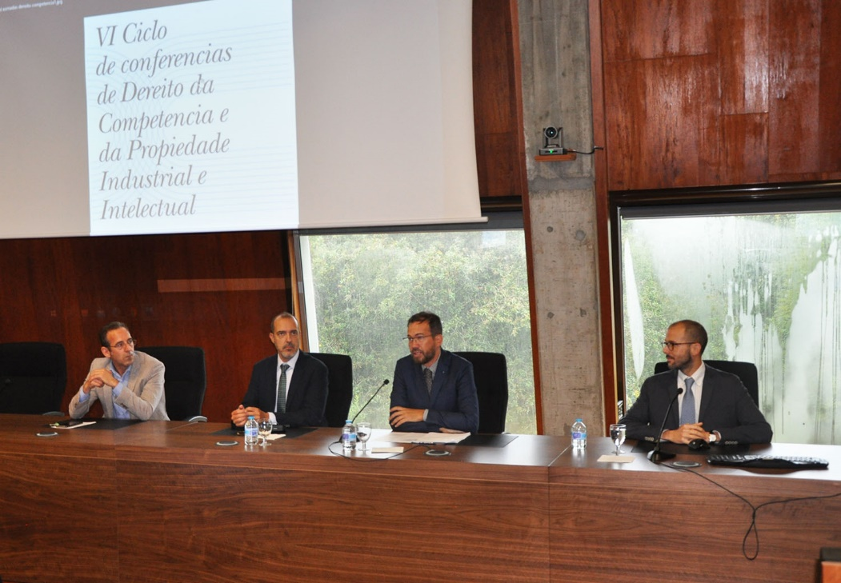
Figure 5. From left to right: the Dean of the Faculty, Professor Francisco José Torres Pérez; Professor Rafael Sánchez Aristi (Catedrático de Derecho civil, Universidad Rey Juan Carlos); the host, Professor Pablo Ignacio Fernández Carballo-Calero; and our Guido

In reporting on the event, the Diario da Universidade de Vigo wrote that three ‘professionals of recognised prestige’ [the third being Professor Rocío Quintáns Eiras, Catedrática de Derecho Mercantil, Universidade da Coruña] addressed a packed lecture theatre and delved deep into ‘the most relevant and up-to-date issues that affect’ antitrust and Intellectual Property Law. Guido reports that it was nice for once to have the shortest and simplest-to-pronounce family name in the room.

Events organised

Since the last Trumpet, the RSE-funded Scottish Law and Innovation Network (SCOTLIN) has organised three virtual (en)lightening talks (led by Dr Clubbs Coldron with Arletta Gorecka) about:

‘Bureaucratic Capacities and Responsible Uses of AI: A Challenge for Local Governments?’ (speaker Rodrigo Brandão, University of São Paulo; discussant Aline Iramina, University of Glasgow and SCOTLIN)

‘Decolonising copyright’ (speaker Jade Kouletakis, Abertay University & SCOTLIN steering committee; discussant Professor Dalindyebo Shabalala, University of Dayton)



‘Clashing Forms of Regulation and Rights’ (speaker Professor Abbe Brown, University of Aberdeen & SCOTLIN co-founder; discussant Professor Caroline Ncube, University of Cape Town)

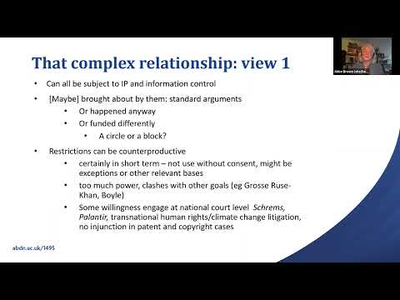

Get in touch

If you would like to contribute or suggest anything for future bulletins, please get in touch with Guido.

