
Stirling Law School’s Bulletin 2/2022
This bimonthly bulletin is for sharing Stirling Law School’s achievements in research, teaching, and engagement. In these difficult times, it’s crucial to celebrate, strengthen our sense of community, and create opportunities for cross-Faculty and cross-University collaborations. We hope you’ll enjoy this wee snippet (this time not so wee, also due to an increase in pictures) of Stirling Law School’s recent successes.
Contents

Highlight of this issue 1
Impact and engagement 2
Funded research 3
Publications 4
Journal articles 4
Chapters 5
Encyclopaedia entries 5
Editorials 6
Blog posts and series 6
Employability News and Teaching Excellence 6
Esteem, network, and citizenship 8
Dissemination and media presence 9
Internationalisation 12
Events organised 13
Upcoming events 16
Moving up 17
New appointments 17
Get in touch 18

Highlight of this issue

We are proud to contribute to the University’s excellent REF outcome. We are delighted that the latest iteration of the REF confirmed that we keep improving overall and making the difference. We are the only Law School in Scotland whose entire research impact submission is ranked as outstanding or signifying very considerable impact. We are particularly happy to report that our impact case studies related to the research carried out by two amazing women, namely Professor Katie Boyle and Dr Annalisa Savaresi. We did very well thanks to all our current staff (professional services and academic) and the staff who have retired or left during the REF cycle who made a significant contribution to Stirling Law's REF success. We owe Dr Ben Fanstone (Research Development Officer)) a huge thank you as he coordinated the evidence and guided the drafting of the impact case studies. While this was a choral exercise, we wish to particularly acknowledge the hard and invaluable work put into it by Tikus Little, Dr Dave McArdle, Professor Gavin McLeod Little, Professor Paul Beaumont, Professor Katie Boyle, and Dr Annalisa Savaresi. Thank you! Professor Beaumont (Head of Law) set out the intention to create in the next few years an even stronger research environment in Law in which research can flourish and continue to produce very high-quality publications that have significance, originality, and rigour, as well as making a significant difference in the world through the impact that our publications have.

Impact and engagement

Professor Katie Boyle’s evidence to the Ad Hoc Committee on a Bill of Rights for Northern Ireland was cited extensively by the Committee in their final report.

Between 16-18 March 2022 Dr Annalisa Savaresi acted as lead rapporteur at the 21st ASEM Seminar on Human Rights and Climate Change, hosted by the Ministry of Foreign and European Affairs of the Grand Duchy of Luxembourg. The seminar was attended by governmental representatives, scholars and civil society from Asia and Europe and invited speakers included UN Special Dr David R. Boyd, United Nations Special Rapporteur on Human Rights and the Environment and Michelle Bachelet, United Nations High Commissioner for Human Rights.

On earth day, Amnesty International launched its first free MOOC on human rights and climate change. The contents of the course were written by Dr Savaresi, working in partnership with Amnesty’s team

IPCC report cites Dr Savaresi’s work on climate change litigation, the report recognizes that litigation is on the rise and that it influences the outcome and ambition of climate governance. In doing so, the report draws on research by Dr Savaresi, analysing the specific role of human rights arguments and remedies in climate litigation (Savaresi and Auz 2019; Savaresi and Setzer 2022)

On the Paris Agreement, the report includes the IPCC’s first evaluation of the Paris Agreement. In doing so, the report draws on analyses by Dr Savaresi on the ‘hybrid’ nature of the Agreement’s governance arrangements (Savaresi, 2016) and on the interplay between climate change and human rights law (Savaresi, 2018 and Duyck, Savaresi et al. 2018).

Guido Noto la Diega gave oral and written evidence to the UK Intellectual Property Office in the context of their call for views “Standard Essential Patents and Innovation”. The written submission, available here, sheds light on some issues related to the Standard Essential Patents (SEP) ecosystem and to provide workable solutions. SEPs are patents that protects technologies that are essential to implementing a standard (e.g. 5G, Bluetooth, etc.). Between December 2021 and March 2022, the UK Government sought views as to whether the Standard Essential Patents (SEPs) framework is functioning efficiently and strikes the right balance for all entities involved. This exercise was part of the "UK Innovation Strategy: leading the future by creating it", which set out the government’s long-term plan for delivering innovation-led growth. The call for views and this submission focus on issues of (i) competition and market functioning, (2) transparency; (3) frameworks.

Professor Paul Beaumont is pleased to report a successful end to his six-year role as Chair of the Experts' Group on Family Agreements Involving Children at the international organisation charged with the progressive unification of private international law - the Hague Conference on Private International Law (HCCH). The HCCH, which has a membership of 90 States and the EU, adopted by consensus a new type of soft law instrument - a 'Practitioners' Tool' - at its Council of General Affairs and Policy (CGAP) meeting in March 2022. The relevant part of CGAP's Conclusions and Decisions says:

'CGAP approved the Practitioners’ Tool: Cross-Border Recognition and Enforcement of Agreements Reached in the Course of Family Matters Involving Children, subject to editorial amendments, for publication. With the conclusion of the Experts’ Group’s work, CGAP expressed its gratitude to the Chair, Professor Paul Beaumont' (see here for details).

Professor Beaumont was a member of the EU delegation at the first meeting of the HCCH Jurisdiction Working Group in February 2022.

Funded research
Professor Boyle has led the successful conclusion of a 3 year Nuffield Foundation funded project on Access to Justice for Social Rights: Addressing the Accountability Gap including the publication of the following outputs:

Open Access Main Report: Katie Boyle, Diana Camps, Kirstie English & Jo Ferrie, The Practitioner Perspective on Access to Justice for Social Rights: Addressing the Accountability Gap (Nuffield Foundation 2022)

A set of four briefing papers on the UK’s legal obligations relating to social rights (taken together or as stand-alone papers)
1. Economic, Social and Cultural Rights: International Legal Obligations - An Explainer – Katie Boyle & Aidan Flegg
2. The Right to Social Security in the UK – An Explainer - Katie Boyle & Aidan Flegg
3. The Right to Adequate Housing in the UK – An Explainer - Katie Boyle & Aidan Flegg
4. The Right to Food in the UK – An Explainer - Katie Boyle & Aidan Flegg

Additional briefing papers
· The access to justice journey – Katie Boyle
· The UK’s unmet legal needs: a comparative study of legal aid and the social rights gap – Aidan Flegg & Katie Boyle
· Effective remedies & structural orders for social rights violations – Gaurav Mukherjee
· Thematic analysis on access to justice for social rights: An Explainer – Kirstie English
· An interdisciplinary research approach: A legal and discursive analysis of social rights policy in the UK – Diana Camps

Publications

Journal articles

Annalisa Savaresi and Joana Setzer, ‘Rights-Based Litigation in the Climate Emergency: Mapping the Landscape and New Knowledge Frontiers’ (2022) 13 Journal of Human Rights and the Environment 7.

This article revisits and expands on extant scholarly inquiries into the so-called ‘rights turn’ in climate litigation, with the objective of providing a more comprehensive appreciation of the role of human rights litigation in the context of the climate emergency. We rely on well-established categories used in the literature on climate litigation and on human rights and the environment to provide the first systematic analysis of rights-based litigation that aligns with climate objectives. Building on this basis, we consider the significant data and knowledge gaps concerning human rights litigation that does not align with climate objectives. We flag the need to better understand the role of rights-based litigation in the context of the complex societal changes associated with a just transition towards net zero emissions. The article contributes to scholarly inquiry into this new and increasingly prominent area at the intersection ofhuman rights and environmental law, highlighting knowledge gaps that deserve further investigation, both from an academic and from a policy and practice perspective.

Dr Pontian Okoli authored a paper “Corruption in International Commercial Arbitration – Domino Effect in the Energy Industry, Developing Countries, and Impact of English Public Policy” in (2022) 15(2) The Journal of World Energy Law and Business 136.

A major argument is that English courts should strike a balance between the interests of institutions, governments and people when they deal with difficult cases that concern public policy. This is especially so with respect to allegations of corruption when parties seek to enforce foreign obligations emanating from developing countries.

Many congratulations to Neil Brannigan who graduated with an LLB Honours degree in 2021. His Honours dissertation was outstanding and he revised it for publication. It is now published in the April issue of the Journal of Private International Law having got through the double-blind refereeing process successfully. His article is, "Resolving conflicts: establishing forum non conveniens in a new Hague jurisdiction convention" (2022) 18(1) Journal of Private International Law 83-112. It has a real chance of making an impact as it is directed at the Working Group on Jurisdiction at the HCCH (see above) which has begun the work of drafting a possible global treaty on conflicts of jurisdiction.

Chapters

Katie Boyle and Diana Camps ‘A Social Rights Perspective on Social Welfare Law, Policy & Practice’, in Michael Adler (ed), A Research Agenda for Social Welfare, Law, Policy & Practice, (Edward Elgar 2022)

This chapter seeks to outline a future research agenda for social rights that (a) reclaims social rights as legal rights and (b) exposes the structural flaws that undermine the recognition of social rights as legal rights. We draw upon recent insights and interdisciplinary methods that have significant potential when applied to social welfare law, policy and practice across the UK. We argue that to build a future research agenda for social welfare law using a human rights lens requires a two-stage approach. First, we contend that research must address the systemic and structural inadequacy of the legal recognition of social rights as legal rights and continue to propose solutions to close this gap. Second, we suggest that adopting a critical interdisciplinary lens helps make visible how underlying systemic and structural issues have led to exclusionary practices in the enjoyment of social rights.

The UNDROP and Climate Change: Squaring the Circle?’ in (Eds) Alabrese, M. Bessa, A. and M. Brunori The UN Declaration on Peasants' Rights (Edward Elgar, 2022) [ with M. Alabrese]

This is the first book to address and review the United Nations' Declaration on the Rights of Peasants and Other People Working in Rural Areas (UNDROP), which was adopted by the United Nations General Assembly in December 2018.

Encyclopaedia entries

‘Computer programs’, in Giovanni Comandé (eds), Encyclopedia of Law and Data Science (Edward Elgar 2022) 70
‘Software’, in Giovanni Comandé (eds), Encyclopedia of Law and Data Science (Edward Elgar 2022) 326

This Encyclopaedia brings together jurists, computer scientists, and data analysts to map the emerging field of data science and law for the first time, uncovering the challenges, opportunities, and fault lines that arise as these groups are increasingly thrown together by expanding attempts to regulate and adapt to a data-driven world. It explains the concepts and tools at the crossroads of the many disciplines involved in data science and law, bridging scientific and applied domains.
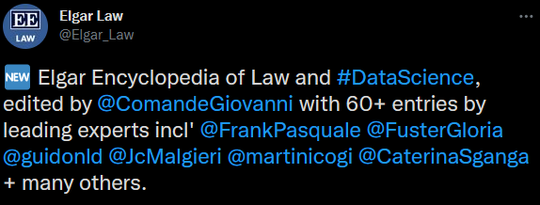

Editorials

Annalisa Savaresi, Mariagrazia Alabrese and Joanne Scott, ‘Editorial: Climate Change Litigation and Human Rights: Stocktaking and a Look at the Future’ (2022) 13 Journal of Human Rights and the Environment 1.

This editorial introduces a special collection of articles on the role of human rights law in climate litigation. The collection draws on selected papers presented at the ground-breaking workshop ‘Implementing the Paris Agreement: Comparative Lessons from the Global Human Rights Regime’, which took place on 6–7 May 2021 at Sant’Anna School of Advanced Studies, Pisa, Italy. The workshop brought together scholars and legal practitioners in order to share insights and explore the future potential of human-rights-based climate litigation. The idea behind both the workshop and this collection of articles is to take stock of recent developments in climate change litigation.

Blog posts and series

In March-April 2022, Dr Savaresi edited a blog post series on Rights-based Climate Change Litigation for the Global Network for Human Rights and the Environment. The posts in the series can be found here.

Annalisa has published the following blog posts:

- (with Joana Setzer), ‘A First Global Mapping of Rights-Based Climate Litigation Reveals a Need to Explore Just Transition Cases in More Depth’ (Grantham Research Institute on climate change and the environment)
- ‘The Role of Human Rights in Climate Litigation: A Global Review’ (CCEEL, 24 March 2022)
- (with Margaretha Wewerinke Singh) ‘Historic inquiry holds the Carbon Majors accountable for the impacts of climate change in the Philippines’ (GNHRE)

Employability News and Teaching Excellence

The quinquennial teaching and learning review of the Stirling Law School in March 2022 had a very positive outcome. Our LLB Programmes will be reaccredited for another 5 years by the Law Society of Scotland. The Teaching and Learning Review Panel were very complimentary about Law's undergraduate and postgraduate taught programmes and about the vision for the development of our research postgraduates.

As part of the Law Work Placement module this semester 18 students from BA & LLB Law programmes spent time on work placement in a variety of legal settings. The feedback has been amazing and there have been some very positive outcomes:
- Anderson & Strathern – Student Zainab Bello has secured a 12- month fixed term contract in Risk and Compliance ahead of deciding her future plans.
- CAB – Denny – Student Rebecca Wallace will continue her volunteering role there
- EY Cyprus – Student Rosemary Tawonezvi participated in a very successful international remote placement
- Players Football Association Scotland – two students, Aiden Kelly and Lewis Wilson received highly positive feedback for their performance on placement. This was a new placement for the module, and we were delighted with the highly positive outcome.
- Scottish Power – Student Ian Sargison returns to the legal team at Scottish Power for a second summer, following a successful placement with the via the module last academic year.
Well done to all our students who represented the University and the School of Law so well while out on placement this semester!

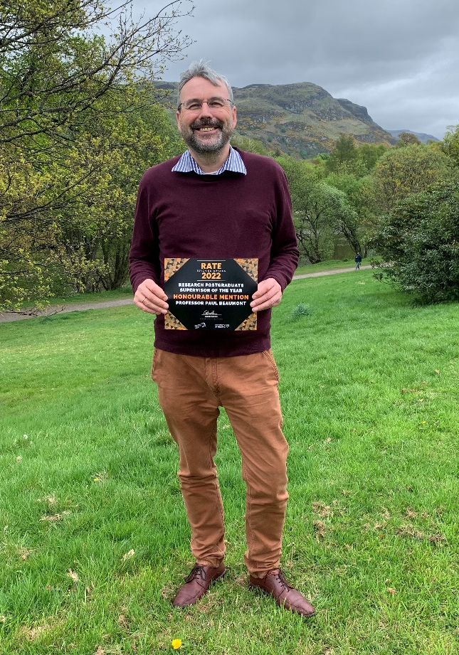
Chuffed to see so many colleagues having their commitment to teaching and supporting students recognised at the RATE Awards 2022! Shout out to our alum Pauline Darnbrough for winning the Outstanding Support Award and for her honourable mention in the Dedication to EDI category. Honourable Mentions to current colleagues were given to our Professor Alison Green for Outstanding Contribution to Academic Education, Professor Paul Beaumont for Best PGR Supervisor and. Law School staff received many nominations in the following categories: Best Tutor Award (Dr Carole Dalgleish, Arletta Gorecka); Excellence in Teaching in the Faculty of Arts & Humanities (Dr Pontian Okoli, Carole, Arletta); Research Postgraduate Supervisor of the Year (Pontian); Excellence in teaching in Stirling Management School (Carole).

A/Prof Guido Noto La Diega joined a stellar lineup of colleagues and students – Dr John I’Anson (Faculty of Social Sciences), Allyson MacKay (Student Union VP for Communities), and Jennifer Cowell (academic skills advisor) – to discuss what ‘decolonising the curriculum’ looks like in practice. This was an online event organised by the Faculty of Social Sciences’ Equality Diversity and Inclusion Committee and led by Dr Liz Forbat.

Esteem, network, and citizenship

It was great to see that Law staff was recognised at the Research Culture Awards 2022, that are designed to recognise the work that colleagues do in supporting the University Research Culture and are masterfully organised by Professor Rachel Norman. Professor Katie Boyle and A/Prof Guido Noto La Diega have been nominated for two categories: Outstanding Leadership and Mentoring. Professor Hong-Lin Yu has also been nominated in the Outstanding Mentor category. In the Outstanding Early Career Researcher category we are delighted to see our new colleague Dr Zoi Krokida. As we write the ceremony has not taken place so we do not know who the ‘specially commended’ colleagues will be.

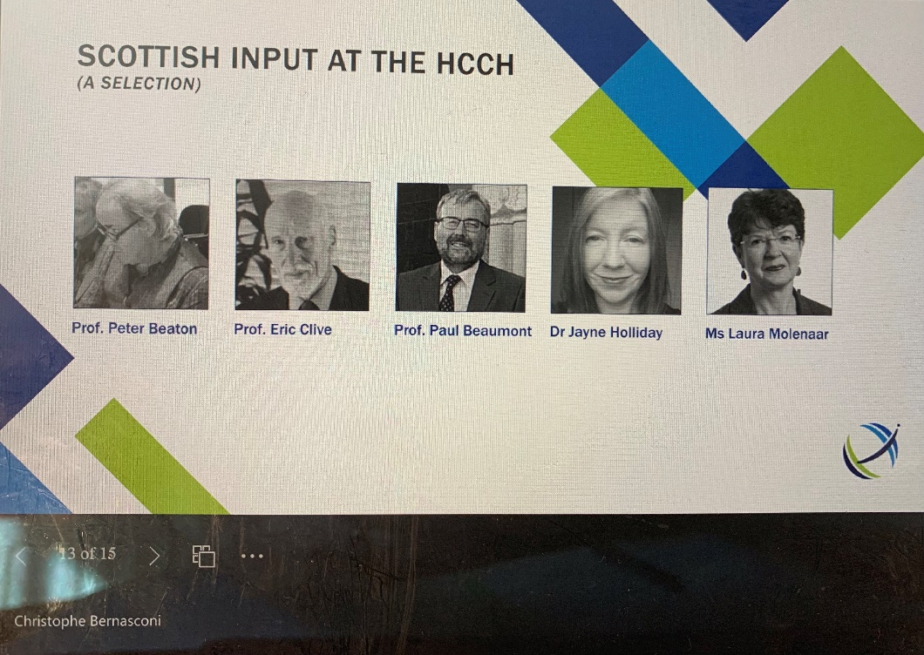
Professor Paul Beaumont and Dr Jayne Holliday were touched to be mentioned by the Secretary General of the Hague Conference on Private International Law (HCCH), Dr Christophe Bernasconi, in his slide 'Scottish Input at the HCCH' in the recent Scottish Private International Law Reference Group meeting. Paul has provided his expertise at the HCCH for the past 26 years initially on behalf of the UK and Scotland, and latterly on behalf of the European Union. Jayne would like to thank the HCCH for their contribution to and support of Beaumont and Holliday (eds) A Guide to Global Private International Law (Hart, 2022).

Guido and Dr Dave McArdle has been invited to join the mentorship scheme for Ukrainian academics set up by Dr Anna K. Bobak (Faculty of Natural Sciences) on behalf of Science for Ukraine UK.

Dissemination and media presence

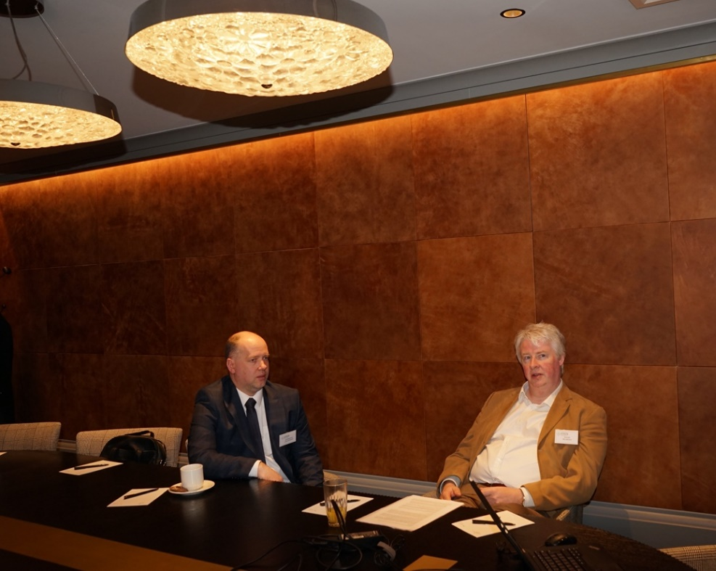

In April, Dr David McArdle presented a paper on direct nationality discrimination in the wake of the CJEU judgment in Topfit v DLV at the ‘Emerging Trends in Economics, Culture and Humanities’ Conference hosted by EKA University, Riga. Topfit concerned nationality restrictions placed on a recreational sports participant who wished to compete in events organised in the host country. Its significance lay in the CJEU’s departing from the Advocate General’s Opinion to hold that direct nationality discrimination, which on its face precluded such restrictions, was relevant even though the applicant was not engaged in economic activity, and that any restrictions on the right to compete had to be both necessary and proportionate to a legitimate aim. While issues of necessity and proportionality were ultimately matters for the referring court, the case illustrates how the EU’s developing sports policy, as now articulated in Art 165 TFEU, has a relevance beyond professional or elite amateur participation.

EKA Riga is a Stirling University institutional staff exchange partner under the Erasmus scheme. Dave’s participation was the first of several proposed grant applications, teaching and other engagements with colleagues there and, through their networks, with the other Baltic states. A shortened version of his paper is forthcoming in the Elgar Concise Encyclopaedia in Sports Law, to be published in late 2022.

In May, Dave presented a paper on football transfer disputes and labour rights within Chinese clubs at an online Comparative Workshop on International Sports Law hosted by the China University of Politics and Law in Beijing. This paper, which is very much a work-in-progress, explores how the global regimes dealing with athletes’ free movement rights – which are themselves a consequence of EU free movement law - have led to overseas players in China having far greater workplace protections than those enjoyed by domestic players at the same clubs, whose precarious position is more akin to that of South American players in the 1950s. He argues that those different protections, along with the widespread wage disparities and the corruption which is rife within China’s biggest clubs, facilitates illegal gambling, matchfixing among players and officials, and money laundering on a global level. This makes a mockery of China’s ambitions to use international success in men’s football as a source of both soft power and a much-needed income stream.

Dr Pontian Okoli delivered a presentation on the “Conditions for the Enforcement of Foreign Judgments” in the EU. This was at the JUDGTRUST Conference on EU Judgments and Mutual Trust (21-22 April 2022) which took place at the T.M.C. Asser Instituut in The Hague.

Professor Paul Beaumont and Dr Jayne Holliday spoke at the Festival of Private International Law at the University of Edinburgh on Monday 16th May to bring the private international law community in Scotland up to date with the private international law activities at the University of Stirling.

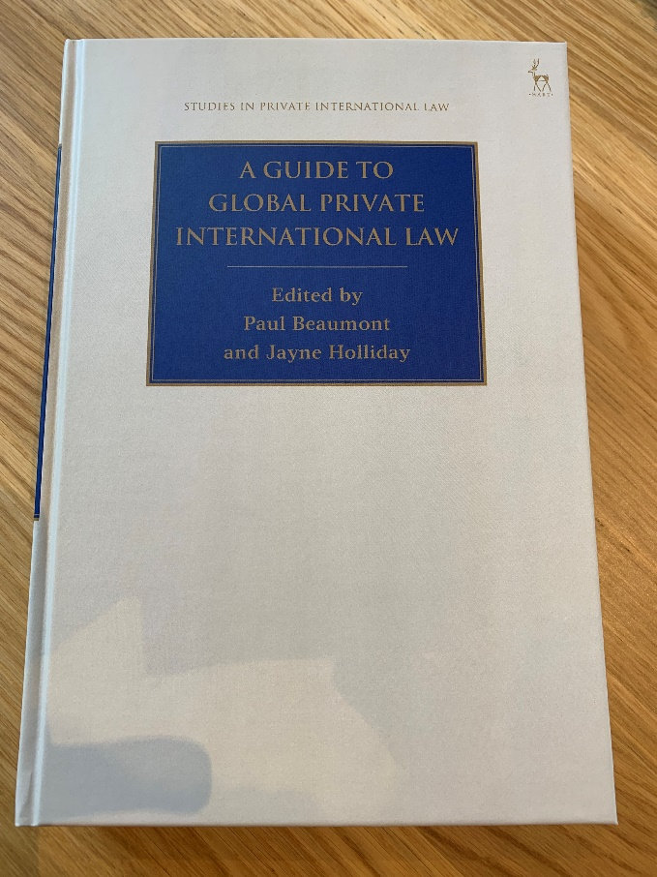
In addition, Paul and Jayne were delighted to hold the book launch of their co-edited book P Beaumont and J Holliday (eds), 'A Guide to Global Private International Law' (Hart, 2022) at the Festival of Private International Law on Tuesday 17th May. Paul and Jayne co-authored 2 chapters of the book with each other (the introductory and concluding chapters), Jayne co-authored another 3 chapters on Divorce, Child Abduction and Succession, and Paul co-authored another 6 chapters on the HCCH, Pragmatism, Choice of Court Agreements, Recognition and Enforcement of Judgments, Family Agreements, and Maintenance.

"This book provides a substantial overview of the discipline of private international law viewed from a global perspective.

The guide is divided into 4 key sections. Theory, Institutional and Conceptual Framework Issues, Civil and Commercial Law (apart from Family Law) and Family Law.

Each chapter is written by a leading expert(s). The chapters address specific areas/aspects of private international law and consider the existing global solutions and the possibilities of improving/creating them. Where appropriate, the chapters are co-authored by experts from different legal perspectives in order to achieve as balanced a picture as possible.

The range of contributions includes authors from Europe, North America, Latin America, Africa, Asia and Oceania. An essential resource for academics, practitioners and students alike." See here for more information.

The Pericles Law Centre in Russia invited Arletta Gorecka to speak about competition law and privacy in their module on privacy law. She discussed the latest developments on the intersection between competition law and privacy and she spoke about the theoretical angle of their relationship.
On 29 April, Dr Savaresi addressed the International Law Association British Branch Spring Conference 2022 ‘International law and climate change’, talking about her work on the right to a healthy environment in climate litigation. More information about the meeting and registration here.
On 19 May Dr Savaresi presented her work on corporate accountability in the context of the ‘Corporate Responsibility and Liability in relation to Climate Change conference’, to be held at Utrecht University.

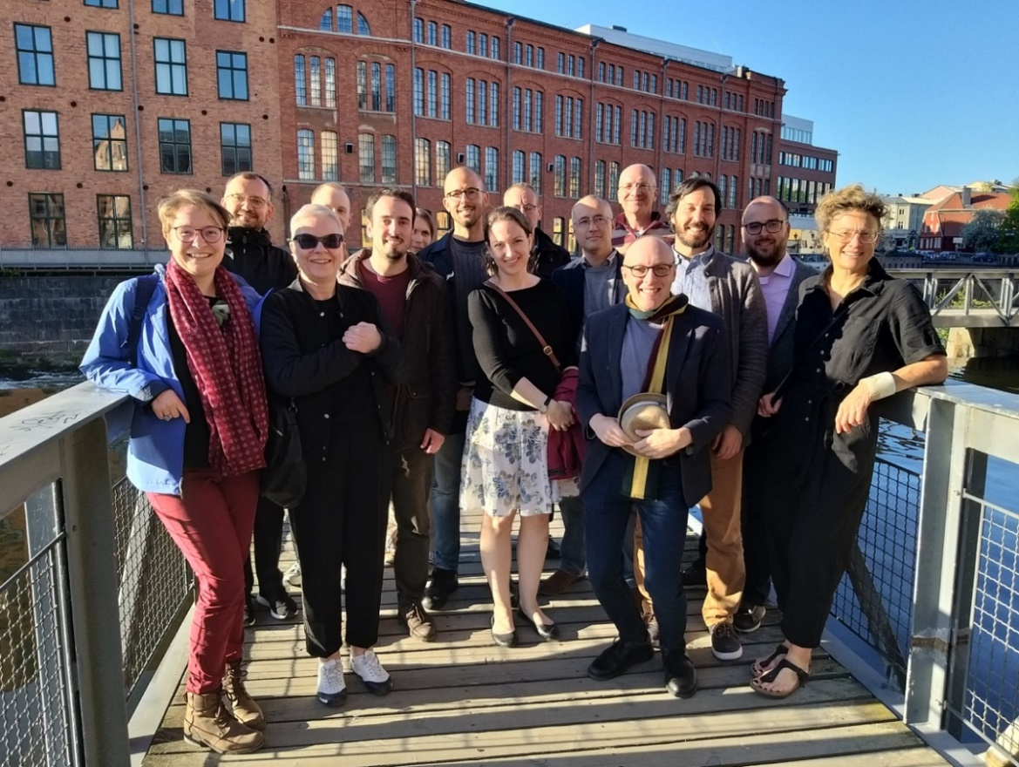
In May, Guido Noto La Diega attended the ERC-funded multidisciplinary workshop “Patents in the service of war and peace”, conclusive event of the 5-year €2.5M project "Patents as Scientific Information, 1895-2020” (PASSIM), led by Professor Eva Hemmungs Wirtén (Linköping University, Sweden). Guido was one of the invited discussants and provided detailed feedback about the papers presented by both early career and experience colleagues.

In other esteem-related news, Guido was invited to join the Program Committee of IEEE Computational Intelligence in Bioinformatics and Computational Biology Conference (CIBCB 2022).

Internationalisation

Zoi Krokida has been appointed International Research Fellow 2022-2023 at the Information Society Law Center at the University of Milan, which is a multidisciplinary research center with a focus on Digital Transformation Law.

In April and May, Annalisa Savaresi will visit the University of Bologna, Italy, where she will convene classes on international environmental law, in the context of the Global MBA in Green Energy and Sustainable Businesses. She will furthermore contribute to the event “Interdisciplinary Perspectives on Climate Change” co-organised with the Department of Legal Studies, University of Bologna.

Guido Noto La Diega has concluded a two-year visiting professorship in European and Comparative Innovation Law at the Università di Macerata, one of the oldest universities in the world. At Macerata, Guido conducted research about commons in the Internet of Things (to be published in a top Italian peer-reviewed journal) and big data sustainability (to be published in open access in a major book). Connected to this visiting professorship, Guido has been invited to join the Advisory Board of the new open access journal Rassegna di diritto della moda e delle arti (specialised in the law of fashion and the arts) and is working on an international research project with Professor Ermanno Calzolaio and Professor Laura Vagni about AI and microenterprises in China.

Events organised

Professor Katie Boyle, Dr Domenico Carolei, Dr Damian Etone and Aidan Flegg contributed to the organisation of three seminal workshops during Katie’s appointment as Co-Coordinator of the Economic and Social Rights Academic Network for the UK and Ireland (2021-2022). The workshops were co-hosted with the Irish Centre for Human Rights at NUI Galway, UCD Equalities Study Centre at University College Dublin, and the Bonavero Institute of Human Rights at the University of Oxford.

In April 2022, the University has hosted the 1st Annual Conference of the Scottish Law and Innovation Network (SCOTLIN), funded by the Royal Society of Edinburgh (RSE). Organised by a team bringing together most Scottish universities and led by Guido Noto La Diega, the theme of this (mostly) in-person conference was Sustainable Innovation, Law, and Policy in a Post-COVID World.
The videos of the presentation are available on YouTube (check out the full programme here), these include:
- The first-even presentation in person by our (and Strathclyde’s) Arletta Gorecka, who talked about ‘EU Competition Law and Privacy: the new theory or the old problem?’
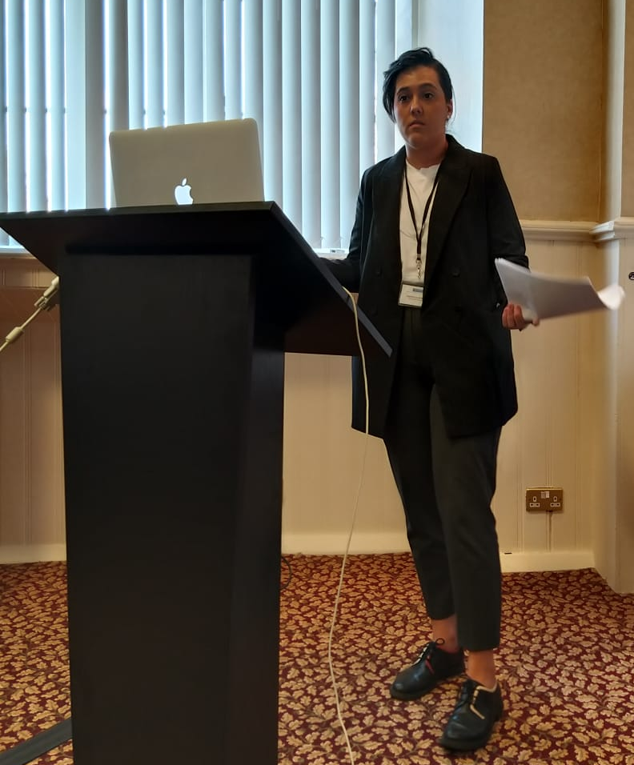

- Dr Mo Egan’s ‘Future-proofing Justice Through Automatic Online Convictions’
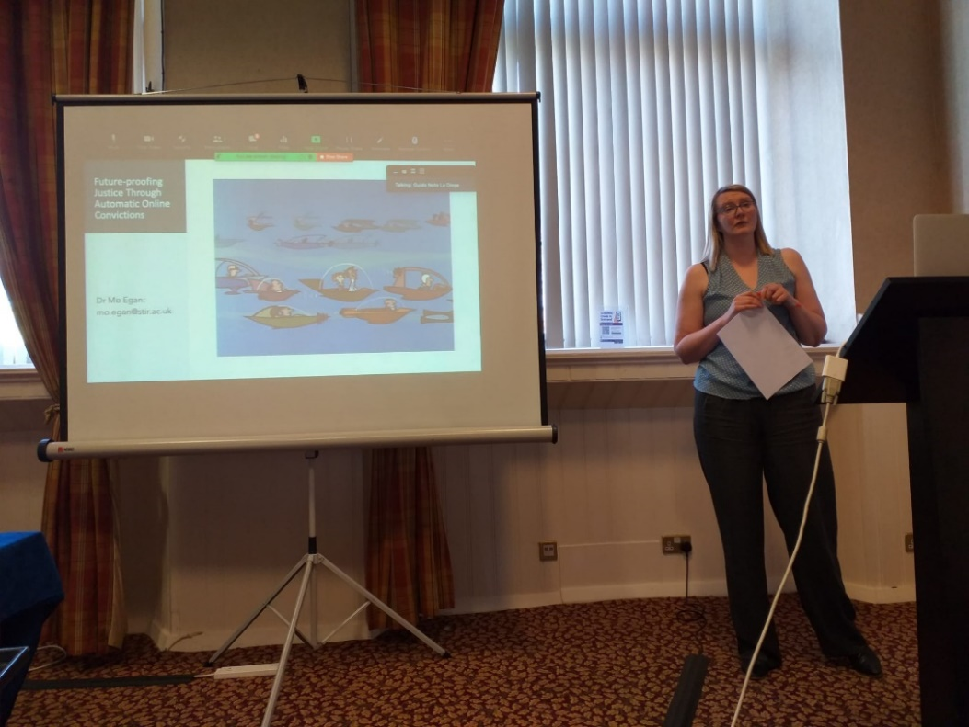

- Professor William Webster (Stirling Management School), ‘Is all data the same? The ramifications of big data practices in public services’
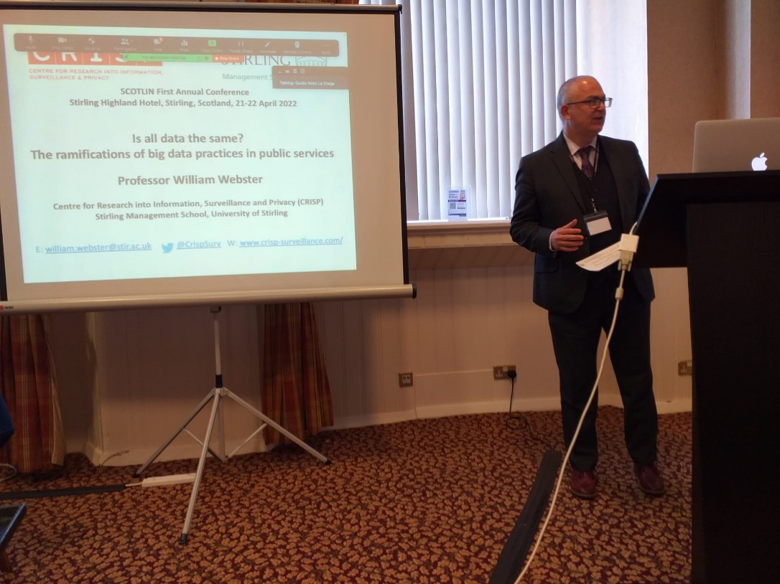

- Dr Benjamin Clubbs Coldron, ‘Smart Regulation for the Internet of Things: the Vulnerable Consumer’
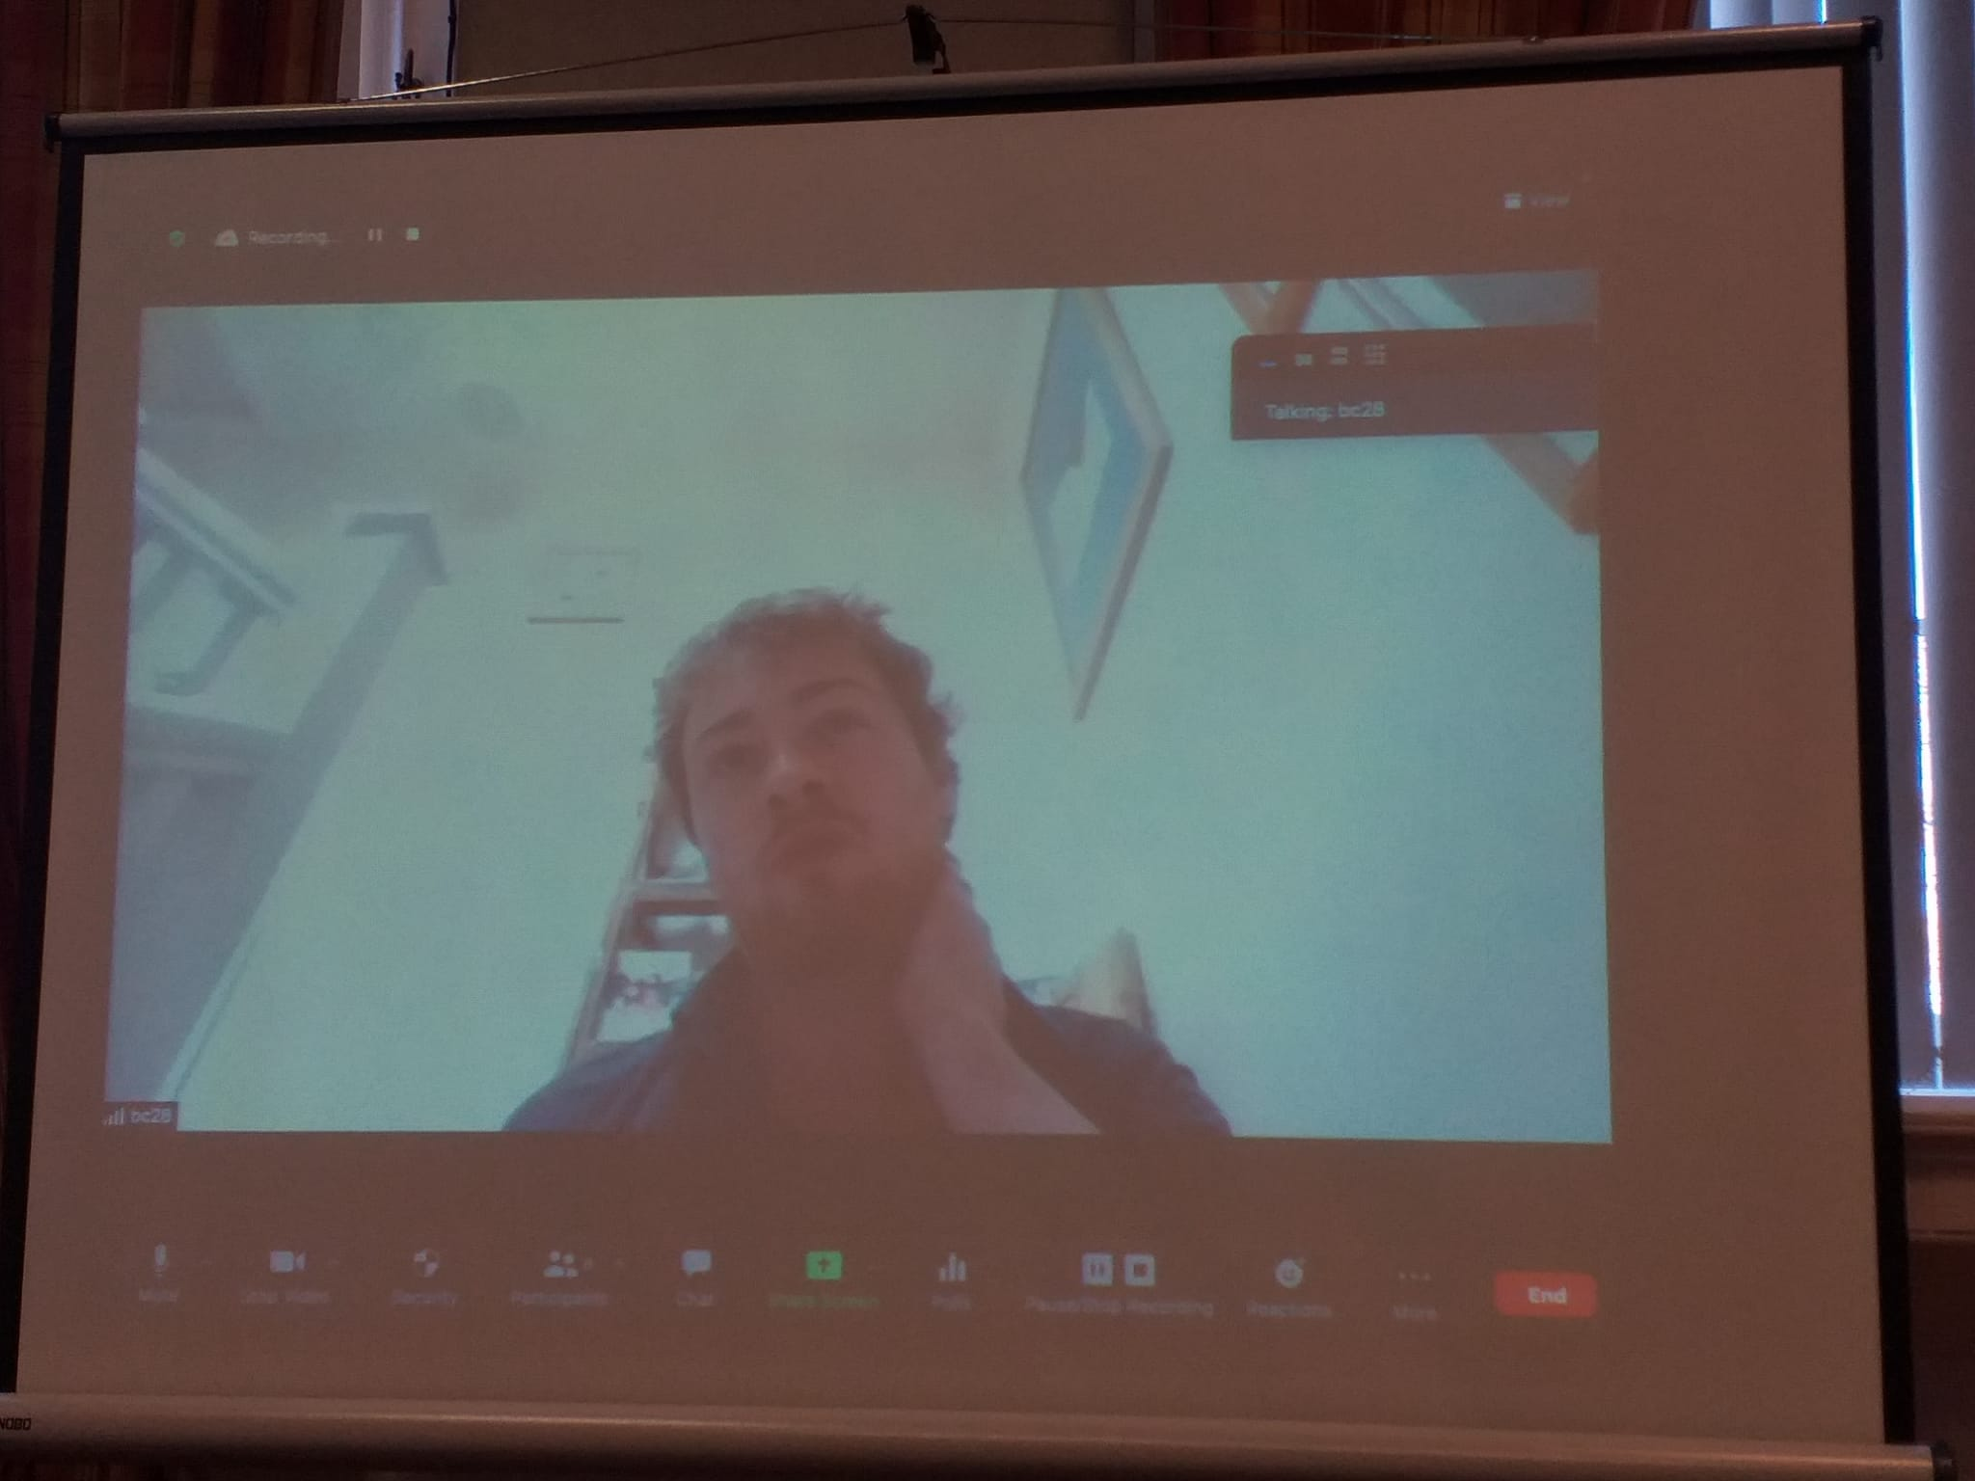

- Last and certainly least, Guido’s ‘Data Sustainability. How Do We Open Up Data in the Fourth Industrial Revolution?’*
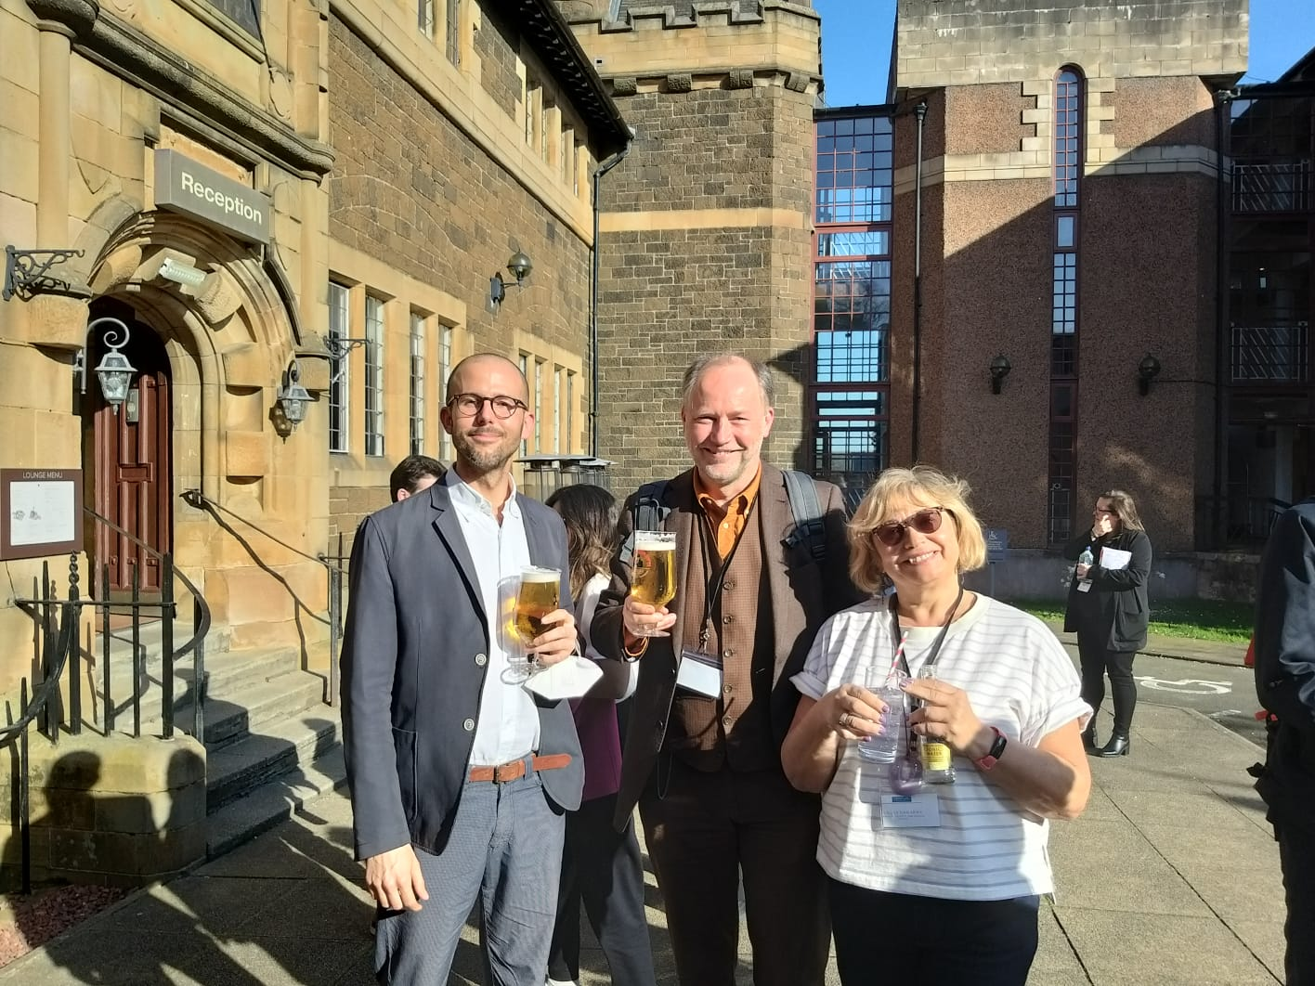

*photo taken (not during but) after the presentation, here with Professor Lilian Edwards (Newcastle University, Fellow of the Ada Lovelace Institute) and Professor Martin Kretschmer (University of Glasgow, Co-Director of CREATe)

Upcoming events

Professor Paul Beaumont is one of the key organisers of, and chair of one of the sessions at, the Conflicts of Jurisdiction Conference on 23-24 June 2022, a major international online conference co-sponsored by the Journal of Private International Law, the HCCH and the Singapore Management University. This conference is designed to bring leading academics and policy makers at the HCCH together to help the HCCH Working Group prepare a new treaty on Conflicts of Jurisdiction. The programme is available here.

After the success of SCOTLIN2022, we are delighted to share that on 1-2 June 2022 the 1st SCOTLIN Early Career Symposium 2022 will take place in the University of Edinburgh’s Old College. Check out the programme here. This RSE-funded symposium is fully dedicated to – and led by – early career scholars, including PGR students and it brings together colleagues from most Scottish universities and some English universities. If you want to join in person, please confirm with an email to the chair of the organising committee Dr Daria Onitiu at donitiu@ed.ac.uk and let her know any dietary requirements for lunch.

For online attendees, please find below the Zoom details for Day 1 & 2 of the conference:
Topic: 1st SCOTLIN Early Career Scholars Symposium - Day 1
Time: Jun 1, 2022 10:50 AM Greenwich Mean Time
https://ed-ac-uk.zoom.us/j/87681255511
Meeting ID: 876 8125 5511
Passcode: evK5Fb4R

Topic: 1st SCOTLIN Early Career Scholars Symposium - Day 2
Time: Jun 2, 2022 11:00 AM Universal Time UTC
https://ed-ac-uk.zoom.us/j/82224705223
Meeting ID: 822 2470 5223
Passcode: d7zuaR2G

In other SCOTLIN news, as you know the RSE-funded research network organises monthly virtual (en)lightening talks, the next one will be by Dr Patricia Živković (University of Aberdeen) about Social, Legal, and Ethical Implications of Machines Learning about Our Emotions and Intentions. Please register here.

PhD viva

One of our PhD students, Mohammad Abu Hazeem, co-supervised by Professor Hong-Lin Yu and Dr Mo Egan, passed the viva without correction on 18 May 2022. His PhD thesis is titled "Challenges Undermining the Use of Mediation in the Jordanian Civil Justice System: Lessons Learnt from England". The examination Committee is comprised of Professor Bryan Clark (Newcastle Law School), Dr Pontian Okoli (Stirling Law School) and Dr Emma MacLeod (Independent Chair, HPH, Stirling). Both examiners spoke very highly of the quality of work produced and recommends the award of a PhD without correction.

Dr Abu Hazeem’s research explores the challenges that undermine the use of mediation in Jordan, and the lessons that can be learnt from the English civil justice system. The main goals of the research are to fill in the gaps in the Jordanian literature regarding the use of mediation and, significantly, for Jordan to learn from English practices that would contribute to the uptake in the use of mediation. The study employs a qualitative approach in conducting semi-structured interviews with seventeen Jordanian judges with experience in court-based mediation, and a quantitative approach in disseminating a questionnaire to 99 lawyers to gain insight into their perspectives and experiences in engaging in the practice of court-based mediation. The findings of the empirical study identified several barriers to the use of mediation in Jordan that informed the comparative study with England, mainly the lack of a court duty or power to encourage the use of mediation, lack of statutory and professional duty upon lawyers to encourage their clients to attempt mediation before litigation, and the lack of mediation education, training and awareness among stakeholders (judges, lawyers and public). Furthermore, the study explores the concept of access to justice and mandatory mediation. The study concludes that these obstacles can, potentially, be overcome. This would involve a system based on the English experience of imposing a duty on the court to encourage the use of mediation, and vesting the court with the power to impose costs sanctions on parties for refusing to attempt mediation unreasonably. Lawyers and the parties involved would help the court to further the overriding objective of the CPR by engaging in mediation, and by increasing mediation education, training and awareness among stakeholders. Accordingly, the study presents a theoretical and practical framework to the further development of court-based mediation in Jordan.
Congratulations, Dr Abu Hazeem!!

Moving up

Our own Katie Boyle has been promoted to Professor. Katie has been leading human rights scholarship in Scotland, the UK and internationally and her impactful work is making the difference as lastly recognised in the REF. She has made an outstanding contribution to Stirling Law School in many ways, notably through the quality of her research, its impact on policy and legislation in Scotland, through her excellent teaching, her mentoring of early career staff, and through the leading role she has played in the development of the MSc in Human Rights and Diplomacy. See here the praise coming from the world of law practice. Congratulations on a very well-deserved promotion, Professor Boyle!

New appointments

The following excellent people will be joining the Law School staff on 1 August 2022:

Dr Jonathan Brown - Senior Lecturer in Scots Law
Dr Leslie Dodd - Lecturer in Scots Law
Dr Catriona Mullay - Lecturer in Law

All three are on teaching and research contracts and will be great additions to the team.

The new appointees will enable us to strengthen the already excellent teaching of the core LLB modules (notably Contract, Delict, Property, Trusts and Succession, and Public Law and Legal System) and to deliver new Honours modules on Constitutional Law, Roman Law and Contemporary Issues in Scots Private Law. The new module in Roman Law will mean that Stirling Law School will offer the LLB students the opportunity to get all the exemptions possible to become an Advocate (barrister) in Scotland.

Get in touch
If you would like to contribute or suggest anything for future bulletins, please get in touch with Guido.

