
Stirling Law School’s Bulletin 1/2021
This bimonthly bulletin is for sharing Stirling Law School’s achievements in research, teaching, and engagement. In these difficult times, it’s crucial to celebrate, strengthen our sense of community, and create opportunities for cross-Faculty and cross-University collaborations. We hope you’ll enjoy this wee snippet of Stirling Law School’s recent successes.
Contents
Highlight of this issue 1
Impact and engagement 1
Publications 2
Income generation and research collaborations 4
Employability News and Teaching Excellence 4
Esteem, network, and citizenship 6
Dissemination 6
Events organised 7
Onwards and upwards 8
Get in touch 9

Highlight of this issue
Leading environmental law expert Dr Annalisa Savaresi has been appointed to Scotland’s new environmental body. In January 2021, Environmental Standards Scotland (ESS) has started operating on a non-statutory basis to prevent an environmental governance gap arising from the UK leaving the European Union. When fully established as a statutory body, its proposed remit is to monitor and investigate public authorities’ compliance with environmental law, the ‘effectiveness’ of environmental law and how it is implemented and applied. It will also enforce environmental law by taking the steps it considers appropriate to secure public authorities’ compliance. Congrats Annalisa!

Impact and engagement
Emeritus Professor Fraser Davidson's work had been cited in the UK Supreme Court case Halliburton Company v Chubb Bermuda Insurance Ltd [2020] UKSC 48. In particular, Lord Hodge mentioned Professor Davidson's SULI Arbitration and used his writing to support the Court view on the duty of impartiality whereby “an arbiter is subject to a duty to disclose to the parties any factor of which he is aware which might provide a basis for a challenge”. You can see this in [112].
Dr Domenico Carolei was recently interviewed by Forbes, to discuss Amazon CEO Jeff Bezos’ donation to the WWF. In this interview, Domenico explains how new philanthropies could induce, through their generous donations, NGOs to comply with human rights standards filling virtually a regulatory vacuum in international law.
Sam Abboud has been carrying out a Knowledge Exchange exercise with Westminster Solicitors. Westminster Solicitors are a boutique London law firm specialising currently in Criminal Law and Immigration Law. They wanted to build up a Corporate Law capability and asked Sam to co-interview candidates virtually for the roles of Senior Solicitor and Paralegal (August 2020). More recently, Sam has helped the firm develop some of its equity financing standard documents. In return, Sam has shadowed the criminal law partner and founder of the firm, in a case involving allegation of fraud perpetuated by a director who was alleged to have used his company as a ‘vehicle’ for this alleged fraud which has been on-going since September and has now reached the discovery stage.
The launch of the Scottish Law and Innovation Network (SCOTLIN) by Associate Professor Guido Noto La Diega has been covered by Scottish Legal News, Practice Source, Law Society of Scotland, and Hey Legal.

Publications
Dr Pontian Okoli co-authored the chapter "The HCCH's Development in Africa" in The Elgar Companion to the Hague Conference on Private International Law (Edward Elgar, 2020).

The HCCH aims to unify the rules of private international law. This chapter examines how African countries can achieve greater participation in the important work of the HCCH, with a view to ratifying more Hague Conventions.

He also published “The Fragmentation of Mutual Trust in Commonwealth Africa – A Foreign Judgments Perspective” (2020) 16(3) Journal of Private International Law 519-548.
Mutual trust plays an important role in facilitating the recognition and enforcement of foreign judgments. The paper examines how a progressive application of mutual trust may help African countries to maximise the benefits of the global framework on foreign judgments developed by the Hague Conference on Private International Law.

Dr Domenico Carolei’s article “Accountability for Human Rights: Applying Business and Human Rights Instruments to Non-Governmental Organisations” will be published on the Spring issue (2021) of the Journal of Human Right Practice (Oxford University Press).

Abstract: often seen as selfless champions of human rights, NGOs are vulnerable to attacks from unscrupulous states, which makes NGO regulation and accountability for human rights a sensitive issue. Yet, like all organisations, NGOs can have negative human rights impacts. States and international organisations have developed business and human rights (BHR) instruments that apply to corporations but there is no equivalent for NGOs. This article assesses the extent to which BHR standards may be relevant to enhance NGO accountability for human rights. It argues that these instruments, although not designed with NGOs in mind, are relevant to their operations and provide an attractive and moderate avenue to enhance NGO accountability. Ultimately, this paper shows that applying BHR instruments to NGOs could strengthen these instruments.

Dr Annalisa Savaresi edited an issue of Questions of International Law on the theme: Plugging the enforcement gap: The rise and rise of human rights in climate change litigation.

Associate Professor Guido Noto La Diega has coordinated the special issue “Internet of Things (IoT)” of the leading consumer law journal Revue européenne de droit de la consommation and exploited the coordinator privilege to publish therein a paper co-authored with Professor Cristiana Sappa (IÉSEG School of Management, Lille) on ‘The Internet of Things at the Intersection of Data Protection and Trade Secrets. Non-Conventional Paths to Counter Data Appropriation and Empower Consumers’. This paper attempts to answer the question: can manufacturers of smart devices “own” our personal data? The preprint is available in open access.

Income generation and research collaborations
Dr Annalisa Savaresi was awarded a 10k grant from the British Academy for the project ‘FRONTLINERS: Climate change and human rights: closing the accountability gap’. The project will consist of a series of outreach and capacity building activities on human rights and climate change, in the lead up to COP26 in Glasgow, to be carried out in collaboration with Prof Joanne Scott (European University Institute).

The prestigious Modern Law Review has funded Associate Professor Guido Noto La Diega’s project 'Are we owned? A Multidisciplinary and Comparative Conversation on Intellectual Property in the Algorithmic Society’ (£4,915.00). This will allow for an in-person conference in Stirling on Friday 8th October 2021 and ensuing publication in the UK’s top law journal.

Confirmed speakers include Professor Christina Mulligan (Vice Dean of Brooklyn Law School), Professor Marco Ricolfi (Director of the Nexa Center for Internet & Society, University of Turin), Professor Joshua Fairfield (William Donald Bain Family Professor of Law, Washington and Lee University School of Law), Associate Professor Matthew David (Department of Sociology, Durham University), and Amy Thomas (Research Associate at CREATe / University of Glasgow). Further information, including call for abstracts, here.

Guido has also joined the Horizon2020 project IMPETUS (Intelligent Management of Processes, Ethics and Technology for Urban Safety) funded by the European Commission (€8M) and led by Joe Gorman. IMPETUS aims at enhancing the resilience of cities in the face of security threats in public spaces. Guido is one of the smart city experts of COSSEC (Community of Safe and Secure Cities), a stakeholder platform that ensures that the requirements set out by IMPETUS include larger societal objectives.

Employability News and Teaching Excellence
The University has signed a Memorandum of Understanding with global law firm Ashurst LLP which will deliver a series of workshops and a hackathon for students on Tikus Little's 2nd year Commercial Awareness in Law module. The workshops and hackathon will introduce students to delivering a modern legal service, legal technology and how to build a legal app. 10 students who have taken part in this programme - the New Law Programme - will also be eligible for placements on our Work Placement module in their 3rd year.
Despite COVID-19 and the restrictions that this has placed on placement providers, Elaine Watson has secured 16 remote work placements with a range of employers for our Honours students for Spring 2021. Placements are with Ashurst LLP, the Royal Bank of Scotland, Brodies LLP, Scottish Power plc, LawScot, CAB Stirling Research Project, Grangemouth CAB, Stirling University Research and Enterprise, Central Scotland Regional Equality Council and Bonnaccord Law which is a law practice specialising in life sciences and IP run by Patricia Barclay. Patricia was the first Scottish solicitor to be awarded a fellowship from the American Bar Association and also sponsors a prize on our Intellectual Property module.
The MSc programme in Human Rights and Diplomacy recently signed collaborative partnerships with the Institute for Human Rights and Democracy in Africa (IHRDA) and East African Centre for Human Rights (EACHRights). This collaboration gives our students the opportunity to undertake placements with these international partners as part of their master’s programme.
Stirling Law Society, in collaboration with Dundee, Abertay, and Edinburgh Napier Law Societies, has organised the Legal Aid Conference (Wednesday 10th February at 3-6pm). This online event is focussed on promoting learning and understanding of legal aid issues and the work carried out by solicitors in this area. The conference will include presentations and networking sessions where you can meet our guest speakers. You can register here.


Esteem, network, and citizenship
Dr Dave McArdle was recently appointed as academic advisor to 23 Essex Street, a barristers' chambers in London and Manchester which has a particular strength in sports law. He will provide specialist opinions on their cases when required, and work with them to heighten members' visibility in the field through event organisation/sponsorship and co-authored publications.
Associate Professor Guido Noto La Diega has been appointed to the Advisory Council of the Open Rights Group Scotland. Advisory Council members are tech, legal, campaigning and political experts who give the Open Rights Group advice about a range of issues.
Guido has also joined the board of referees of one of Italy’s top law journals Jus Civile, published by Giappichelli Editore.

Dissemination
Dr Dave McArdle gave two guest lectures to the British Association for Sport and Law for its PG Cert programme in January. These concerned English personal injury law and explored why athletes with degenerative brain conditions like dementia would find it almost impossible to sue former employers in respect of those conditions.
In late February, Dave gave a paper at the (United States) Sport and Recreation Law Association's annual conference, exploring cases involving Chinese football clubs which have been heard by the Court of Arbitration for Sport and explaining how they highlight the gulf between players' rights under FIFA's regulations on player contracts and what is actually happening in China. This is a project undertaken in collaboration with the legal counsel of one of China's biggest clubs.
Dr Domenico Carolei presented his research at the online workshop on ‘NGO-NGO interactions in global governance’ organised by Centre for Global Cooperation Research (Germany) and The Elliott School (USA). Domenico’s paper looked at how human rights norms can generate inter-organisational conflict between NGOs. In May 2021, workshop participants will meet again virtually to discuss their papers further, and work towards the publication of an edited volume.
Associate Professor Guido Noto La Diega has presented “Your Phone is not Yours: the Death of Ownership in the Internet of Things” on Wednesday 24 February 2021 at an online event organised by the Scottish Society for Computers & Law. What happens when every object you own – not just computers and phones – becomes embedded with software and other IP-protected digital contents? What happens when proprietary smart devices are everywhere: in one’s bedroom, in one’s bathroom, in one’s body? Our behaviour becomes heavily restricted by those Terms of Service, Privacy Policies, End-User License Agreements, etc. that cover every aspect of the smart devices we thought we owned. We have become digital tenants, not owning or controlling any object around us and data about us. To the point that, one can argue, we no longer own: we are owned.
Guido has also presented
- ‘AI inventions, AI-assisted inventions, AI-generated inventions’ (LLM Intellectual Property, Bournemouth University, 18 January 2021)
- (with Shaira Thobani), ‘COVID-19 Contact Tracing Apps in the UK and in Italy: Functions, Incentives, Risks’ (YouKey Talks, The Italian Chamber of Commerce and Industry – Unione Stampa Periodica Italiana, 30 December 2020). Fancy practising your Italian? Watch the video of the talk on YouTube.

Events organised
The MSc programme in Human Rights & Diplomacy is holding a human rights career and networking event on Friday 12th March from 12.30pm - 3.30pm. This event is primarily for the students on the MSc programme in Human Rights and Diplomacy. See here for details about some of the organisations attending the event. This is a great opportunity for human rights organisations to network with our staff, students and other human rights NGOs, charities and organisations to find out how our talented masters students in the MSc in Human Rights and Diplomacy can support their work through research and projects.
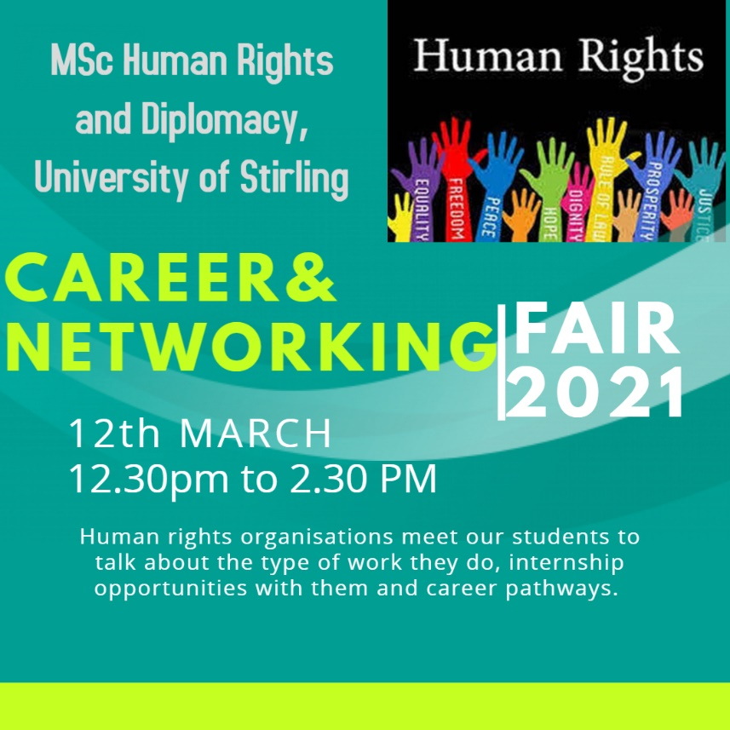
There is time to register for two events organised by the Scottish Law and Innovation Network (SCOTLIN), funded by The Royal Society of Edinburgh:
- SCOTLIN launch event with an introduction by our very own Guido Noto La Diega, Professor Martin Kretschmer (Glasgow Law School), and Dr Rossana Ducato (Aberdeen Law School), and keynote speech by former Law Commissioner Professor Hector MacQueen (Edinburgh Law School) on "Law and innovation in Scotland: some impressionistic thoughts"
- International conference “Hate Speech, Digital Discrimination, and the Internet of Platforms”. Annual conference of GenIUS, Italy’s journal of gender, sexuality, and law. You can register here.

Onwards and upwards
Professor Gavin McLeod Little has retired at the end of December after two decades of distinguished service to the University. Instrumental in the setting up of the original Law Department and in the foundation and accreditation of its programmes, he has been a major contributor to the success story that is the Stirling Law School today. In particular, he has been central to the building of its internationally recognised research profile, especially in his own area of the environment. Gavin will be continuing with his personal research into Energy and Environmental Law, working on projects that contribute to Scottish Government plans for energy transitions and a low carbon future, and in recognition of that he will be continuing his association with the University as an Emeritus Professor.
After being at Stirling Law School for the best part of ten years, Dr Sarah Carrick is leaving us to take on a lectureship at Manchester Met, where she will teach sports law as well as the core subjects on the LLB including criminal law and contracts. As a teaching assistant, Sarah rendered herself indispensable. As a grad student, she was a pleasure to work with. As a friend, we wish her all the best!
Onwards and upwards, Gavin and Sarah, you will be missed!

Get in touch
If you would like to contribute or suggest anything for future bulletins, please get in touch with Guido Noto La Diega <gn12@stir.ac.uk>.

