
THE TRUMPET
Stirling Law School’s Bulletin 3/2024
This bulletin is for sharing Stirling Law School’s achievements in research, teaching, and citizenship. This recognises the importance of celebrating successes, strengthening our sense of community, and creating opportunities for cross-Faculty and cross-University collaborations. We hope you’ll enjoy these snippets of Stirling Law School’s recent successes.
Table of Contents

Impact and engagement 1
Publications 3
Books 3
Journal articles 4
Chapters 5
Esteem, network, and citizenship 6
Dissemination and media presence 6
Events 8
Get in touch 8

Impact and engagement

Earlier this month, Professor Paul Beaumont and Dr Jayne Holliday submitted a large funding application to the AHRC with a full economic cost of about £1.3 million with colleagues from the Universities of Exeter, Sussex and Maastricht. The proposed start date for the project is January 2026 for a duration of 48 months. A summary of the application is provided below.

- Context

The Hague Conference on Private International Law (HCCH) is a global organisation which works to unify private international law (PIL) rules used for legal cases with a cross-border element, through the creation and management of Treaties (known as Conventions in the HCCH). An aim of the HCCH is to enhance access to justice in cross-border cases.

The Hague Conventions are very important to Great Britain (GB). Post Brexit, GB's PIL framework is no longer based on EU law, but rather on Hague Conventions. In light of the UK ratification of the 2019 Hague Judgments Convention in 2024, this seems the right time to analyse the operation of the Hague Conventions between GB and three key EU Member States, France, Germany and The Netherlands ('targeted countries'), in order to assess access to justice under the Hague regime.

- The Challenge the Project Addresses

Historically, access to justice has not been viewed as a central objective for PIL rather it is usually one of legal certainty. For the purpose of this study, the intended focus is on access to justice, with legal certainty being only a means for parties to attain their desired remedies within a reasonable time and at a proportionate cost (Danov and Beaumont, 2015/2016 at 151; Beaumont et al, 2017). In addition, there is no systematic data currently available on how the Hague Conventions are operating between GB and key EU Member States. By building on the applicants’ prior empirical studies, this project intends to fill that gap.

- Aims and Objectives

The aim is to survey law firms and conduct semi-structured (and some elite) interviews; and analyse reported judgments in relation to cross-border family, civil and commercial disputes.

The objectives are to:
- ascertain how the Hague Family regime (primarily Children 1996 and Maintenance 2007) and the Hague non-family regime (Choice of Court 2005 and Judgments 2019) are functioning in the targeted countries, identifying their strengths along with any weaknesses which may undermine access to timely and effective legal remedies in cross-border cases.
- propose policy choices which improve administration of cross-border justice through the ratification/adoption of international conventions and/or through soft mechanisms for cooperation (such as explanatory reports; good practice guides; Central Authorities; various transnational networks of law firms operating across borders).

- Potential Applications and Benefits

The project will ascertain the extent to which the effectiveness of the Hague regime and its implementation in the targeted countries should be enhanced with a view to improving access to justice. We will also recommend soft law and hard law instruments which may be advanced by the HCCH to improve the interpretation and application of the Hague Conventions. The results should benefit businesses and individuals involved in cross-border litigation not just in the targeted countries but in all Contracting Parties to the Conventions.

During the period May-June 2024, Allene Fields and Emilia Vassiliades from the Masters programme in Human Rights and Diplomacy offered support to the mandate of the UN Special Rapporteur on Climate Change and Human Rights, Elisa Morgera, by carrying out background research. The research was relevant for the preparation of the first two thematic reports of the Rapporteur, who started her mandate on 1 May 2024 and delivered a report on intersectionality (UN Doc A/HRC/56/46) in June and another report on access to information on climate change and human rights (UN Doc A/79/176) in mid-July. The Rapporteur discussed the first report at the Human Rights Council in July 2024 (see video-recording of a short presentation; and the full dialogue, see also here and here); and will discuss the second report at the UN General Assembly in October 2024.

The UN Special Rapporteur is a pro-bono and independent position supported by the UN. The UN Special Rapporteur on the promotion and protection of human rights in the context of climate change role entails contributing to the development of international human rights standards to address and prevent the adverse effects of climate change on human rights in national policymaking, legislation and planning, as well as in international cooperation and in the business sector. The Special Rapporteur’s work aims to contribute to the achievement of SDG13 and SDG14, supporting the resilience and adaptive capacities of people in vulnerable situations to respond to the adverse impacts of climate change.

Professor Emerita Elaine E Sutherland responded to Scottish Government, “Media Reporting on Child Homicide Victims: a Consultation on the Issues” (Edinburgh: Scottish Government, 2024), 30th September 2024.

Publications

Books
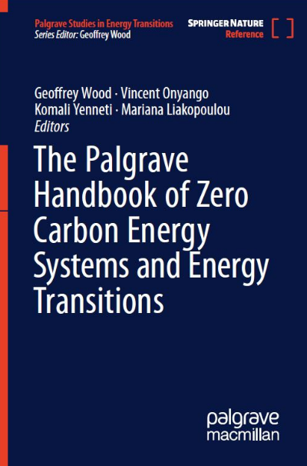
Dr Geoffrey Wood saw the hardcopy and eBook publication of his seventh book (and third handbook) Zero Carbon Energy Systems Energy Transition (co-edited with Dr Vincent Onyango (University of Dundee), Dr Komali Yenneti (University of Birmingham) and Mariana Liakopoulou (Energy Trades Europe). Published by Palgrave Macmillan as the first volume in their exciting new multi-volume Palgrave Studies in Energy Transitions (PSET) series, the Zero Carbon Energy Systems Energy Transition handbook provides a comprehensive and authoritative source of information, analysis and recommendations on the multi- and inter-disciplinary subject of zero carbon energy systems.

DOI: https://doi.org/10.1007/978-3-030-74380-2

Comprising 990 pages spanning 6 sections and 31 chapters from 62 chapter authors, the handbook advances thinking and research underlying the on-going energy transition by covering a wide range of energy technologies and sources (e.g. fossil fuels, renewables, low carbon energy) including investigating the potential of new and alternative technologies and fuel sources and looking at the power, heating/cooling and transport sectors. Further, the handbook looks at varied legal jurisdictions and governance approaches including developing and developed countries and investigating potential new approaches to achieving a zero carbon energy system by providing a broad range of theoretical and methodological approaches from a range of disciplines; Inclusion of a global range of case studies from Africa, Arctic, Asia, Australasia, Europe, the Middle East, the Americas (Central, North and South) and the Pacific, from the international, national, sub-national to city/community level.

As the lead editor of the Zero Carbon Energy Systems Energy Transition handbook, Dr Wood notes that this project has been a fantastic experience to work with experts from a multitude of disciplines and backgrounds with the aim to tackle the challenges and opportunities of achieving a zero carbon energy transition. He is extremely grateful to the co-editors and all chapter authors who contributed their time and expertise in this handbook.

Journal articles

Dr Craig Anderson has recently published two journal articles.

- In “Encroachment and Public Interest” (2024) Juridical Review 142 (available to view here), he considers the role of public interest in the Scottish courts’ decision-making with regard to the removal of encroaching buildings and other structures. This is set in the broader context of what it means to talk of the public interest and what its significance is in private law more generally.

- In “Liability to a Hirer for Damage to Property: Armstead v Royal & Sun Alliance Insurance Company Ltd” (2024) 28 Edin LR 407 (available to view here), he discusses a recent UK Supreme Court decision considering the rights of a hirer of corporeal moveable property if the property is damaged through the fault of a third party.

Dr Linda Mensah published the article “Battling on Multiple Frontiers: An African Feminist Examination of Women's Struggles in Artisanal and Small-Scale Mining (ASM)” (2024) 10(1) Cogent Social Sciences 1-28. Available to view here.

Abstract: This paper presents an African feminist response to the invocation of culture in the exclusion and marginalization of women from access to and participation in resource spaces such as artisanal and small-scale mining (ASM). It explores the intersection between culturally endorsed patriarchal subjugation and the ongoing colonialities of an extractivist mining political economy enmeshed with local displacements, classed consolidation, male-centered tenurial arrangements and changing gender relations that continue to militate against the advancement of women. Building on the African feminist conceptualization of extractivist patriarchal capitalism, this paper addresses how women in ASM battle capitalist patriarchy from both formal state laws and informal customary legal regimes. It emphasizes the need for an African feminist intervention in re-imagining culture, not as opposed to women’s advancement in ASM, but as a crucial lever of liberatory possibilities for women seeking livelihood opportunities in the sector.

Dr Pontian Okoli’s co-authored article “Arbitrators’ fees: securing payment through a navigation between statutory provisions and the common law in Nigeria”, was published recently. The publication, which benefits from interviews with some arbitrators in Nigeria, can be found in (2024) 32(4) African Journal of International and Comparative Law 503-522.

Abstract: This article critically examines the Nigerian Arbitration and Conciliation Act 1988 considering the school of thought that its section 26(4) impliedly repealed the arbitrator’s common law right of lien on the award alongside section 54 of the Nigerian Arbitration and Mediation Act 2023 now expressly providing for the Arbitrator’s right to lien on the award. Based on a comparative analysis of statutory provisions and the common law, a core argument is that the arbitrator’s common law right to lien on the award as security for fees remains valid. This legal enquiry offers an analytical template on how to assess the common law’s influence as a gap-filling mechanism subject to Nigerian statutory and case law.

Professor Annalisa Savaresi co-authored the article “Conceptualizing just transition litigation” (2024) 7 Nature Sustainability 1379–1384. This is available to view here.

Abstract: The transition towards low-carbon societies is creating winners and losers, raising new questions of justice. Around the world, litigation increasingly articulates these justice questions, challenging laws, projects and policies that aim to deliver climate change adaptation and/or mitigation. In this Perspective, we define and conceptualize the phenomenon of ‘just transition litigation’. This concept provides a new frame for identifying and understanding the diverse justice claims of those affected by climate action. We set out a research agenda to further investigate this phenomenon, with a view to enhancing societal acceptance and support for the transition.

Professor Emerita Elaine E Sutherland published the article “How to increase the impact of the UNCRC Act”, in Scottish Legal News (25th January 2024). This is available here.

In this article, Professor Sutherland argues that the United Nations Convention on the Rights of the Child (Incorporation) (Scotland) Act 2024 is something of a disappointment in the light of the ambitious plans that preceded it, but that its impact could be increased immeasurably by passing a new child law statute, codifying all the existing child law legislation.

Chapters

Professor Annalisa Savaresi published (with Jacques Hartmann) “Corporate actors and climate harms: the role of human rights law” in E De Jong, Corporate Accountability and Liability for Climate Change (Edward Elgar, 2024). Available to view here.

Professor Emerita Elaine E Sutherland published “Scotland: Incrementalism and Compromise in Reforming Child and Family Law” in R F Wilson and J Carbone (eds), International Survey of Family Law: 2023 Edition (50th anniversary volume) (Antwerp: Intersentia, 2024). Available to view here.

Abstract: Unsurprisingly – and as in many other jurisdictions – contemporary Scots child and family law differs, sometimes quite radically, from the law as it was half a century ago. This chapter focuses on the development of intimate adult relationships where law reform has followed a clear trajectory, with the legal system recognising a wider range of relationships and making them available on a more diverse basis. It reviews how the law has evolved, interrogating what has driven the various reforms and how the process has worked – an exercise that may inform those addressing reform of child and family law in the future.

Esteem, network, and citizenship

Dr David McArdle has recently been appointed as trustee for Chesterfield football club, providing advice and oversight in respect of its community and charitable activities (https://spireitestrust.org.uk/). Although a volunteer role, it carries significant potential for impact and grant capture.

Dr David McArdle is additionally acting as an academic consultant at 23 Essex Street, a barrister’s chambers in London and Manchester. Dr McArdle’s first briefing note for them and their professional networks concerned the Supreme Court ruling in Revenue and Customs Commissioners v Professional Game Match Officials [2024] UKSC 29, which was handed down in September. The judgment has given the tax authorities and referees a very strong indication that part-time referees in tiers 2 to 4 in England are employees (albeit only on match days), which will have significant implications for their tax and national insurance contributions.

Dissemination and media presence

Dr Domenico Carolei presented at the International Charity Law Network Conference 2024. Dr Carolei presented a paper on the human rights responsibilities of NGOs at the 2024 International Charity Law Network Conference in Toronto, held in September 19–20th 2024. The event brought together 60 experts from among academics, regulators and practitioners working on a wide-range of charity law issues. The conference was hosted by Osgoode Hall Law School, York University, and was supported by the Mastercard Foundation, the Muttart Foundation, and Notre Dame Law School. Dr Carolei’s visit and participation to the conference was sponsored by Notre Dame Law School.

Dr David McArdle gave two online keynote lectures in October.

- The first, at Rijeka University Law School in Croatia, explored the implications of the European Union’s policy decision to withdraw from the regulation of gambling around 2012, focusing on how member states have regulated gambling within their jurisdictions, the relevance of anti-money-laundering laws in pursuing the link between gambling and organised crime, and the implications for sports’ attempts to combat gambling-related matchfixing.

- Relatedly, Dr McArdle’s second paper at the University of the West Indies, Trinidad looked at how the Court of Arbitration for Sport has approached matchfixing cases, noting especially the challenges that sports bodies face because of their limited budgets, their restricted powers of investigation and the inability to bring proceedings against those over whom they have no jurisdiction. A series of cases arising from matchfixing in Albania were used to illustrate those points.

Dr Pontian Okoli, one of the founding members of the Nigerian Group on Private International Law, was a panellist and delivered the closing remarks at the Group’s annual lecture (“Double and triple decker Nigerian marriages: validity recognition and effect”), which took place on 18th November 2024. This lecture explored aspects of international family law with a focus on Nigerian marriages and considered contemporary challenges through the lens of private international law.

In October, Dr Scarlet Robertson presented a paper “Detecting Global Crime at a Local Level: The interaction between community policing and human trafficking in Scotland” at the Policing and Society International Conference hosted by the University of Akureyri, Iceland. The presentation was well received and this was an excellent opportunity to present findings on the current and potential role of local police in detecting transnational crime and enforcing criminal law to an audience of academics and police officers from around the world.

Professor Annalisa Savaresi delivered the talk “A just transition? The role of litigation in the transition towards net zero societies” at the University of Aberdeen, Law School on 21st November 2024. Further information on the talk can be found here.

Professor Annalisa Savaresi delivered the keynote address at ESIL Interests Groups on International Environmental Law and on European and International Rule of Law Conference “The crossroad of international environmental law enforcement: The instrumentalization of other legal regimes and discourses in the era of fragmentation and the Anthropocene” at the Universitat Oberta de Catalunya, Barcelona, on 2nd December 2024. This is available to view here.

Professor Annalisa Savaresi published two articles in The Conversation:

- A Savaresi and J Setzer, “People around the world are using courts to question whether climate policies are fair – new study” (October 22nd 2024).

- H van Asselt and A Savaresi, “Shell’s legal victory is disappointing – but this is not the end for corporate climate litigation” (15th November 2024).

Professor Savaresi additionally published H van Asselt and A Savaresi “Corporate climate (un)accountability? Landmark Shell ruling overturned on appeal” in the CCEEL Blog (13th November 2024).

Professor Emerita Elaine E Sutherland the following papers at the University of Glasgow and University of Strathclyde:

- “An Age of Inconsistency: Legal Capacity of Children and Young People in Scotland”, Capacity in Scots Private Law Workshop, School of Law, University of Glasgow (10-11th September 2024).

- “Age, Maturity and the Law in the Lives of Children and Young People in Scotland”, The Person in Scotland and the World: 40 Years of Private Law Reform Conference, Strathclyde Law School, University of Strathclyde (15th November 2024).

Events
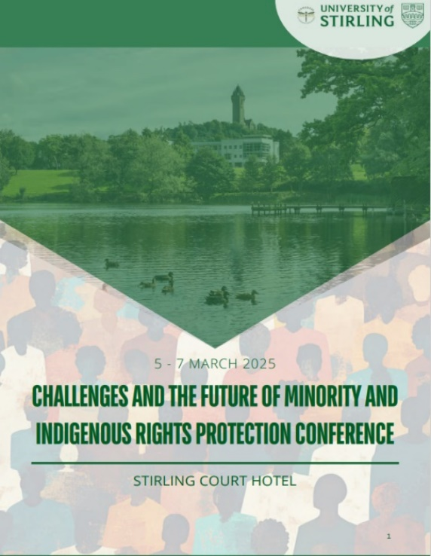
Dr Damian Etone, Dr Edit Frenyo, Dr Linda Mensah and Emilia Vassiliades are part of the organising committee for a paid conference that the University will be hosting.

This is on the theme “Challenges and the Future of Minority and Indigenous Rights Protection” and will take place between 5-7th March 2025 in partnership with the Congress of Nations and States.

For further info, see here

Dr Damian Etone received a grant from the Stirling Fund to develop a “Human Rights Movie Screening Series”. This will consist of a curated selection of films that address various human rights issues such as racial discrimination, gender equality, LGBTQ+ rights, refugees and migration, freedom of speech, and more. The plan is to host three screenings beginning in the Spring (one every semester) on campus. Post-screening discussions will be facilitated by experts in human rights including academics, activists, filmmakers, and NGO representatives. These discussions will provide students with a deeper understanding of the issues presented in the films and encourage critical thinking and dialogue.

Get in touch

If you would like to contribute or suggest anything for future bulletins, please get in touch with Robbie here.

