
THE TRUMPET
Stirling Law School’s Bulletin 2/2023
This quarterly bulletin is for sharing Stirling Law School’s achievements in research, teaching, and citizenship. In these difficult times, it’s crucial to celebrate, strengthen our sense of community, and create opportunities for cross-Faculty and cross-University collaborations. We hope you’ll enjoy this wee snippet of Stirling Law School’s recent successes!
Table of Contents

Impact and engagement 1
Publications 2
Books 2
Journal articles 3
Chapters 5
Encyclopaedia entries 5
Trade press 6
Blog posts 6
Book reviews 6
Income generation 7
PGR success 8
Research environment 9
Employability news and teaching excellence 9
Esteem, network, and citizenship 10
Knowledge exchange and dissemination 11
Media presence 14
Internationalisation 14
Upcoming research visits at Stirling Law School 14
Upwards and onwards 15
Get in touch 15

Impact and engagement
The European Commission has formally invited Professor Guido Noto La Diega to join the EU Task & Finish Group on Data Governance and Ethics in recognition of Guido’s ‘highly relevant expertise on this topic’. The Task & Finish Group will focus on examining how good data governance and ethical processing is best applied within an EU Digital Education Content framework, taking into account existing EU legislation. This forms part of the stakeholder engagement under the EU study titled Policy options for digital education content in the European Union. The Task & Finish Group will aim to:
- Further investigate issues to be addressed;
- Identify recommendations for the way forward.
This invitation follows Guido’s involvement in drafting the EU Guidelines on AI in Education as a member of the European Commission’s Expert Group on AI and Data in Education and Training.


Figure 1 Digital Education Action Plan – Action 3

Publications

Books
Monograph: Domenico Carolei, Non-Governmental Organisations and the Law: Self-Regulation and Accountability (Routledge 2023).

This book examines accountability issues and the problems of regulating non-governmental organisations (NGOs) through self-regulation. It focuses on methods of self-regulation for NGOs in response to prominent scandals that revealed problems with their accountability, notably the ‘Mafia Capitale’ scandal in Italy and the Oxfam GB scandal in Haiti. It also touches upon other accountability failures, including the allegations against the WWF of facilitating human rights abuses of indigenous groups in Cameroon.
The work brings a legal approach to the topic of NGO self-regulation and accountability, contributing to the academic and policy debate in several ways. It advances a brand-new theoretical model to explain the reasons behind NGOs non-compliance with self-regulation, examines the reasons for self-regulation failures, identifies new accountability routes, and recommends proposals for sectoral reform.
The book will be of great interest to scholars, researchers and PhD students who work in the area of NGO regulation and accountability from a legal perspective as well as to accountability and NGO scholars working in other disciplines. It will also appeal to practitioners and policymakers who work on the development of NGO policies.

Our Honorary Professor Francis McManus has published the book, Noise and Noise Law: A Practitioner’s Guide with Edinburgh University Press.

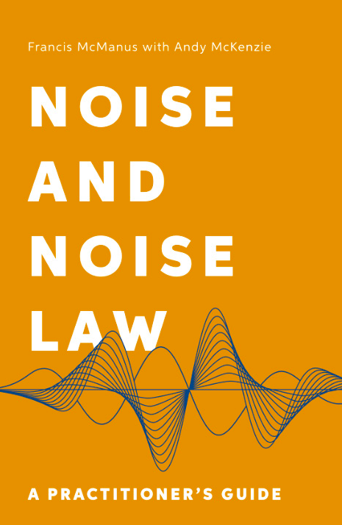
Figure 2. Book cover of Noise and Noise Law: A Practitioner's Guide by Francis McManus
This key reference text covers both the common law and the statutory controls over noise; including a detailed discussion of the role of planning law, with special attention given to the role of environmental assessment. Leading cases are covered in detail, for example, Baxter v Camden LBC, Coventry v Lawrence, Hatton v UK, Webster v Lord Advocate and Dennis v MoD. Dr Andy McKenzie contributed several chapters on the technical aspects of the book.
To get a 30% discount on the book, go to the online catalogue of Edinburgh University Press and use the code NEW30 at checkout.

Dr Damian Etone has led an edited collection with 18 Contributing authors now submitted for Publication - Damian Etone, Alice Storey, and Amna Nazir, Human Rights and the UN Universal Periodic Review Mechanism: A Research Companion (Routledge, Forthcoming)

Journal articles
Dr Pontian Okoli's article "Jurisdictional Rule 'X' in the Conflict of Laws: Challenges of Policy and Security in Internet Torts with Business Implications" was published in (2023) Georgia Journal of International and Comparative Law 397-460

Adopting a comparative legal approach with a European baseline, this article examines the need to articulate a clear policy with respect to Internet jurisdiction. Any applicable policy should cater to the interests of both developed and developing countries. Building on a foundational analysis with respect to the nature of relevant cases and parties, the article critically examines how best to ascertain appropriate courts to hear defamation cases. This approach is suggested with a view to not only ensuring a necessary and complementary participation by both public and private actors, but also achieving solutions to jurisdictional issues from a pragmatic standpoint.

R. Luporini and A. Savaresi ‘International human rights bodies and climate litigation: Don’t look up?’ RECIEL (2023)

This article systematically analyses complaints concerning climate change before international human rights bodies. Since 2005, these bodies have been increasingly asked to hear complaints related to climate change but have granted claims of climate applicants only on one occasion. This article therefore considers the inherent limitations of international human rights bodies for the pursuit of climate objectives, as well as avenues to overcome the hurdles facing climate applicants. Based on the evidence we examined, we conclude making some predictions on the role that international human rights bodies might play in future climate litigation.

P. de Vilchez and A. Savaresi ‘The Right to a Healthy Environment and Climate Litigation: A Game-Changer?’ Yearbook of International Environmental Law (2023)

This article examines the evidence emerging from the use of the right to a healthy environment in climate change litigation. We look at climate litigation as a case study to ascertain the extent to which the right to a healthy environment contributes to improved implementation and enforcement of climate laws, protects against gaps in climate laws, and creates opportunities for better access to justice for climate litigants. First, we define the parameters of our case study, explaining how we selected the data we analysed, positioning our inquiry into the rapidly growing body of literature on human rights and climate change. Second, we provide a bird’s eye perspective on rights-based climate litigation and on the use of the right to a healthy environment in this litigation. We identify the cases where this right has been invoked, by whom, where and when, and with what outcomes. We then take a closer look at how courts have interpreted and applied the right to a healthy environment in the climate judgments that have been issued to date. We conclude by drawing some general inferences on whether the right to a healthy environment has furthered the chances of success of climate litigants and on whether the recognition of this right is a significant determining factor in the outcome of climate litigation.

M. Rajavuori, A. Savaresi and H. van Asselt, Mandatory due diligence laws and climate change litigation: Bridging the corporate climate accountability gap? (2023) Regulationn & Governance

The debate on corporate climate accountability has become increasingly prominent in recent years. Several countries, particularly in the Global North, have adopted mandatory human rights and/or environmental due diligence legislation. At the same time, judicial and quasi-judicial proceedings are helping to shape the contours of corporate climate accountability. This article considers how litigation against corporations and due diligence legislation interact, and thereby help develop and strengthen corporate climate accountability. While the practice in this area is still limited, there is scope to reflect on early developments and how they may influence both future climate litigation as well as ongoing and future law-making on due diligence. We first review recent developments in climate litigation against corporations, focusing on the extent to which they rely on climate due diligence obligations. We then survey existing and proposed due diligence legislation, examining the extent to which it addresses corporate climate accountability. Finally, we identify scenarios of how due diligence legislation and climate litigation may interact and possibly converge to strengthen corporate climate accountability. We furthermore identify knowledge gaps and areas for further research.

Chapters
Dr Damian Etone contributed to the Global Handbook on National Human Rights Protection systems – See Damian Etone, ‘The South African National Human Rights Protection System’ in Bertrand G. Ramcharan, Gianni Magazzeni, Mona M'Bikay, and Inès French (eds), A Global Handbook on National Human Rights Protection Systems (Brill 2023) available here

This chapter focuses on South Africa’s National Protection System (NPS) to (i) examine the constitutional foundation and structural features of the NPS; (ii) assess the role of various national actors and the extent of their contributions to the strengthening of the NPS; and (iii) highlight the weaknesses of the NPS and how cooperation between various actors could contribute to strengthening South Africa’s NPS. The analysis in this chapter will focus on the constitutional foundations of South Africa’s NPS, the institutions for the protection of human rights (focus on the judiciary, parliament, and the South African Human Rights Commission), and the space for civil society organisations.

P. Velasco Herrejon and A. Savaresi ‘Energy Justice, Indigenous People, and Benefit-Sharing: Evidence from Southern Mexico’ in (Eds.) Wood, G., Gorski, J. and Mete, G., The Palgrave Handbook of Social License to Operate and Energy Transitions (Palgrave, 2022)

This chapter looks at the practice of benefit-sharing in wind energy projects in Indigenous peoples’ lands in the Isthmus of Tehuantepec, Mexico. The aim is to gauge how the procedural, distributive, and recognition justice associated with the development of renewable energy generation capacity have been addressed, the challenges experienced, and the solutions that may be adopted to address these. The chapter is organized as follows. After an introduction setting out the research questions, context, and background of the chapter, part two unpacks the justice questions associated with benefit-sharing in the context of renewable energy generation. Part three looks at how these questions have been addressed in practice in the context of renewable energy projects in the Isthmus of Tehuantepec. Part four reflects on what our case study has revealed about the use of benefit-sharing as a means to engender energy justice.

Encyclopaedia entries
What’s an idea? Professor Guido Noto La Diega tried to answer this rather broad question for the Encyclopaedia of Intellectual Property Law directed by Paul Torremans, Irini Stamatoudi, Peter K Yu, and Bernd Justin Jütte for Edward Elgar. The Encyclopaedia is being printed, but you can read the preprint of the entry here.

Psychology studies have for some time shown that, as humans, we tend to recognise the ownership of ideas and that the unauthorised use of others’ ideas is frowned upon (Olson and Shaw, 2011). Morally, a person is often said to have a natural right to the product of their brain (Vaver, 1990). This explains why Intellectual Property (IP) is so frequently defined as the legal protection of ideas (e.g. British Library, 2023). It is one of core tenets of IP law that ideas as such are not protected, IP protection exists only for manners of expressing or instantiating ideas (Mandel, 2014; Bilski v. Kappos, 130 S. Ct. 3218, 3225 (2010)). In this encyclopedia entry, the concept of idea is illustrated with reference to the idea-expression dichotomy in copyright law, to the exclusion of abstract ideas in patent law, and to the protection of ideas as trade secrets. It will be argued that ideas are becoming increasingly the domain of IP, which is open to criticism from a policy perspective. This entry considers the law as it stands in Europe, including the UK; US law is considered where it addresses the (non)protectability of ideas in a clearer or more direct way (mostly in patent law).

Trade press
Dr Guido Noto La Diega has become an expert for LexisNexis, the leading database for legal professionals. In this capacity, Guido was asked to update the page, ‘Internet of things (IoT)—data protection, privacy and security’. Written with senior consultant attorney Rosemary Jay (Hunton Andrews Kurth) and avvocati Giulio Coraggio (DLA Piper) and Giordana Babini (DLA Piper), this practice note focuses on the data protection and privacy implications of the internet of things (IoT) and the data collected by it.
The following key areas are examined:
- What is the internet of things?
- The internet of things in the Digital Single Market
- The GDPR
- The identified key themes for concern
- Article 29 Working Party Opinion on recent developments in the internet of things
- Security
- UK Code of Practice for Consumer Internet of Things Security
- Network threat analysis

Blog posts
Kati Kulovesi, Annalisa Savaresi, Maiju Mähönen, and Otto Bruun, Finland’s first climate lawsuit: Watching the forest sink (CCEEL blog, 2023)

M. Rajavuori, A. Savaresi and H. van Asselt, New Avenues for Corporate Climate Accountability (Oxford Business Law Blog)

Kati Kulovesi, Annalisa Savaresi, Maiju Mähönen, Finland’s First Climate Judgment: Putting the Government on Notice (CCEEL, 12 June 2023)

Book reviews
Dr Helena Raulus has reviewed A Guide to Global Private International Law, edited by Professor Paul Beaumont and Dr Jayne Holliday (Hart 2022) in the Journal of the Law Society of Scotland. Dr Raulus wrote that the book “is an impressive piece of work […] a very informative and thought-provoking contribution to the field of global private international law […] the editors, Paul Beaumont and Jayne Holliday, deserve a special mention. Getting together all these contributions dealing with such highly technical topics and ending up with a such an easily readable volume has taken a lot of work and should be applauded.”

Two very kind book reviews of Professor Guido Noto La Diega’s Internet of Things and the Law (Routledge 2023) were recently published in the International Journal of Law and Information Technology (Oxford University Press), and in Social & Legal Studies (Sage).
According to Christof Koolen (KU Leuven), the book’s "main claim relating to the human-centric nature of the IoT is bold but necessary [...] Internet of Things and the Law succeeds in sparking the debate about the future of the IoT." As Professor Ben Farrand (Newcastle University) kindly put it, IoT & the Law is "an excellently written, engaging and thorough analysis of the failings of the current system... [a] heartfelt and insightful work."

Income generation
The final conference of the Stirling-based Scottish Law and Innovation Network (SCOTLIN), funded by The Royal Society of Edinburgh (RSE), was hosted by the University of Aberdeen. The Principal Investigator, Professor Guido Noto La Diega, expresses satisfaction with this diverse conference and, more generally, with the way that SCOTLIN has brought together academics, practitioners, activists and industry from across Scotland and beyond. The Head of Aberdeen Law School Greg Gordon added: “We were honoured to host the second outing for this event which is rapidly becoming a fixed date in the Scottish legal industry calendar.” Conference delegates fed back that SCOTLIN has been important in their professional development and that they wish it will continue to exist, especially to support early career researchers. To reflect this, a new leadership board has been appointed; for Stirling, the new leaders are Dr Zoi Krokida and Dr Benjamin Clubbs Coldron. See news item here.

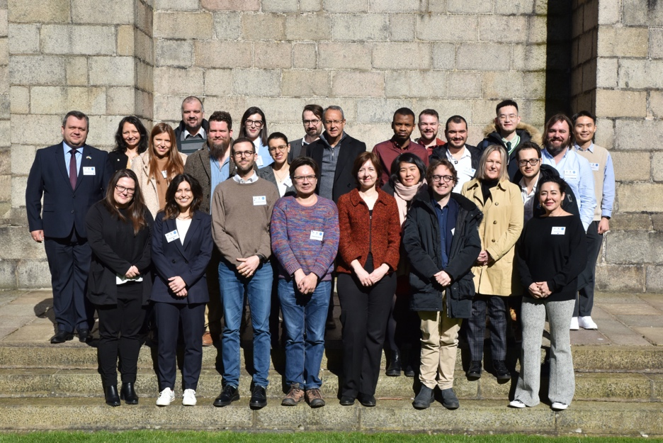
Figure 3. The delegates at the 2nd Annual Conference of the Scottish Law and Innovation Network (University of Aberdeen, 27-28 March 2023)
A wee update about the AHRC-DFG project “From Smart Technologies to Smart Consumer Laws” from Dr Clubbs Coldron, who is the postdoc doing so much of the heavy-lifting. Having engaged with the literature on digital technologies and business models related to the ‘Internet of Things’ (IoT) and studied the current, and future developments of UK, German and European and consumer law acquis, we proceeded to collecting and analysing various ‘legals’ (including end user licence agreements, privacy notices, terms and conditions of sale and use) in the Wearable, connected car and smart home sectors. This meticulous analysis involved a thorough examination of an array of legal documents, including end-user license agreements, privacy notices, and terms and conditions of sale and use, within wearable, connected cars, and smart homes sectors.

Our inquiry yielded a host of potential consumer concerns intertwined with the presentation of products as distinct services, the nuances of disclaimers, scenarios of private enforcement (such as the concept of "bricking"), the realm of remote-control by IoT companies over consumer products, data processing practices, norms of transparency, and the crucial task of upholding GDPR obligations. These insights provided a basis for the development of an empirical research program using interviews and focus groups. Over the past year we have been engaging consumers, industry experts, and insiders. This phase of the research programme is now largely completed, with three focus groups and a series of enlightening interviews substantially enriching our legal analysis and critique of current law, policy and practice.

We are pleased to share that we have completed and submitted a chapter titled "Giving Surveillance Capitalism a Makeover: Wearable Fashion Technology in the Fashion Industry and the Challenges for Privacy and Data Protection Law." (Clubbs Coldron, B., Noto la Diega, G., Phipps-Rufus, T., and Stolte, T.) for inclusion in the Routledge Handbook of Fashion Law. Other publications in the pipeline include an article slated for submission to the Journal of Consumer Policy. Titled "Consumer-Computer Hybridisation in the Internet of Things: Conceptualising Cyborg Vulnerability," this article delves into the nuanced concept of cyborg vulnerability within the IoT and provides a conceptual and ethical framework which can inform debates on legal reform.
A forthcoming writing retreat, scheduled for late August in Bonn, will give the team a chance to work on our forthcoming book on Law in the IoT. Notably, Professor Noto La Diega and Dr. Clubbs Coldron will spearhead chapters delving into the intricate dynamics of "Things" as services and the regulatory dimensions encompassing "bricking" and other forms of private enforcement of contracts. Finally, we will be welcoming Professor Christoph Busch in September for a month-long research visit at Stirling.

PGR success
Anna Pavicic, PhD student supervised by Dr Leslie Dodd, has been working with Karl Magee in the Achive service to scan part of Book 2 of Craig's Jus feudale. On the basis of this, she has just secured a one-month internship in Canada with a company called Ristech & Kirtas which makes scanning equipment. They've also agreed to contribute some funding towards her PhD. Well done Anna, Leslie, and Karl!

Dr Damian Etone led the IAS Cluster on Democracy, Human Rights and Communication /Advocacy in the Digital Age as (together with Professors Rowan Cruft, Andrea Schapper, Christine Caldwell, Dr Alenka Jelen, Dr Terrie Lynn Thompson and Dr Sandy Brownlee) which was one of the four successfully clusters for the first round of IAS studentships. This cluster will be addressing several questions including how law and policy can help to create a safer online environment, curb the spread of information disorder, mitigate bias in AI systems, and help shape the development of human rights compliant algorithms? How do we define democratic social media regulation and what are the strategies/opportunities for effective public participation, digital activism and communication campaigns? How should regulators respond when free speech rights are used to impede democratic participation, reduce inclusion or foster polarisation? Our cluster will have an impact in shaping the ethical conceptualisation, use, regulation, and transformation of the digital environment.

Research environment
This year’s Festival of Research – co-convened by Professor Iain Docherty, Dean of the Institute for Advanced Studies and Professor Rachel Norman, Dean of Research Engagement and Performance – has been a big success. The programme included a series of events dedicated to research at Stirling. To showcase the breadth of research and relevance to the 17 Sustainable Development Goals, the events were grouped into 6 main clusters aligned with recent IAS studentship clusters. The sessions were in the format of a three-minute thesis style presentation AKA Pecha Kucha. Many Law School members presented their research. For example, on Thursday 25th May, there were a number of presentations under the theme ‘Novel methodologies to support future research and better-informed policy’ which includes inter alia the Just AI Lab. As the Lab’s coordinator, Professor Guido Noto La Diega presented their current research on AI, patents, and SDG9.

From the Research Culture Awards initiative, first introduced in May 2020 by Professor Rachel Norman, Dean for Research Engagement and Performance, the Research Culture Champions Network has been established to share the good practice that is highlighted in the Research Culture Awards and look at ways to take on board the ideas that are appropriate for our own research teams. The current Research Culture Champions (12 in total) include our Head of Division Professor Rowan Cruft as well as our Professor Noto La Diega.

Employability news and teaching excellence
At the RATE Awards 2023, the Faculty of Arts and Humanities received an honourable mention in the ‘Faculty of the Year’ category (well done FHSS on winning!); Dr Damian Etone won in the Excellence in Teaching in FAH category (Dr Tracy Kirk received an honourable mention, Dr Leslie Dodd was shortlisted); our alumna Pauline Darnbrough was the winner of the ‘Professional Services and Support Staff of the Year’ award; Dr Pontian Okoli was nominated in the "Tutor of the Year" and "Excellence in Teaching" categories.


Figure 4. Dr Etone receiving the award for Teaching Excellence in the Faculty of Arts and Humanities
One of our Year 2 students, Violet Hejazi, has won a Santander Law Scholarship. The scholarship runs to about £30,000 over three years and it is part of Santander's strategy for the recruitment of future banking lawyers. Violet’s application was supported by Dr Leslie Dodd.

Our MSc Students on the MSc Human Rights and Diplomacy programme have now secured autumn internships with the following organisations:
i. UNICEF (Istanbul)
ii. UN Women (New York)
iii. UN Office of the Victims’ Rights Advocate (OVRA) (New York)
iv. The Universal Postal Union (Legal Directorate) (Bern)
v. FAO (Brussels)
vi. United Nations Development Programme (UNDP) (Indonesia)
vii. Universal Rights Group (Geneva)
viii. Cultural Diversity for Peace (Geneva)
ix. UN Economic and Social Commission for Asia and the Pacific (Thailand)
x. East African Centre for Human Rights (Kenya)
xi. Centre for Sports and Human Rights (Geneva)
xii. African Commission on Human and Peoples’ Rights (The Gambia)
Other students have secured internships more locally with the Islamic Human Rights Commission (London), Revive Campaign, Forth Valley Welcome, Scottish Funding Council, Together Scotland, Wandering Educators (remote), In Defence of Animals (remote), 21 Wilberforce (remote), and Women’s Aid Luton.

Esteem, network, and citizenship
Professor Annalisa Savaresi addressed delegates at the Council of Europe Civil Society Summit in The Hague on 28 February, speaking about the explicit of the right to a healthy environment in Council of Europe instruments.

Professor Noto La Diega is one of two academics in Europe to be appointed to the European Union Intellectual Property Office (EUIPO)’s Steering Committee. The Committee will decide which research projects will be funded under the EUIPO Academic Research Programme. Through this programme, the EU’s leading Intellectual Property (IP) body has the ambition to further develop the ties with academia in order to foster research not only in IP-related areas of interest to the EUIPO but also in the broader field of information technologies. The appointment follows the establishment, between the University of Stirling, the EUIPO, and the European Patent Office (EPO), of a partnership agreement (the Pan European Seal) that allows Stirling students and alumni to access a number of prestigious paid traineeships in Europe’s main IP organisations. Dr Zoi Krokida currently leads on the partnership.

Knowledge exchange and dissemination
In March, Dr Dave McArdle gave a keynote lecture at an international conference on Sport After COVID at the National Taiwan Sport University. His paper looked at how the contract law concept of force majeure was used by sports governing bodies, clubs and broadcasters in the UK, Taiwan and China to resolve disputes when events were cancelled, postponed or played in empty venues. He stressed that well-drafted contract terms and robust insurance policies were far preferable than trying to rely on this most slippery of contractual concepts, and noted that this wasn’t the first time when pandemics had caused the cancellation of sports events; it certainly won’t be the last.

Dave also met with officials from the National Association for the Study of Sport and Entertainment Law, where they discussed potential collaborations around sports arbitration and dispute resolution.

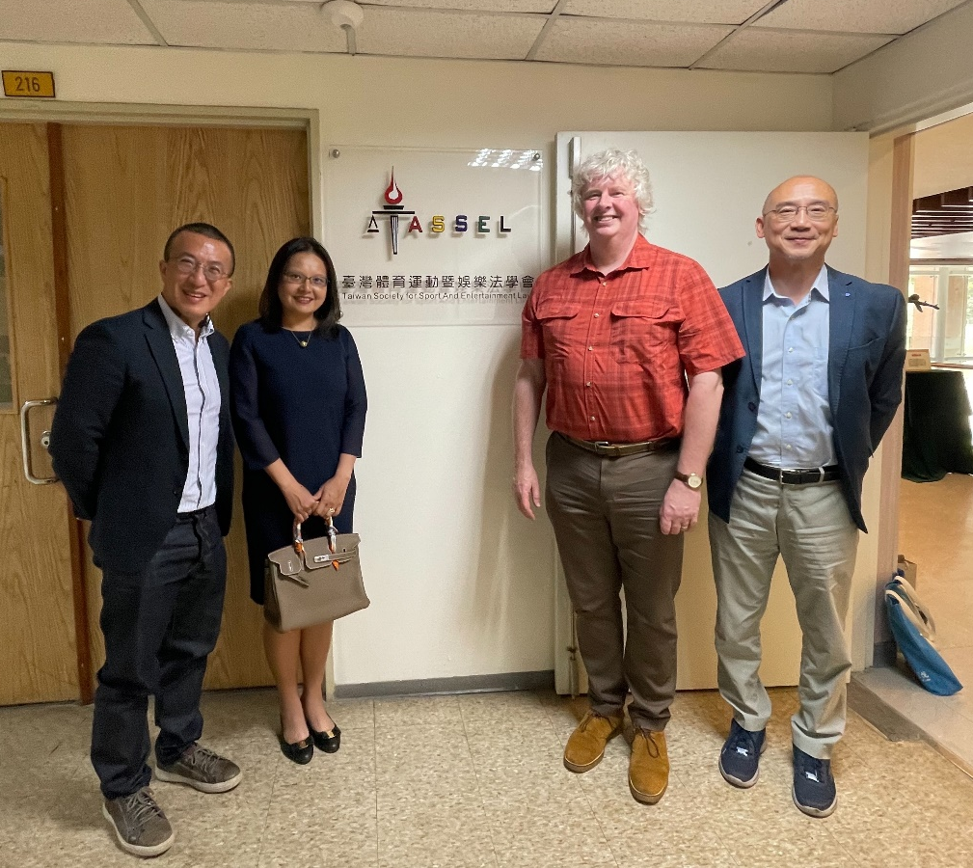
Figure 5 Dave (second right) with the President, Chair and Chief Executive of the Taiwan Society of Sport and Entertainment Lawyers.
In June, Dr McArdle gave an invited paper at a one-day workshop on Socio-Legal Approaches to Protecting Athletes from harm at Manchester metropolitan University, funded by the Socio-Legal Studies Association’s Conference Seminar Scheme (https://www.slsa.ac.uk/index.php/funding-schemes/seminar-competition). Dave spoke about the challenges of using legal remedies to provoke change in how spots bodies respond to athlete concussion, highlighting how the ‘key cases’ which are supposedly authorities for establishing liability in negligence are actually nothing of the sort. He argued instead for heightened awareness among participants and changes to playing rules and playing cultures where necessary.

Professor Annalisa Savaresi gave a talk on “The Role of Citizens in the Energy Transition: Turning Energy Consumers into Energy Producers, Encounters across Sciences and Humanities”, Italian Embassy, London, February 2023

Professor Savaresi contributed to the international Expert Seminar "The Reykjavik Summit: An Opportunity to Promote the Human Right of all Europeans to a Clean, Healthy and Sustainable Environment". 11 April 2023

Professor Savaresi’s speaking commitments included:
- Invited speaker at the workshop Litigating Just Climate Futures co-organised by the universities of Tilburg and Amsterdam on 12 April
- Lecture ‘Seeing the forest for the trees? Regulating land and forest uses for net zero’, University of Trento, School of International Studies as part of the Green Deal Network Lecture series on 4 April
- Paper ‘Human rights-based litigation in the transition towards net zero societies: A double edge sword?’ EnAct Conference on Human Rights and Investment Law for Climate Change: Trends and Prospects, University of Copenhagen, School of Law on 20 March
- International Expert webinar "The Long Overdue Recognition of the Autonomous Human Right of all Europeans to a Clean, Healthy and Sustainable Environment, and Why the Council of Europe Must Act Now ", 20 April
- Discussant at the conference ‘Law as a tool for the social and ecological transition’ at the Université Catholique de Louvain, 21 April
- Panellist at the event Corporate Climate Litigation: Lessons Learned, Comparative Perspectives and Future Pathways, held at the British Institute of International and Comparative Law on 11 May.
- Address at the AICHR Regional Consultation on Business and Human Rights, Environment, and Climate Change in ASEAN, on the theme ‘Issues and Challenges of a Regional Framework on Environmental Rights’ on 29-30 May 2023
- ‘Seeing the forest for the trees?’: The long road to regulating land uses in the EU at the Karlsruhe Institute for Technology department Geography and Geoecology on 5 June.
- Course ‘Land uses the climate regime’ at the Jean Monnet SUSTAIN Summer School at Sant’Anna Institute for Advanced Studies, Italy on 24-25 July 2023

Dr Domenico Carolei presented his research on NGO accountability at "Accountability with adjectives" (online workshop) organised by Gergana Dimova (Florida State University, London) Mel Dubnick (University of New Hampshire), Matthew Flinders (University o of Sheffield) , Chris Monaghan (University of Worchester) - 26 April 2023.

Domenico was also invited to present his research on the applicability of the OECD Guidelines to non-profits at the workshop "Corporate Human Rights Responsibility in the OECD NCP Case Law Analysis” organized by the Friedrich Alexander University-Erlangen Nuremberg (Germany) - 4 and 5 May 2023.

Professor Francis McManus was the guest speaker at a meeting (held 26th June) of the Scottish branch of the Institute of Acoustics. His presentation included discussion of the effectiveness of both common law nuisance and statutory nuisance in the control of noise.

Professor Guido Noto La Diega presented their research at the top global conferences in the IP field. First, they discussed ‘Ending Smart Data Enclosures: The European Approach to the Regulation of the Internet of Things between Access and Intellectual Property’ at the 41st Annual ATRIP Congress «The Interface of Intellectual Property Law with other Legal Disciplines» (University of Tokyo, 11 July 2023). ATRIP (International Association for the Advancement of Teaching and Research in Intellectual Property) is the leading international society for IP scholars. Guido particularly enjoyed the mandatory post-conference karaoke, where they performed the house down to such smashing hits as My Heart Will Go On (Dion 1995) and Time is Running Out (Muse 2003).

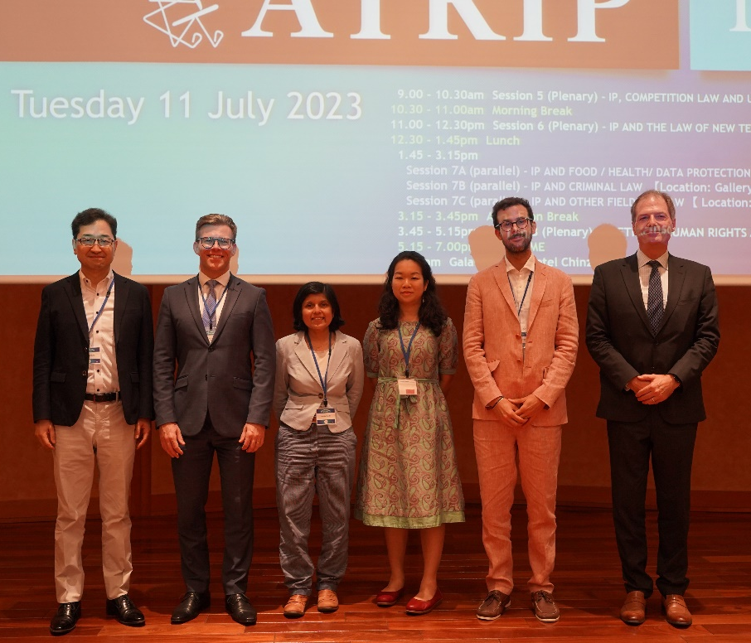
Figure 6. From the right to the left: Professor Tatsuhiro Ueno (Waseda University), Milton Lucídio Leão Barcellos (Leão Intellectual Property), Professor Dinisha Mendis (Bournemouth University), Dr Corinne Tan (Nanyang Technological University), Guido, Professor Daniel Gervais (Vanderbilt Law School)
Second, Guido with co-authors Gabriele Cifrodelli (University of Glasgow) and Artha Dermawan (Max Planck Institute for Innovation and Competition) presented ‘Sustainable Patent Governance of Artificial Intelligence: Recalibrating the European Patent System to Foster Innovation (SDG 9) at the 23rd Annual Intellectual Property Scholars Conference (IPSC 2023), Benjamin N. Cardozo School of Law, New York, 3-4 August 2023). IPSC is the main IP conference in the US. Guido thanks the Faculty of Arts and Humanities and the Division of Law and Philosophy for the generous support of both trips.

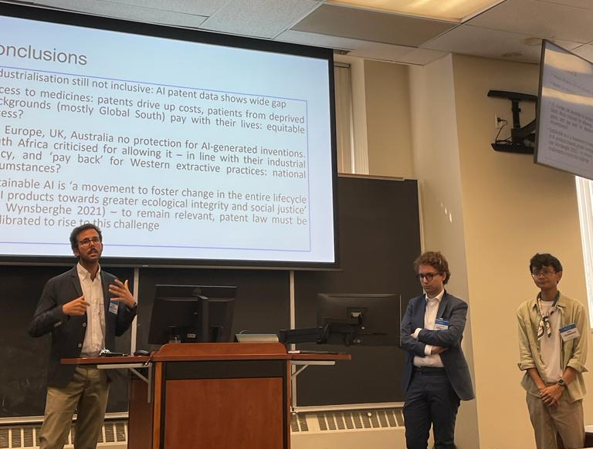
Figure 7. From the left: Guido, Gabriele Cifrodelli, and Artha Dermawan
Guido gave a keynote speech about ‘Let’s ChatGPT about Large Language Models in Legal Education’ at the 2nd UCP International Conference on Law Tech and Legal Education in Pakistan, University of Central Punjab, 17 May 2023. Here you can watch the video of the shorter version of the address, produced by the platform Faculti.

Media presence
Scottish Legal News, the leading online outlet for law practitioners in Scotland, has published an article covering Professor Noto La Diega’s promotion to Chair in Intellectual Property and Technology Law.

Internationalisation
Dr Dave McArdle was recently appointed as a Distinguished Visiting Professor at the OP Jindal Law School in India. He hopes to visit in October to discuss research collaboration and grant capture, and to lead research workshops with early-career academics there. He acknowledges the financial support of both the Division of Law and Philosophy at Stirling and Jindal Law School.

Dr Damian Etone will be a Visiting Scholar at the University of Ghana Law School between September and November 2023.

Upcoming research visits at Stirling Law School
We’re happy to share that Stirling Law School will host a number of visiting scholars, and we hope that this can create opportunities for collaboration across the University.

- Professor Christoph Busch (Osnabrück Universität ) will be in Stirling from 27 September until 18 October. Professor Busch is a world-renowned expert in consumer law and technology and has produced pioneering work especially in the field of the regulation of the platform economy. He is the German lead of Professor Noto La Diega’s AHRC-DFG project on the IoT, and while at Stirling he will be carrying out comparative research on consumer protection, with a focus on liability and personalisation.
- Professor Vinícius Almada Mozetic (Universidade do Oeste de Santa Catarina) – will be on campus on 4-6 October. Professor Mozetic’s research interests are in the field of digitalisation of courts, privacy rights, the protection of data, regulation of AI, interpretative methods and comparative law. On Wednesday 4th October at 12 (noon) he will give an open lecture on AI in education in Brazil and Scotland in room C.LTW1. This will be part of the SCOTLIN network (en)lightening talks series. The lecture explores how AI is not only reshaping traditional pedagogical practices but is also ushering in a new era of personalised and inclusive teaching. He will also look at the implications of AI for educational equity, data privacy, fairness in technology access, and the risk of exacerbating social and economic gaps. Finally he will lay out recommendations for public policy aimed at maximising the benefits of AI in education while mitigating its risks. We hope to see you there!
- Dr Patricia Živković (University of Aberdeen) will visit Stirling as part of a SULI Fellowship. She will spend a week on campus in May-June 2024. Her focus in teaching and researching includes international dispute resolution, with an emphasis on international commercial arbitration, private international law, commercial law, international sales of goods, the law of the European Union, and IT law. While at Stirling, she will carry out research about biometric data and explore collaborations with Professor Guido Noto La Diega, Professor William Webster, and anyone interested in the topic.
- Dr Luigi Previti (Università degli Studi di Palermo) will be in Stirling in October-November 2024 to carry out comparative research on algorithmic decision-making. His research interests include administrative law, migrant rights, and cybersecurity.

Upwards and onwards
The Law School is very grateful for the excellent work done by several departing colleagues – Professor Katie Boyle, Dr Elizabeth Brandon, Dr Jonathan Brown, Dr Zoi Krokida and Professor Simon Marsden – they will be sorely missed! Congrats to our new Chairs – Professor Annalisa Savaresi and Professor Guido Noto La Diega – and to our new Senior Lecturers Dr Damian Etone, Dr Pontian Okoli and Dr Mo Egan on their promotion!

Get in touch
If you would like to contribute or suggest anything for future issues of The Trumpet, please get in touch with Guido.

