Overview | Type of Risk Assessment: | Task / Activity/ Event/ Fieldtrip/ Project (delete as necessary)
Overview | Risk Assessment Title:
Overview | Department / Faculty:
Overview | Location(s):
Overview | Short Description of the Risk Assessment:
Overview | Who is at Risk?  Staff / Students / Visitors / Contractors / etc.
Overview | Responsible key Staff & Contact Details:

What are the hazards? | Who might be harmed and how? | What controls are already in place? | Risk  Rating | What additional controls (if any) are required? | Risk  Rating | Action by whom? | Action by (when)? | Date Completed

Completed by: |  | Date:
Reviewed by (line manager/ supervisor): |  | Date of next review:

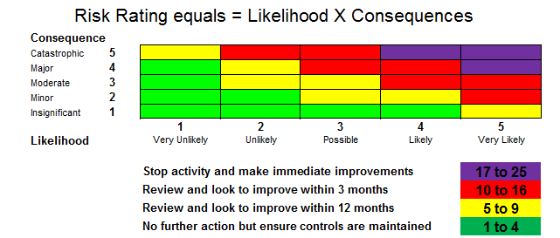

For further information, please refer to the Risk Assessment Policy on our webpage: Risk Assessment Procedures

