How to register with TARGETconnect
Step 1
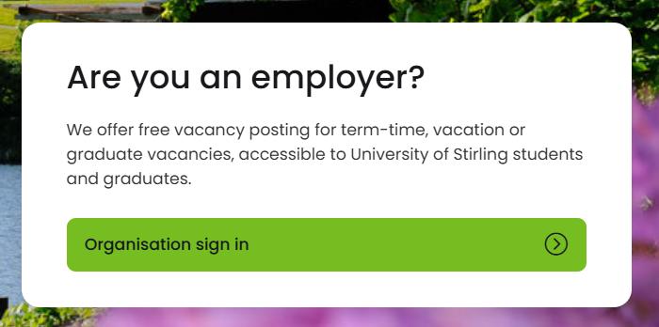
- Select Organisation sign in

- Select Register

Step 2 – Your Details
- Complete your personal details
- Create a password
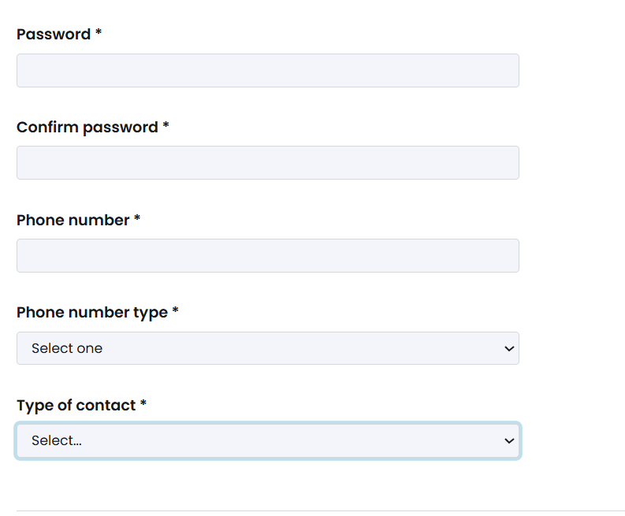
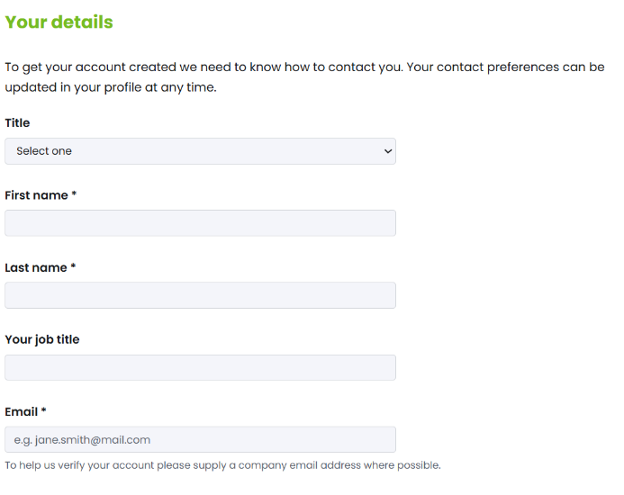

Step 3 – Organisation Details
- Complete your organisation details
- If you are a recruitment agency, you can still register for an account but please be aware you will need to state the organisation you are advertising on behalf of in each vacancy you publish.
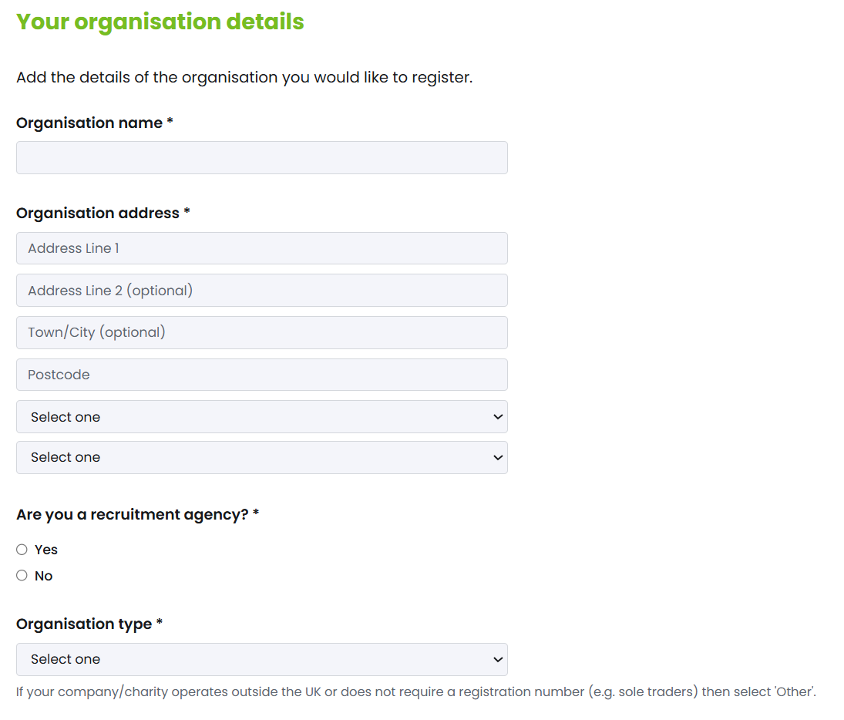

Step 4 – Public Profile
- Your public profile is an important section to complete. This information will be visible to all students and graduates searching your organisation and will be included in your vacancy postings.
- Please include as much information as possible to ensure potential applicants have a clear understanding of your organisation.
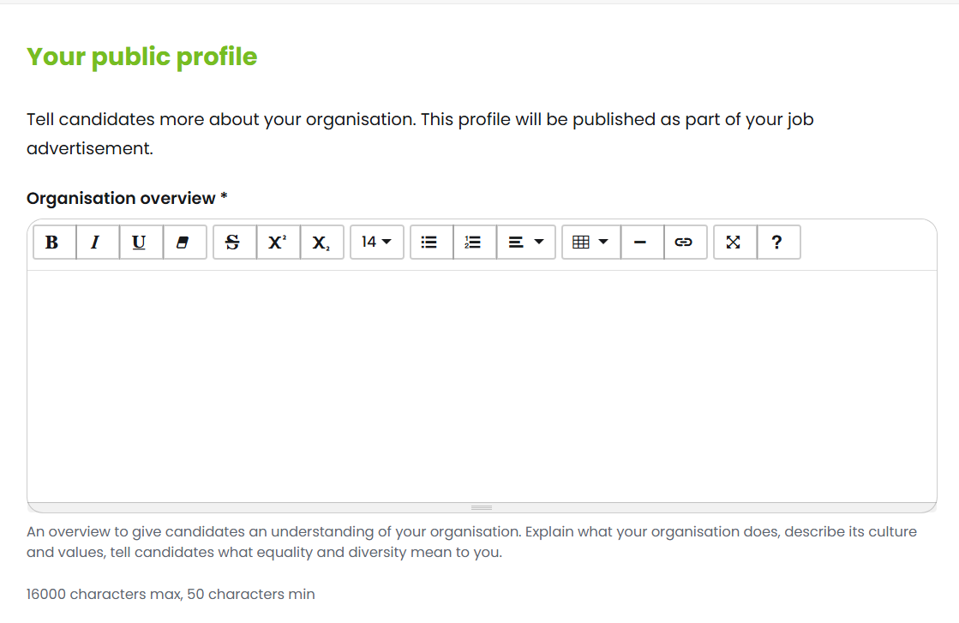

- Select your primary business area and any other relevant business areas to ensure the right candidates can find your opportunities through the search function.

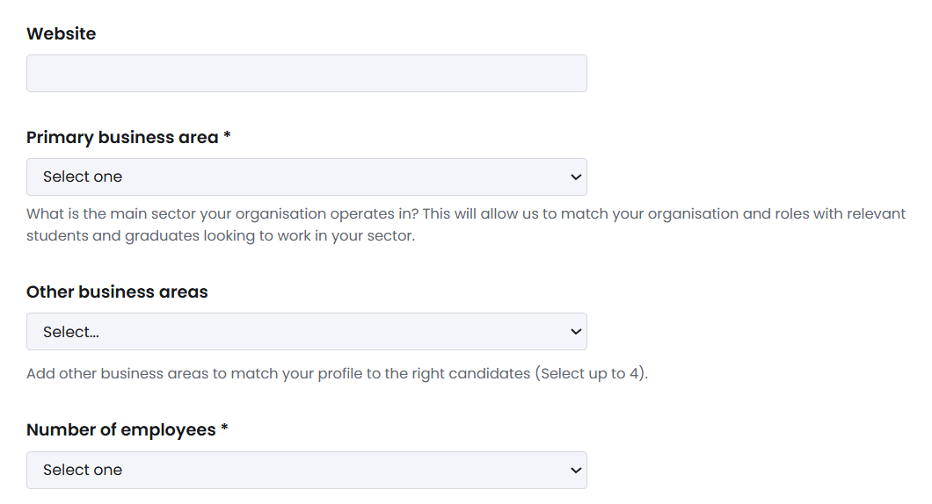

Step 5 – Policies
- Before completing registration, please read the vacancy handling policy and privacy statement.
- The documents can be accessed by hovering over and selecting the titles
- Select yes, the confirm
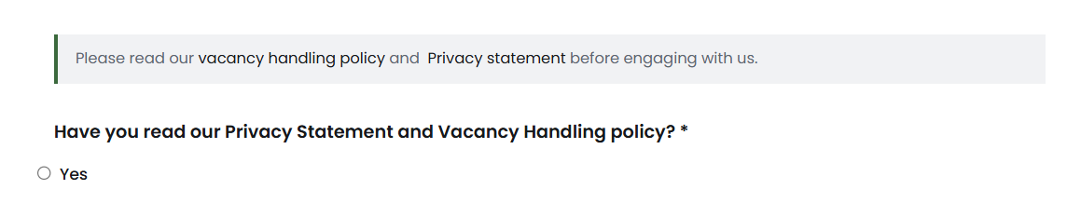

Step 6 – Net Zero and Sustainability Credentials
- Please complete your organisation’s Net Zero and sustainability credentials
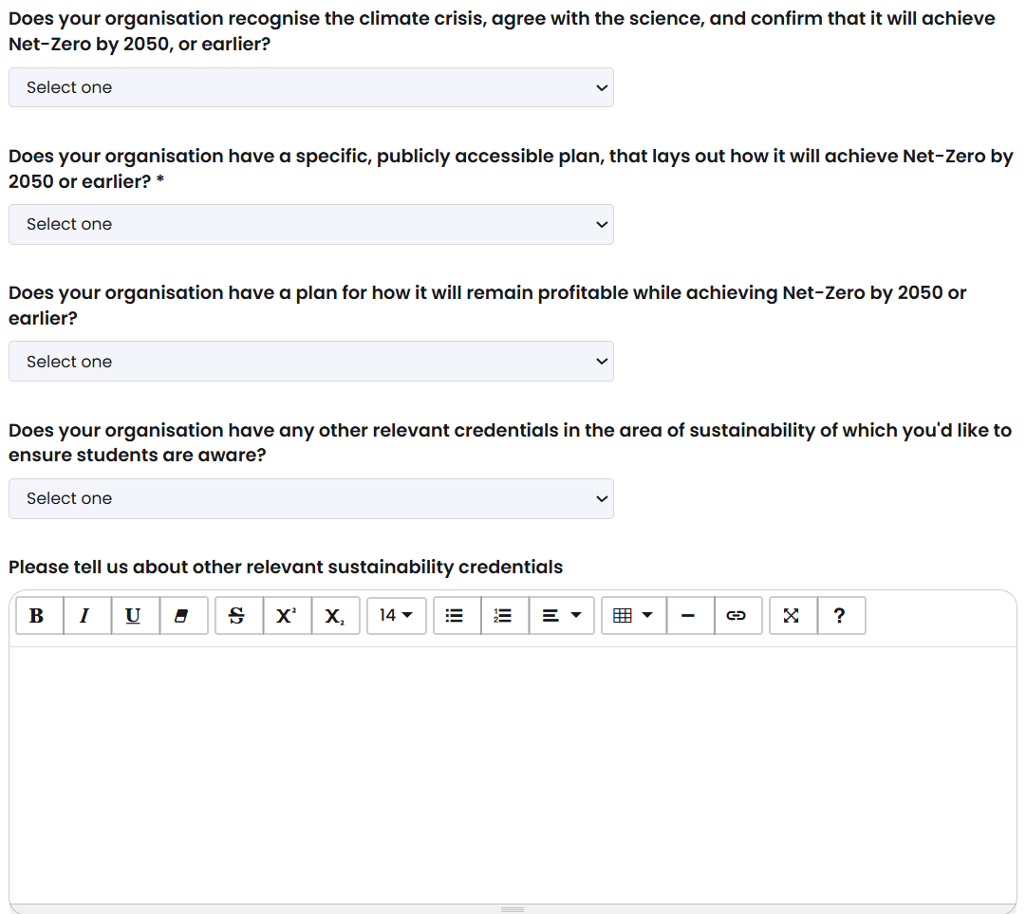
Step 7
- To add your organisation logo to your profile please upload by choosing a file from your device or drag to the tab.
- Select the Register tab to complete registration for Stirling TARGETconnect
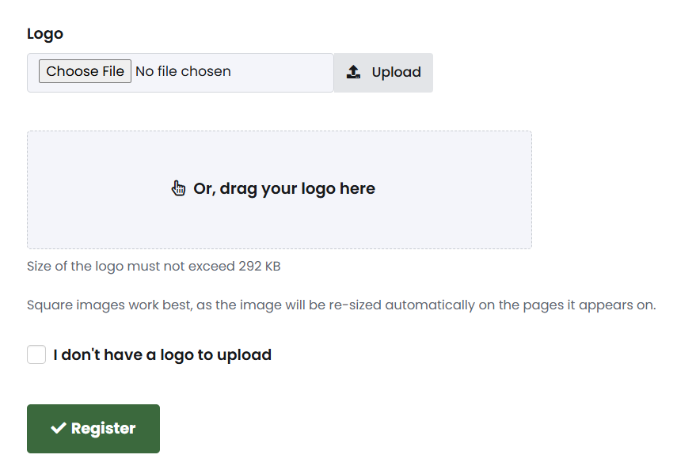
Your application will then come to the Work Based Learning and Employer Engagement Team for approval. Once your organisation has been approved, it will be searchable for TARGETconnect users.

If you have any questions or encounter any issues during the registration process, please contact the Work Based Learning and Employer Engagement Team: employers@stir.ac.uk

