How to publish a vacancy on TARGETconnect
Step 1
- Select the type of opportunity you want to post — ‘General posting type’ is the most used and the system defaults to this.
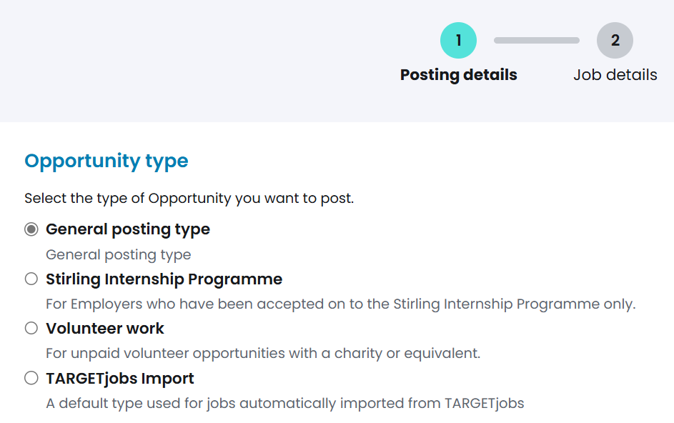
- Then select the main contact for the vacancy. You can either choose from the pre-populated drop-down menu or manually enter their name and email address.
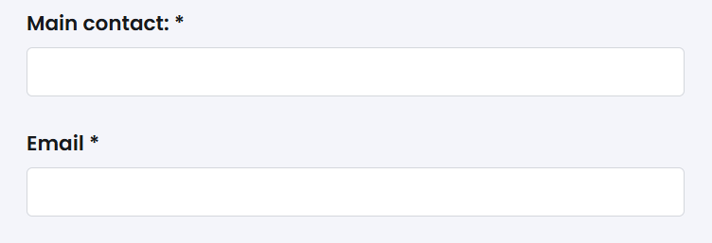
Step 2
- Under ‘Advertising Details’, choose the date you want your advert published and visible to users. If you don’t want to publish right away, you can set a future publish date. Alternatively, the system defaults to today’s date.
- Input the closing date.
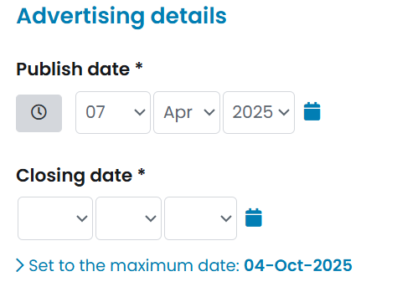

- Select how you wish the candidates to apply.
- You can choose URL or email address, or both. Enter the URL/email address you want to use as appropriate.
- You can tick the box to ‘Add any specific instructions’ e.g.: ‘Please email your CV and a covering letter to the application email address above.’
- Click ‘Next’.
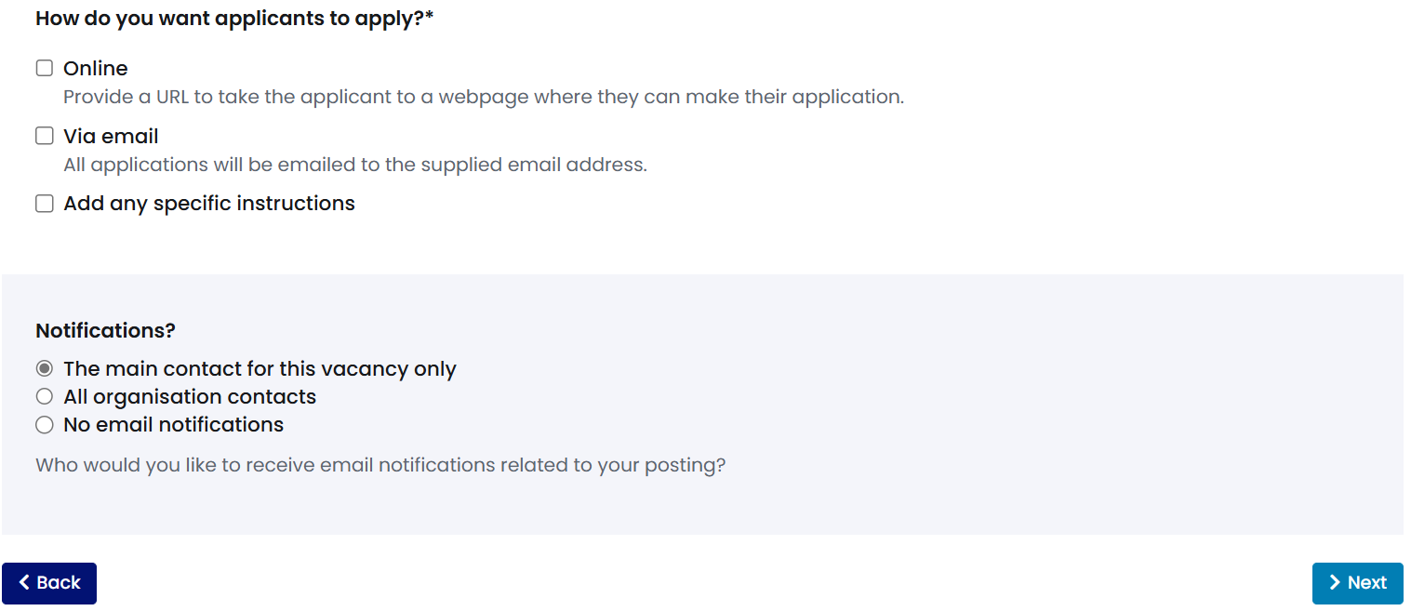
Step 3
- Under ‘Job details’, select the ‘Opportunity type’ from the drop-down menu. You can select more than one. The most used are:
  - Fixed term
  - Graduate scheme – this is for a fixed term programme specifically for graduates within your organisation.
  - Internship
  - Part time
  - Permanent (this can be used for full-time graduate roles)
  - Voluntary role
- Input the Job title.
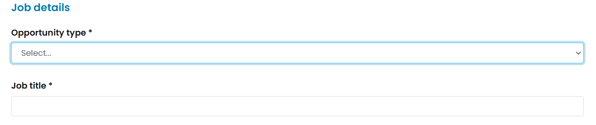
- Provide the ‘Opportunity Description’. Use the description to provide information about your company, define the responsibilities of the role and outline who the perfect candidate would be.

- You can use the buttons in the red box below to format your text.
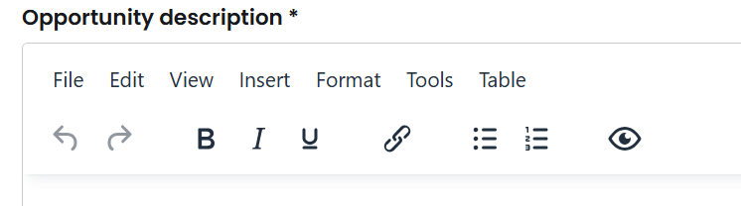
- Select ‘Job sectors’ from the drop-down menu (select up to 5). This is how the students will filter so it’s worthwhile to select all that apply.
Step 4
- Input ’Salary range’ (preferably stating a range rather than just competitive).
- If a fix salary amount is stipulated, please provide this in the ‘Additional salary information’ box.
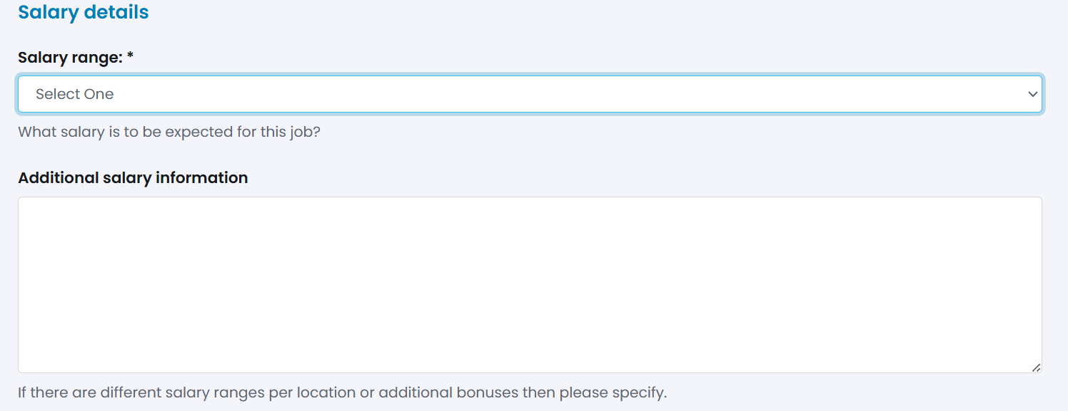
- Select your Location(s) and Countries.
- If your organisation is recruiting for roles at various offices, you can choose more than one location, then provide specific details in the Additional location information text box.
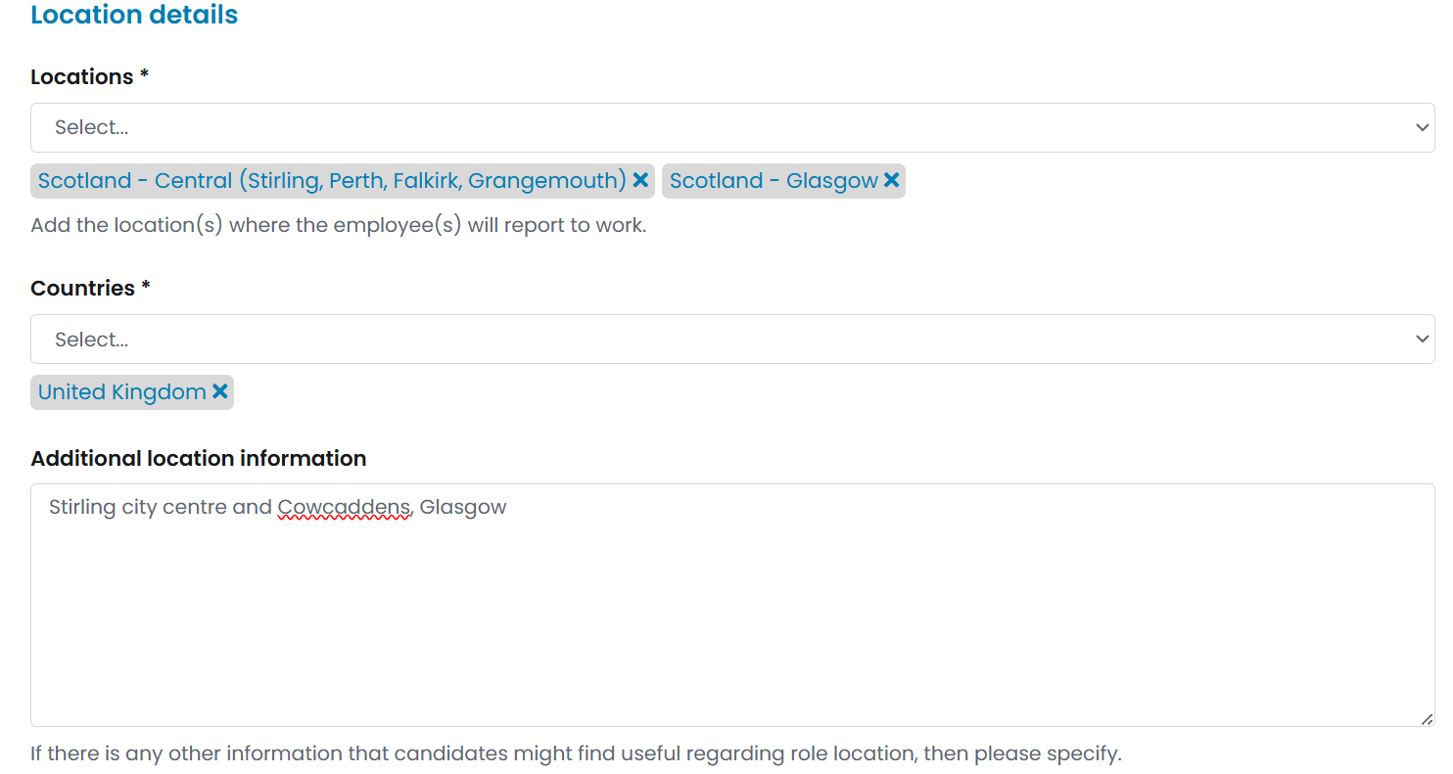
Step 5
- Under ‘Application details’, you have the option to select the number of positions available and to enter interview date(s). These are optional, so if unchanged, they won’t appear on your vacancy.
- Select your Start date. For ‘Immediate’ or ‘Flexible’, no date is required. If ‘Specific dates’ is selected then dates will need added before you can progress to the next section. You can also use the ‘Start date details’ text box to enter any other necessary information about the start date.
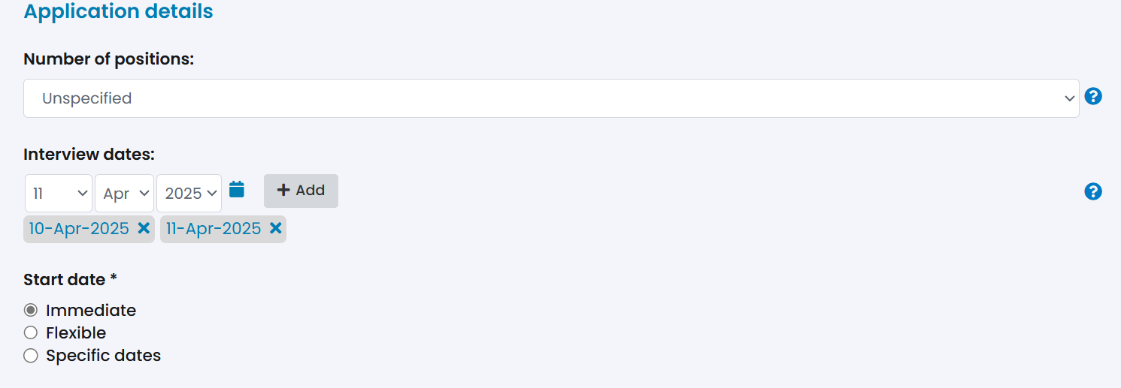
Step 6
- Under ‘Other details’, you can provide essential or desirable skills and experience requirements in the text box provided. If you’d prefer, you can include this information in the ‘Opportunity Description’ box.
- Scroll to the bottom of the page and click ‘Publish’.
- The post will now be sent to the Work-Based Learning team for approval.
- Once live on TARGETconnect, students will be able to browse and apply.
